Sharanya Garipally

Due Date – 05/05/2023

**Emergency Department Management database system**

Project 2

Table of Contents

Section 1: Introduction 2

Section 2: Functional Requirement: 2

Section 3: Entity Relationships(Explaining with UML Diagram) 2

Section 4: Table Information 5

Section 5: API Implementation 6

Section 6: Stored Procedure 9

Section 7: User Authentication 15

Section 8: Views 22

Section 9: Indexes 27

Section 10: Role_Based Access: 33

Section 11: Audit Trail 33

Section 12: Tools Used 49

# Section 1: Introduction

**Overview:**

Electronic Medical Records (EMRs) or Electronic Health Records (EHRs) are considered a critical technology for improving patient care quality and reducing health care cost. It should implement in every health center. For this project I specified data regarding patients in Emergency department.

**Database Design:**

Emergency Department Management database system is a computer base software system.it is designed to improve the quality and management of patients in emergency department.

The Emergency Department Management database system include the registrations of main 5 tables patients, doctors, Nurses, Receptionists and rooms and break down them into further tables with more details storing their details into system by using database. It gives unique ID to patients, doctors, Nurses, Receptionists and rooms to store their details.

# Section 2: Functional Requirement:

In Project 1 we created a Database based on this which consists of:

1. Patient

2. Doctor

3. Nurse

4. Receptionist

5. Insurance

6. Insurance_Info

7. Cure

8. Visit

9. Payments

10. PatientAdmit

11. Room

# Section 3: Entity Relationships(Explaining with UML Diagram)

1. Visit:

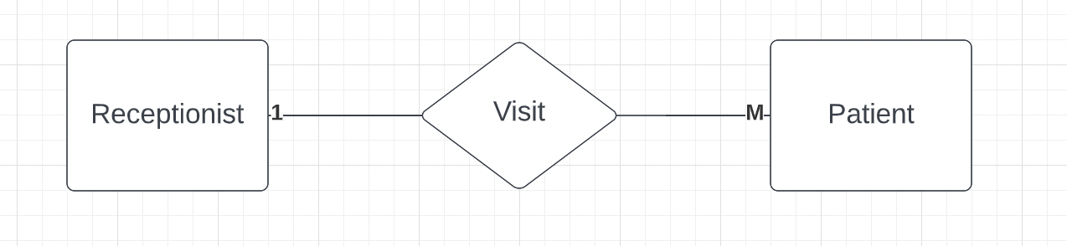

Type of relationship: One - To -Many[1:M]

* One receptionist delas many patients and one patient interact with only one Receptionist.
* Its an Association class

1. Diagnose:

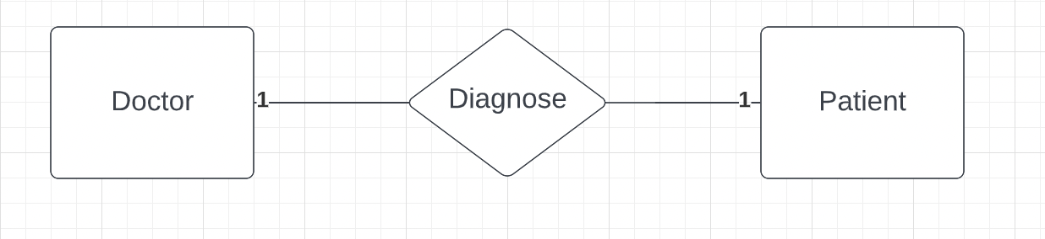

Type of relationship: One - To -One [1:1]

* One Doctor diagnoses only one patient and one patient can have only one doctor checked up at a time.
* Its an association class

1. Use:

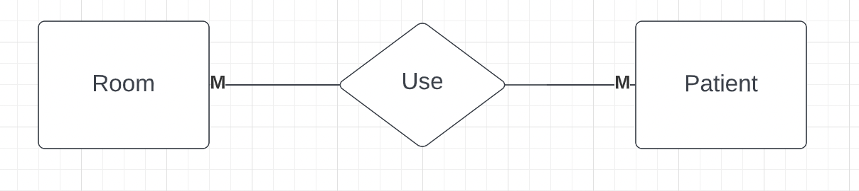

Type of relationship: Many - To -Many [M:M]

* One can admit in many rooms and one room can have many patients.

1. Treat:

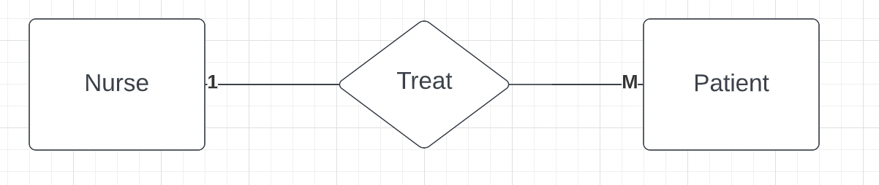

Type of relationship: Many - To -Many [M:M]

* One nurse can treat many patients and one patient treated by only one nurse.

Composition:

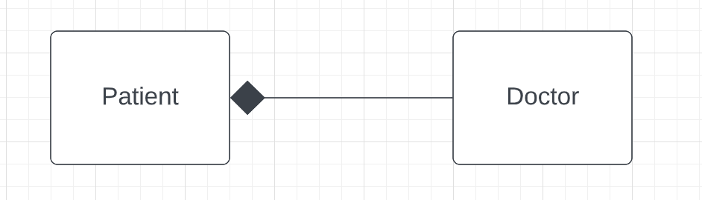

Composition: Every patient has a doctor

Aggregation:

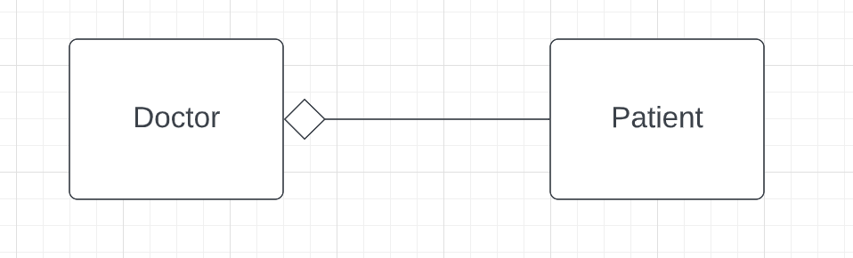

Aggregation: Doctors may have patients; they come and go.

Superclass, Subclass: Insurance is Superclass and InsuranceInfo is Subclass

**ER Diagram:**

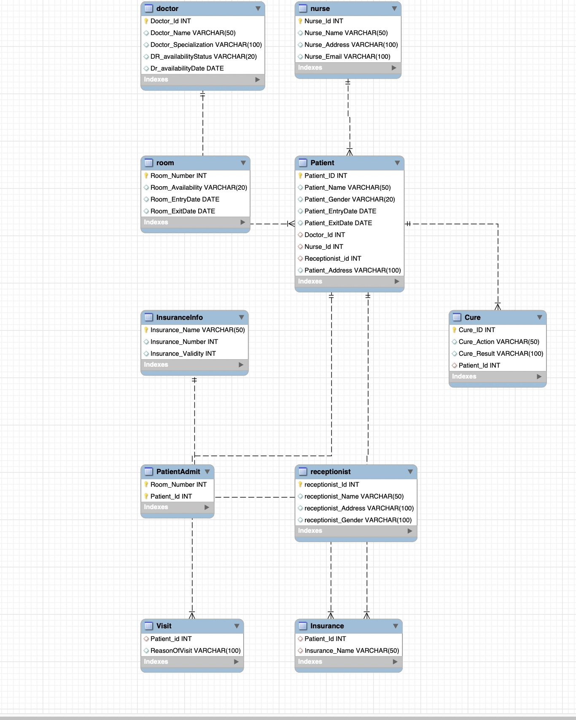

# Section 4: Table Information

1. **Doctor**: Doctor table have 4 attributes:
2. Doctor_ID
3. Doctor _Name
4. Doctor_Specialization
5. Dr_AvailabilityStatus
6. Dr_AvailabilityDate
7. **Nurse:** Nurse table have 4 attributes:
8. Nurse_Name
9. Nurse_ID
10. Nurse_Address
11. Nurse_Email
12. **Patient**: Patient table have 7 attributes:
13. Patient_ID
14. Patient_Name
15. Patient_Gender
16. Patient_EntryDate
17. Patient_ExitDate
18. Doctor_ID
19. Nurse_ID
20. Receptionist_ID
21. Patient_address
22. **Receptionist:** Receptionist have 4 attributes:
23. Receptionist_ID
24. Receptionist_Name
25. Receptionist_Gender
26. Receptionist_Address
27. **Room**: Room table have 4 attributes:
28. Room_Number
29. Room_Availability
30. Room_EntryDate
31. Room_ExitDate
32. **Visit Table:** Which consists of Visit details of patients it consists of 3 columns:
33. Patient_Id
34. ReasonOfVisit
35. Symptoms
36. **Insurance Table:** Which says patient and their insurance provider names.
37. Patient_id
38. Insurance_Name
39. **InsuranceInfo:** consists of Insurance further details:
40. Insurance_Name
41. Insurance_Number
42. Insurance_validity
43. **Cure Table:** Consists of cure details for patients.
44. Patient_id
45. Cure_id
46. Cure_Action
47. Cure_Result
48. **PatientAdmit:** Consists of details for which patient’s rooms are assigned:
49. Patient_Id
50. Room_Number
51. **Payments:** consists of details of bill amount paid by patients:
52. Patient_id
53. Bill_Amount

All Table are in BCNF as there are no partial dependency, no transitive dependency and left side column of functional dependency is a super Key.

# Section 5: API Implementation

For API I created I chose Java Programming as below:

When you run this java program, you can see a text based GUI for options to select.

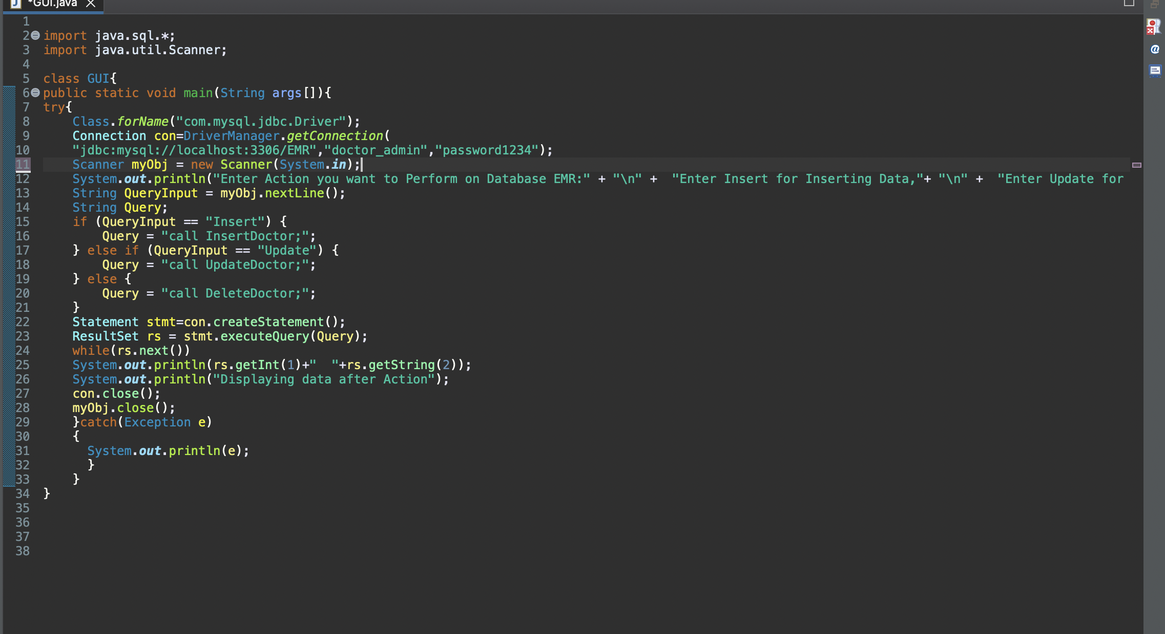

Connecting MySql through JDBC Connection:

Connecting to Doctor_admin user in which only user can connect and perform select,update,delete actions as we grant permission only to doctor.

If patient, try to delete or update it throws error.

When you run this Java Program you can see below GUI which says to enter what action to perform. If you want to do Insertion Enter Insert. This will make code to run Store procedure ‘InsertDoctor’ in which data will inserted with new doctor information Dr_id = 406 and Dr_Name = Dr.Roy.

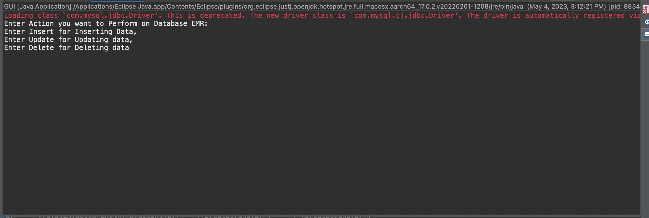

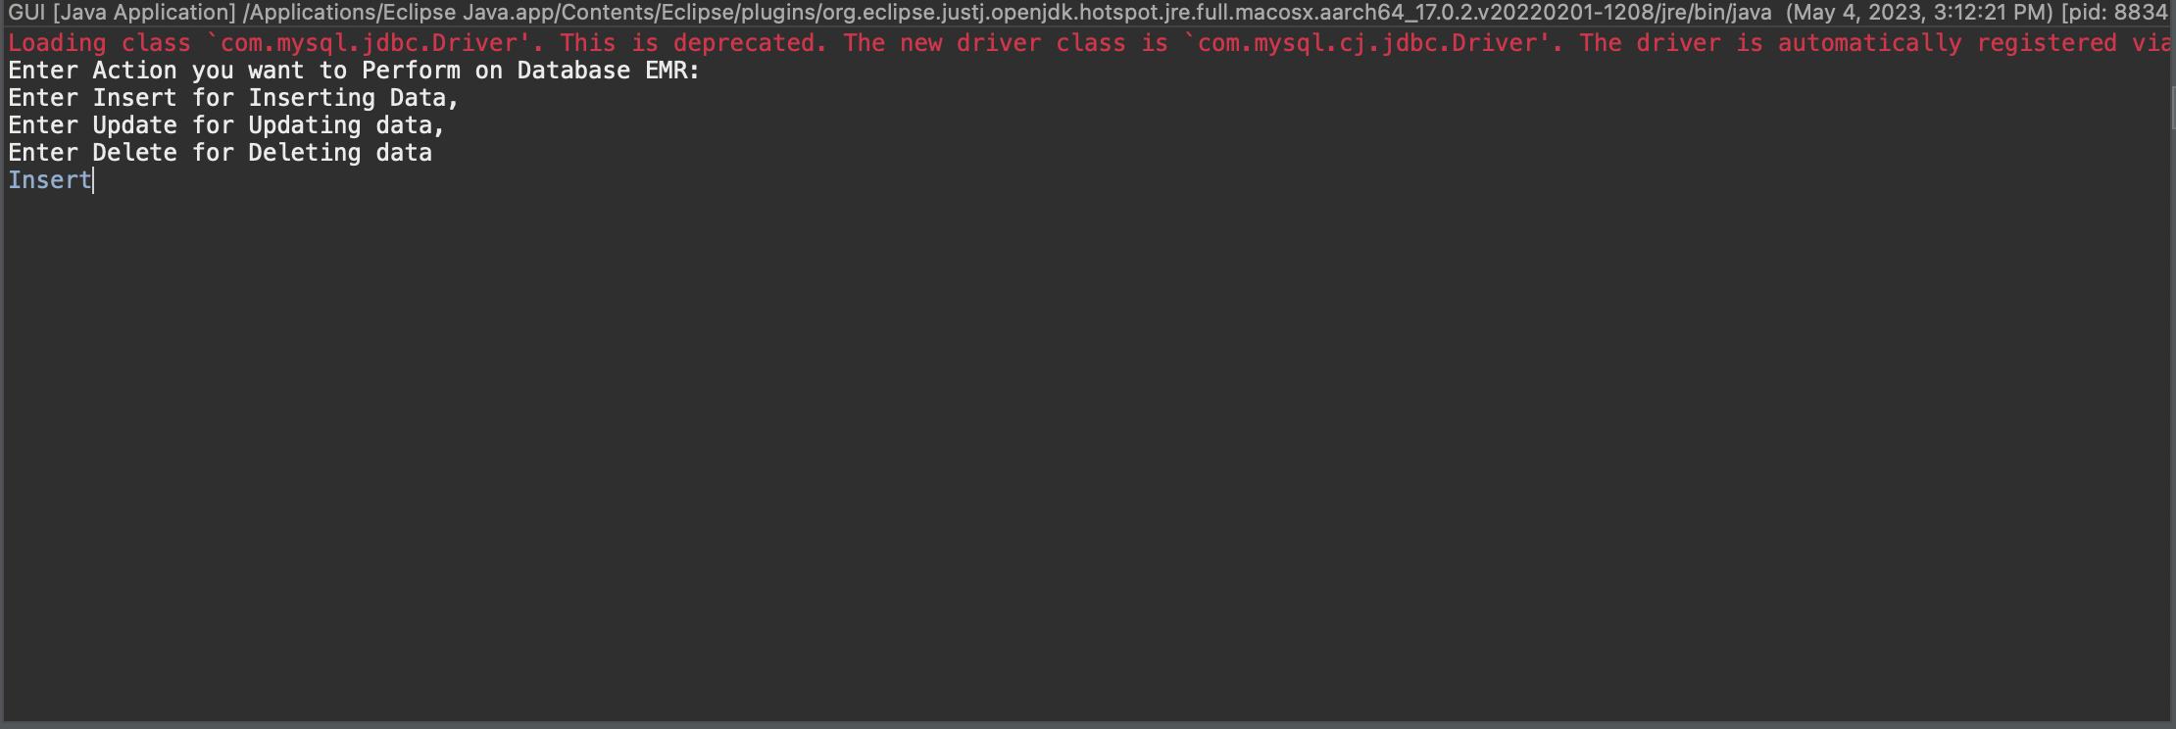

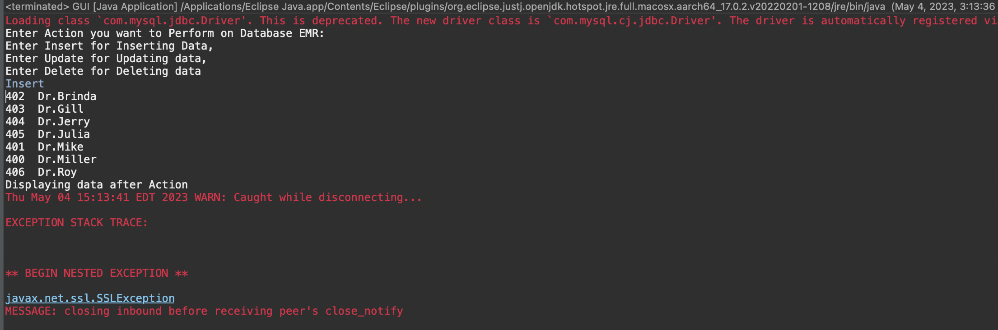

Update:

If you want to update data in database enter Update this will call store procedure UpdateDoctor which update 405 Id Dr_Name to Dr.Raye from Dr.Julia

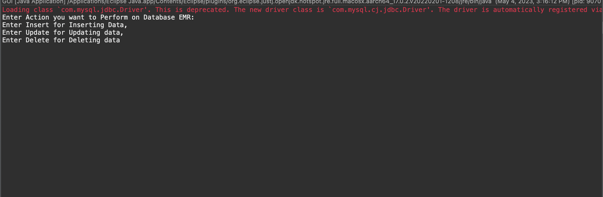

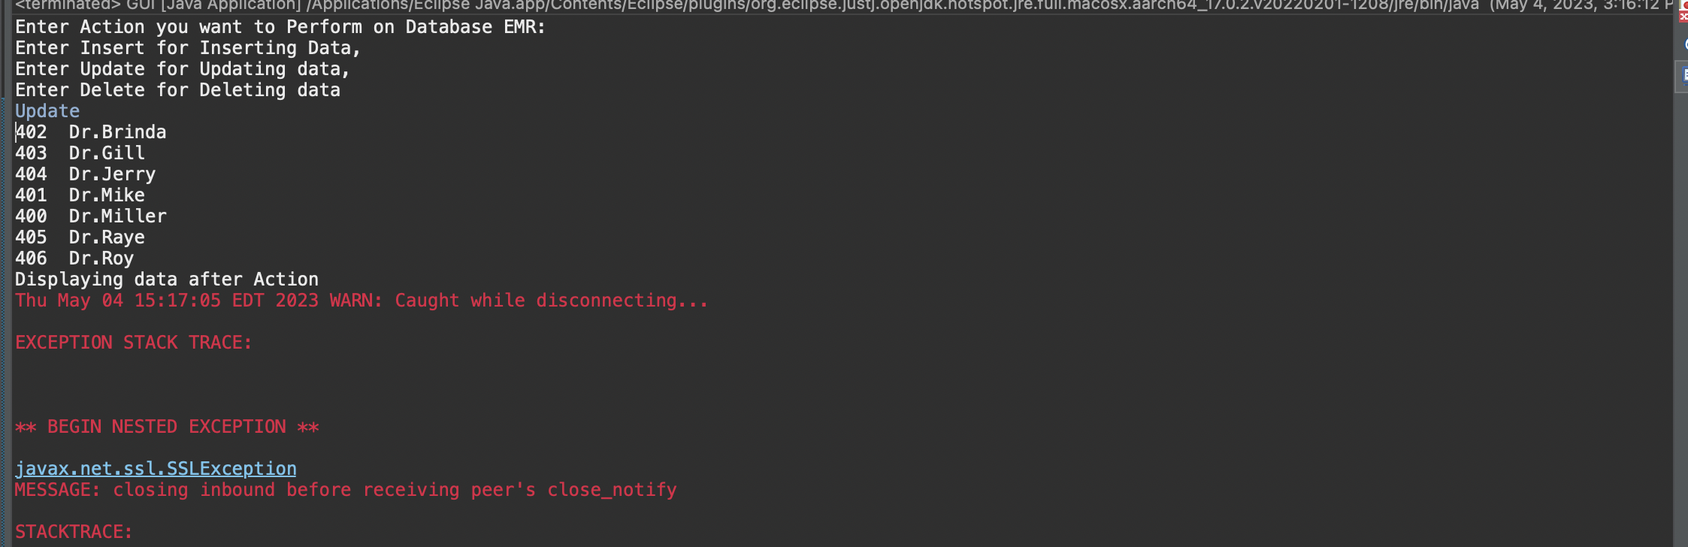

Delete:

If you want to Delete data in database enter Delete this will call store procedure DeleteDoctor which Deletes 406 Id Doctor

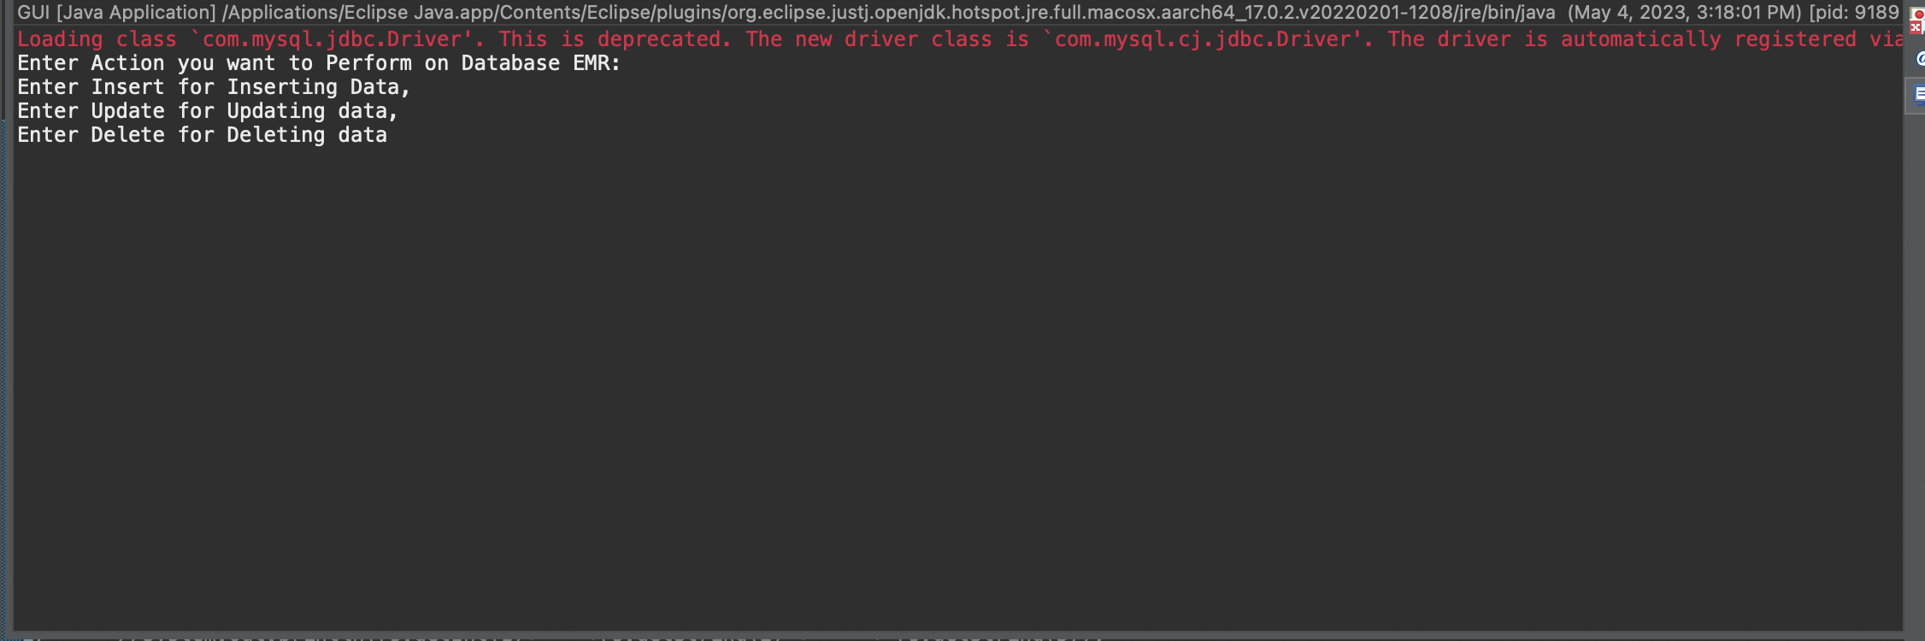

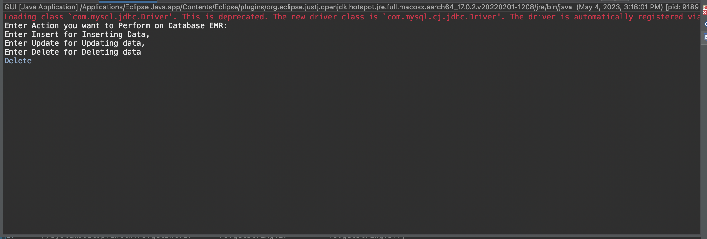

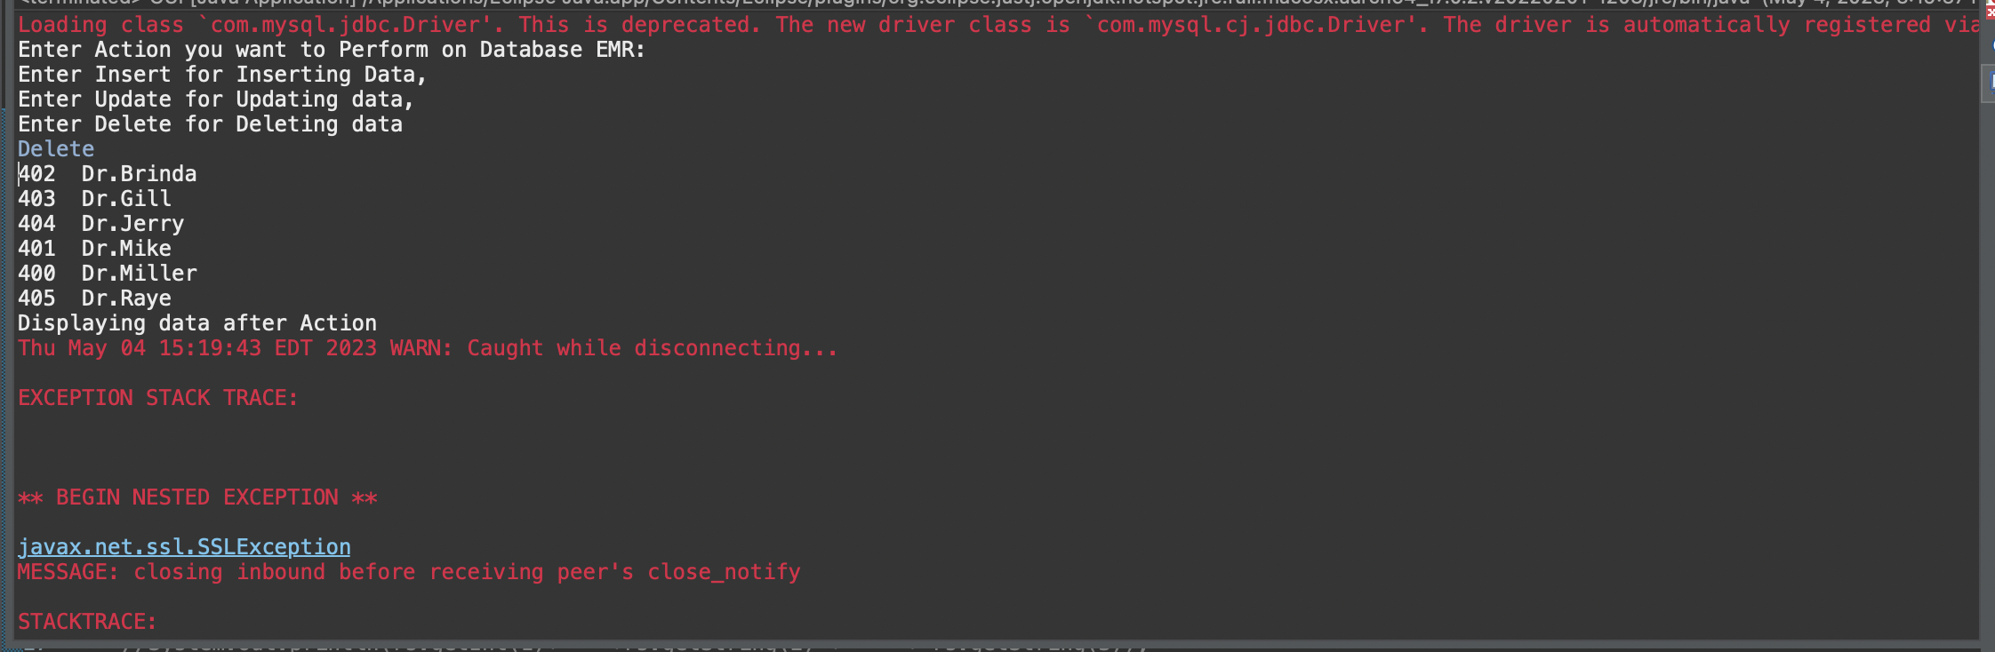

Using this API even without using MySql we can perform actions on database.

# Section 6: Stored Procedure

1. Creatng store procedure name InsertDoctor() – This Procedure inserts data into doctor table and display the table to check the results. When ever we run this stored procedure data will be inserted into doctor table

SQL:

DELIMITER //

CREATE PROCEDURE InsertDoctor()

BEGIN

-- Inserting into Doctor table

INSERT INTO doctor (Doctor_Id, Doctor_Name, Doctor_Specialization, Dr_availabilityStatus, Dr_availabilityDate)

VALUES ('406', 'Dr.Roy', 'Neurologist', 'Yes', '2022-05-18');

-- Seeing if values got inserted

select Doctor_Id,Doctor_Name from Doctor;

END //

DELIMITER ;

Result:

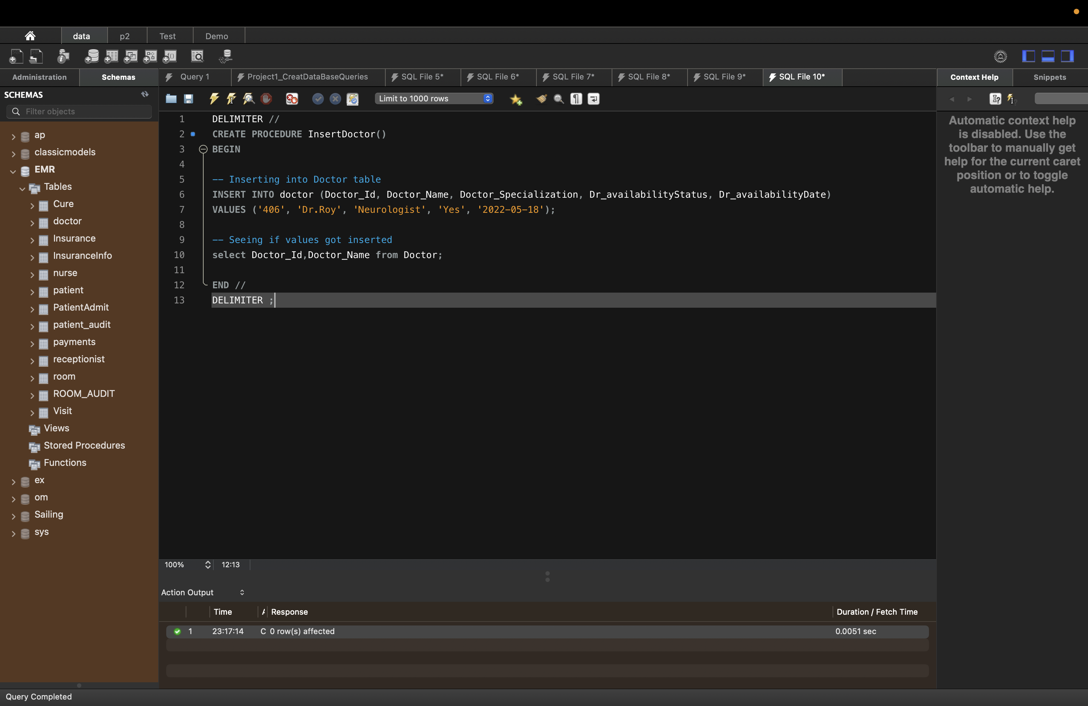

1. Creatng store procedure name UpdateDoctor() – This Procedure Updates data into doctor table and display the table to check the results.

SQL:

DELIMITER //

CREATE PROCEDURE UpdateDoctor()

BEGIN

-- Updating into Doctor table

Update doctor set Doctor_Name = "Dr.Ray" where Doctor_Id = '406';

-- Seeing if values got Updated

select Doctor_Id,Doctor_Name from Doctor where Doctor_Id = '406';

END //

DELIMITER ;

Result:

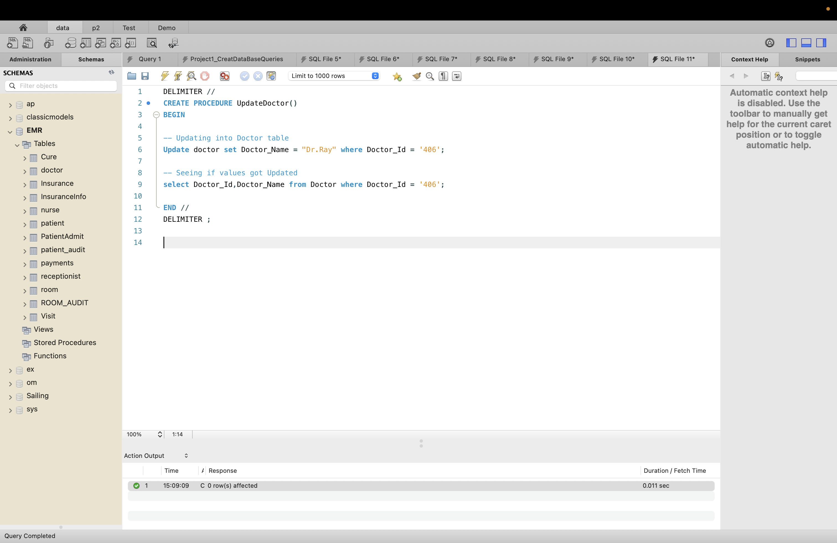

1. Creating store procedure name DeleteDoctor() – This Procedure Deltes data into doctor table and display the table to check the results.

SQL:

DELIMITER //

CREATE PROCEDURE DeleteDoctor()

BEGIN

-- Updating into Doctor table

Delete from doctor where Doctor_Id = '406';

-- Seeing if values got Updated

select Doctor_Id,Doctor_Name from Doctor;

END //

DELIMITER ;

Result:

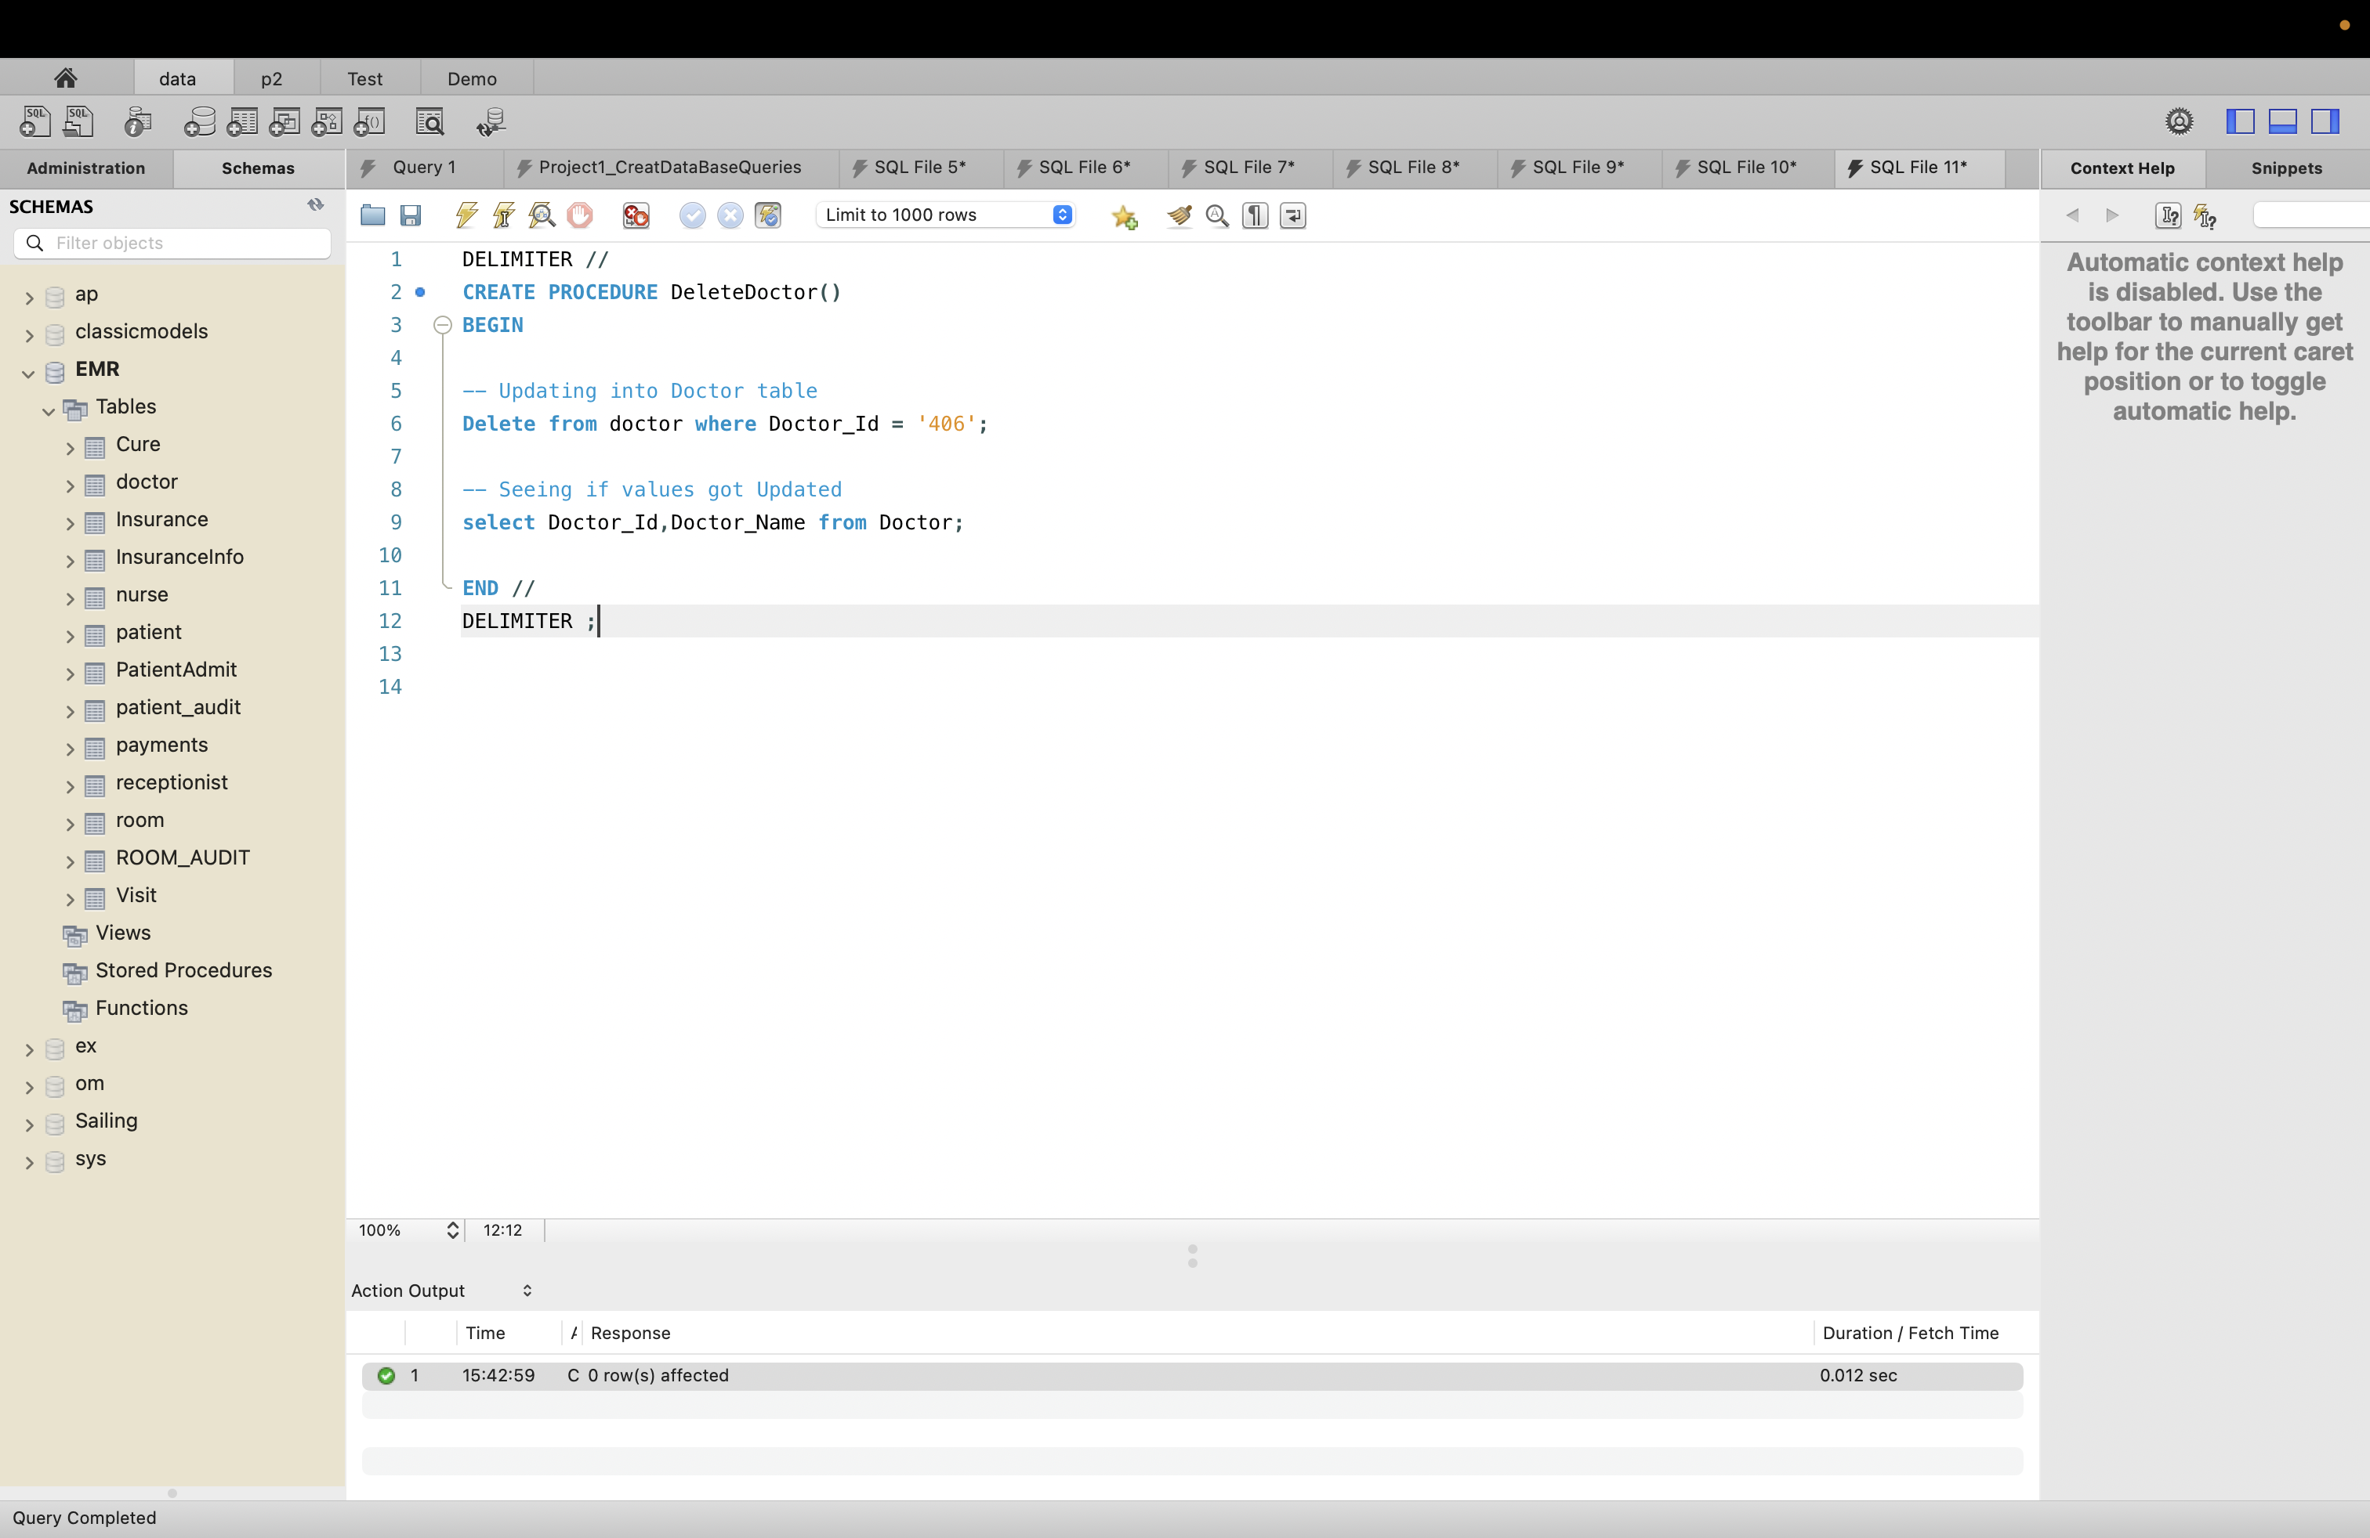

1. Creating Store Procedure name PatientsBill – which Displays Patient and theit Bill Amount

SQL:

DELIMITER //

CREATE PROCEDURE PatientsBill()

BEGIN

-- Select patients and their Bill Amounts

Select t.patient_id,t.patient_Name,p.Bill_Amount from patient t join payments p where t.patient_id = p.patient_id;

END //

DELIMITER ;

Result:

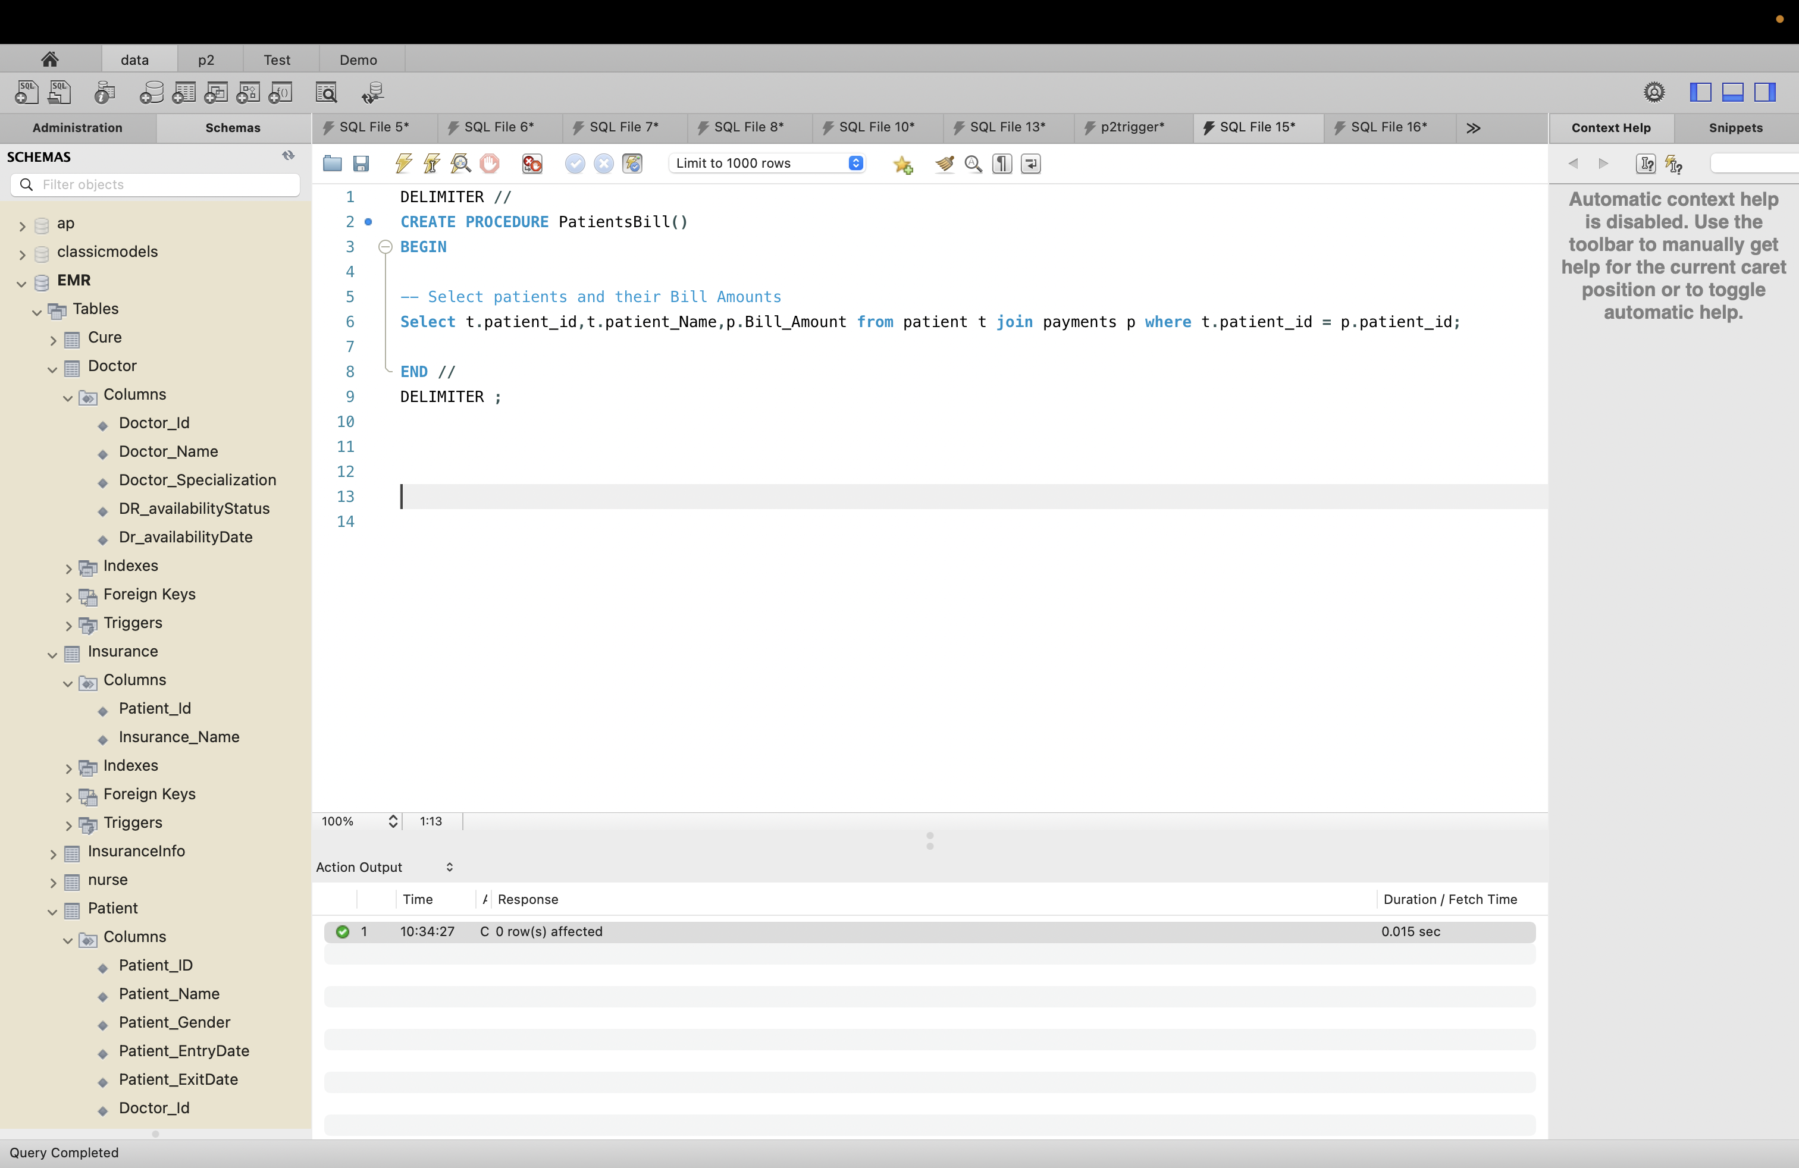

1. Creating Store Procedure name PatientsInsurance– which Displays Patient and their Insurance Name

SQL:

DELIMITER //

CREATE PROCEDURE PatientsInsurance()

BEGIN

-- ISelect patients and their insurance

Select p.patient_id,p.patient_name,i.Insurance_Name from patient p join insurance i where p.patient_id = i.patient_id;

END //

DELIMITER ;

Result:

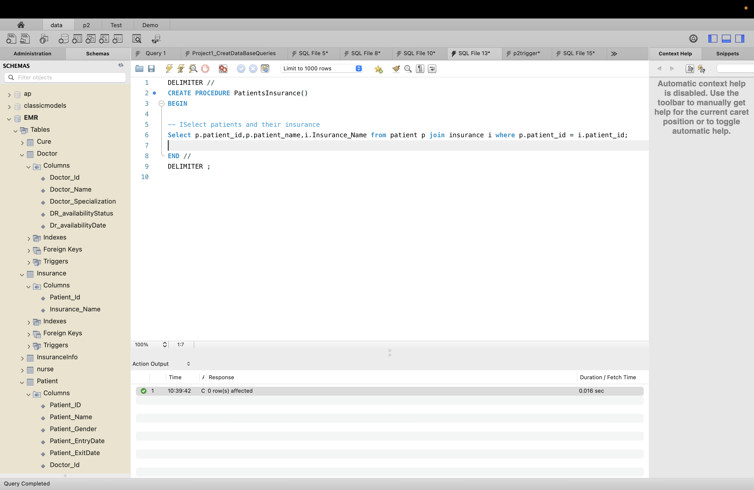

1. Creating Store Procedure name PatientsDoctor– which Displays Patient and their Doctor Name

SQL:

DELIMITER //

CREATE PROCEDURE PatientsDoctor()

BEGIN

-- Select patients and their Doctor

Select p.patient_id,p.patient_name,d.doctor_name,d.Doctor_Specialization from patient p join doctor d where p.doctor_id = d.doctor_id;

END //

DELIMITER ;

Result:

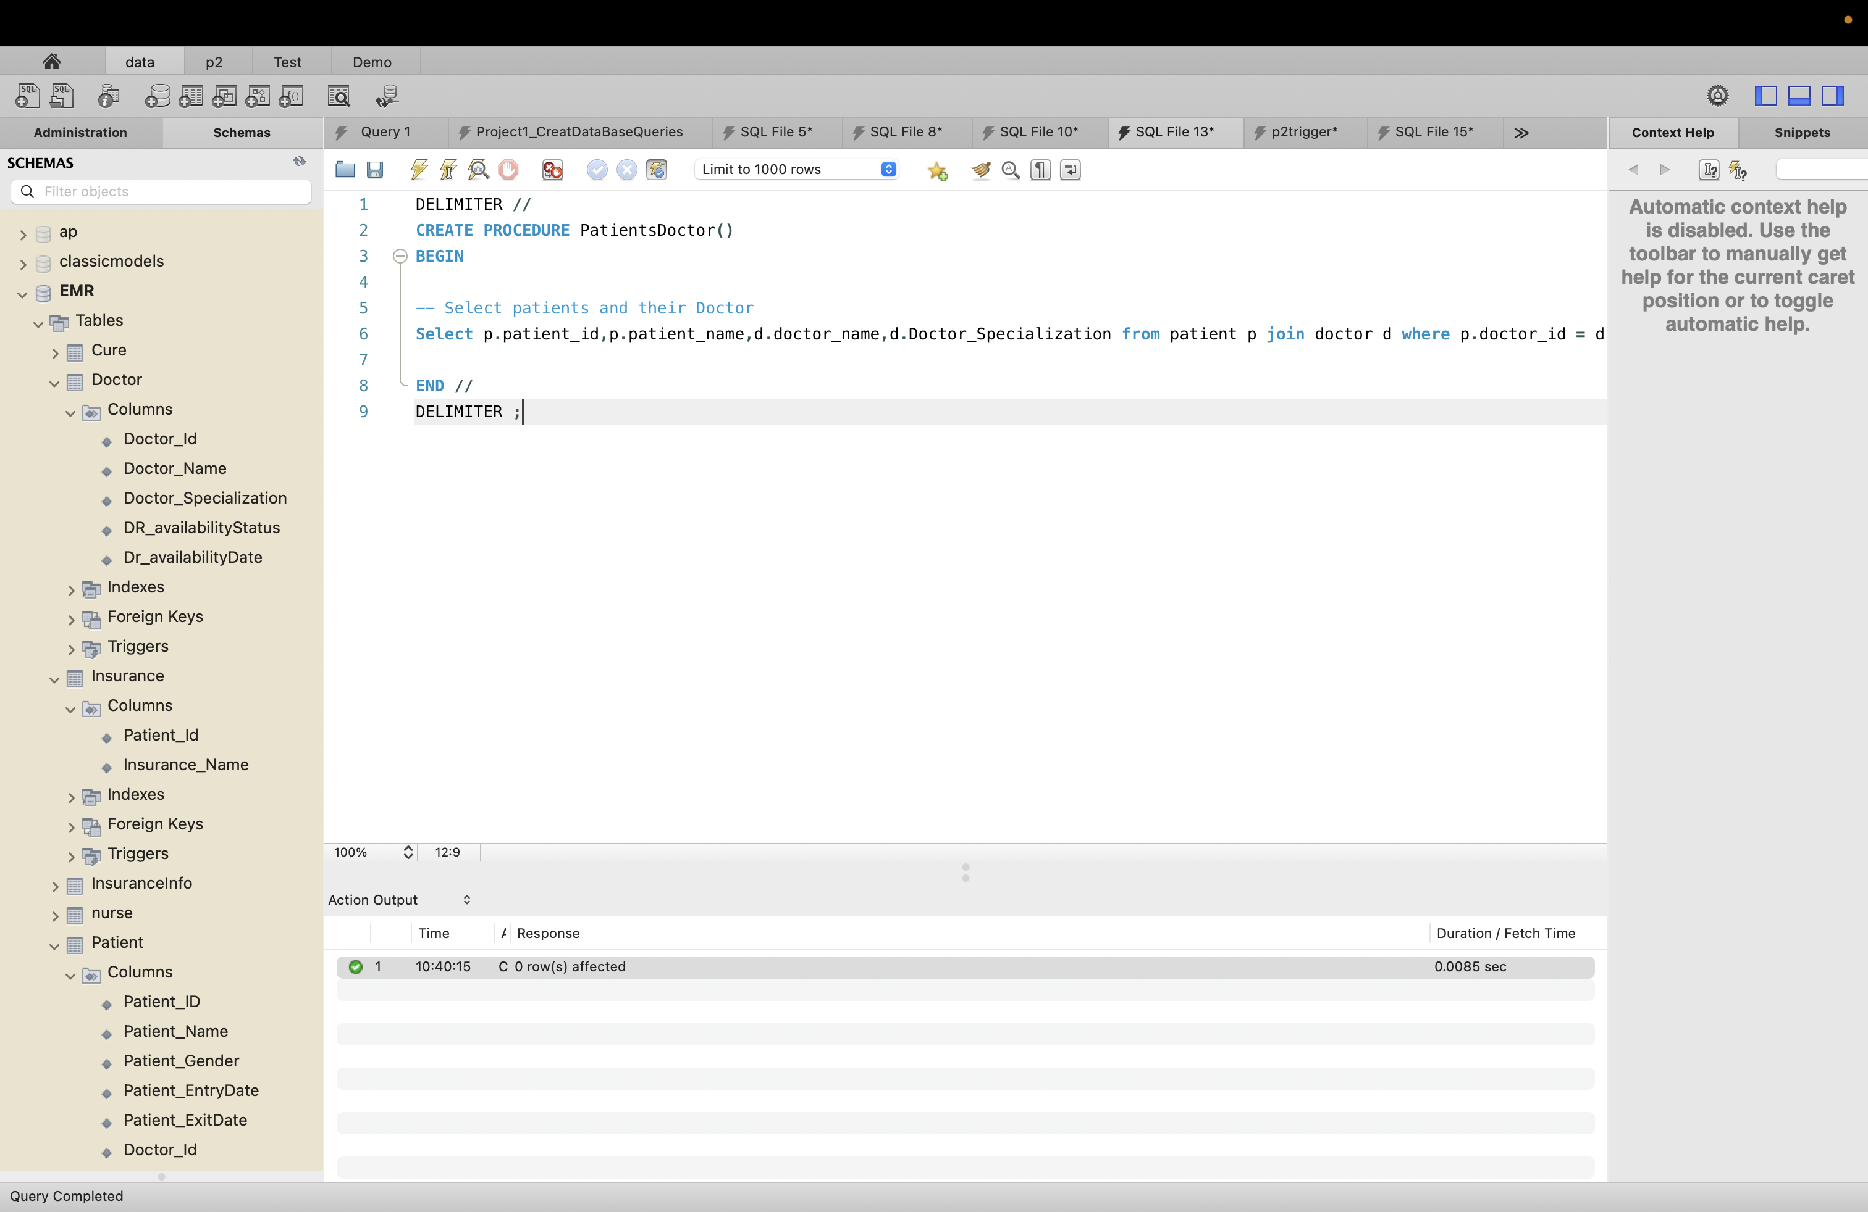

# 

# Section 7: User Authentication

Creating new user with username local_user and password as ‘password’

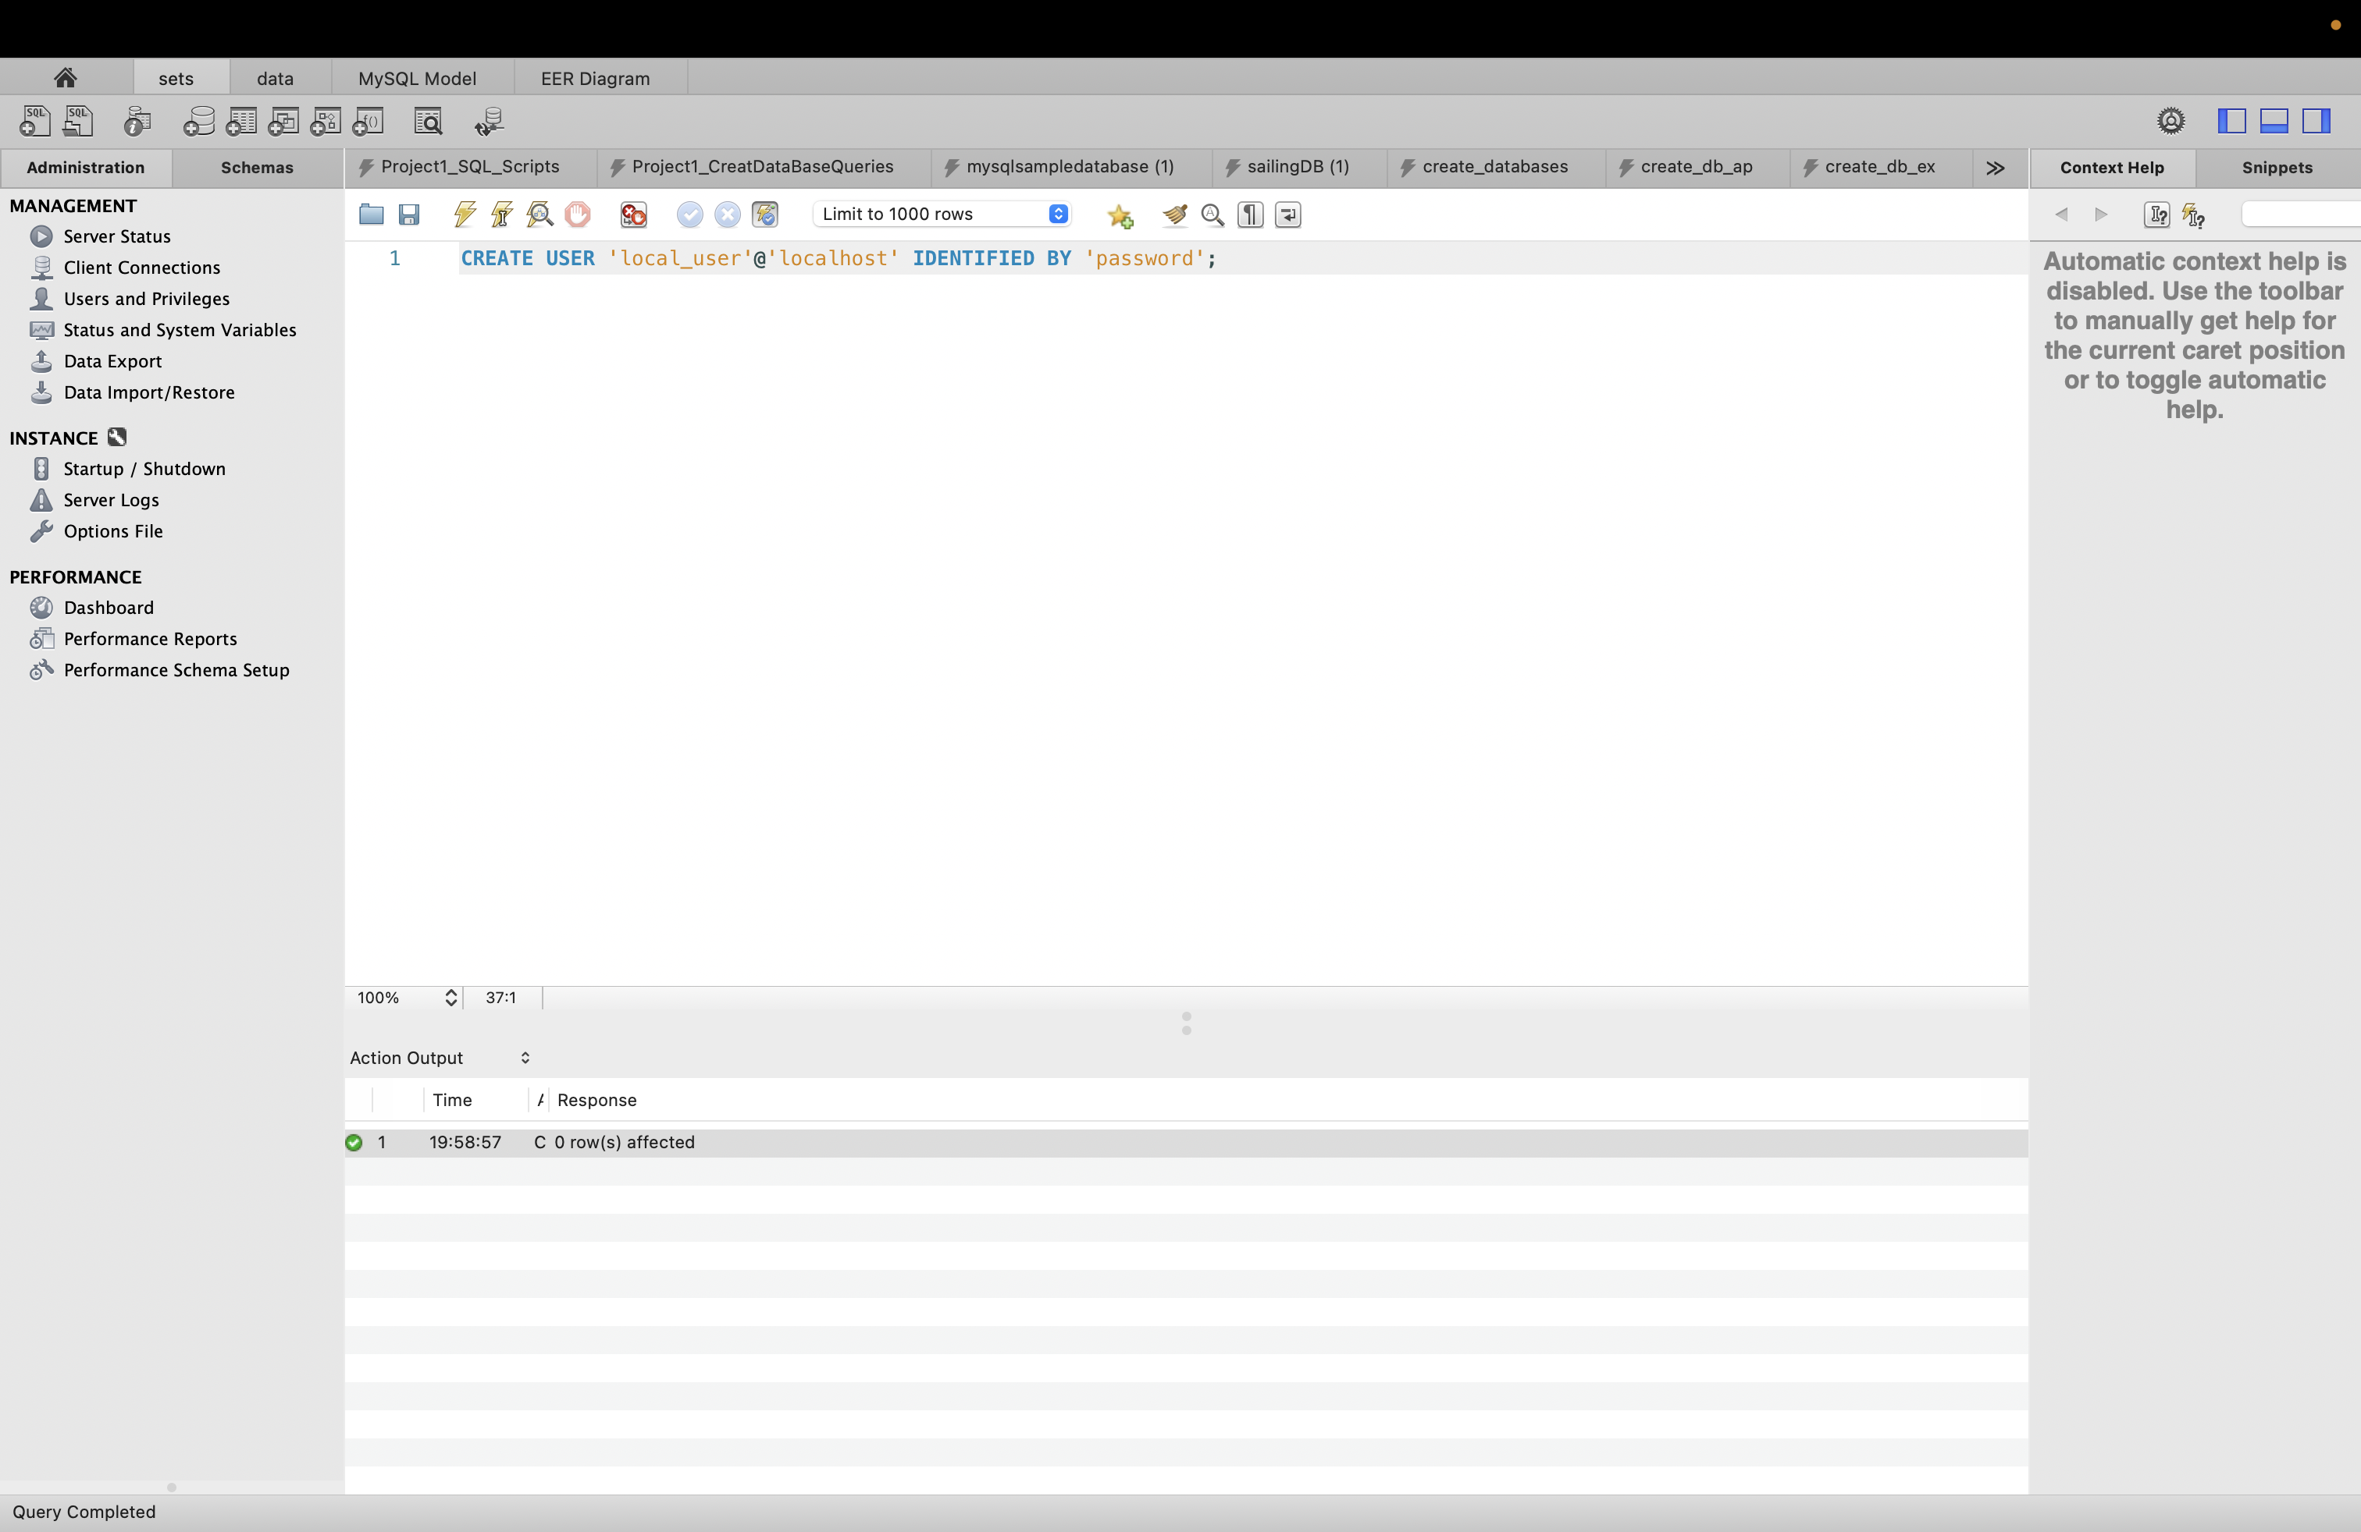

I can see local_user in list.

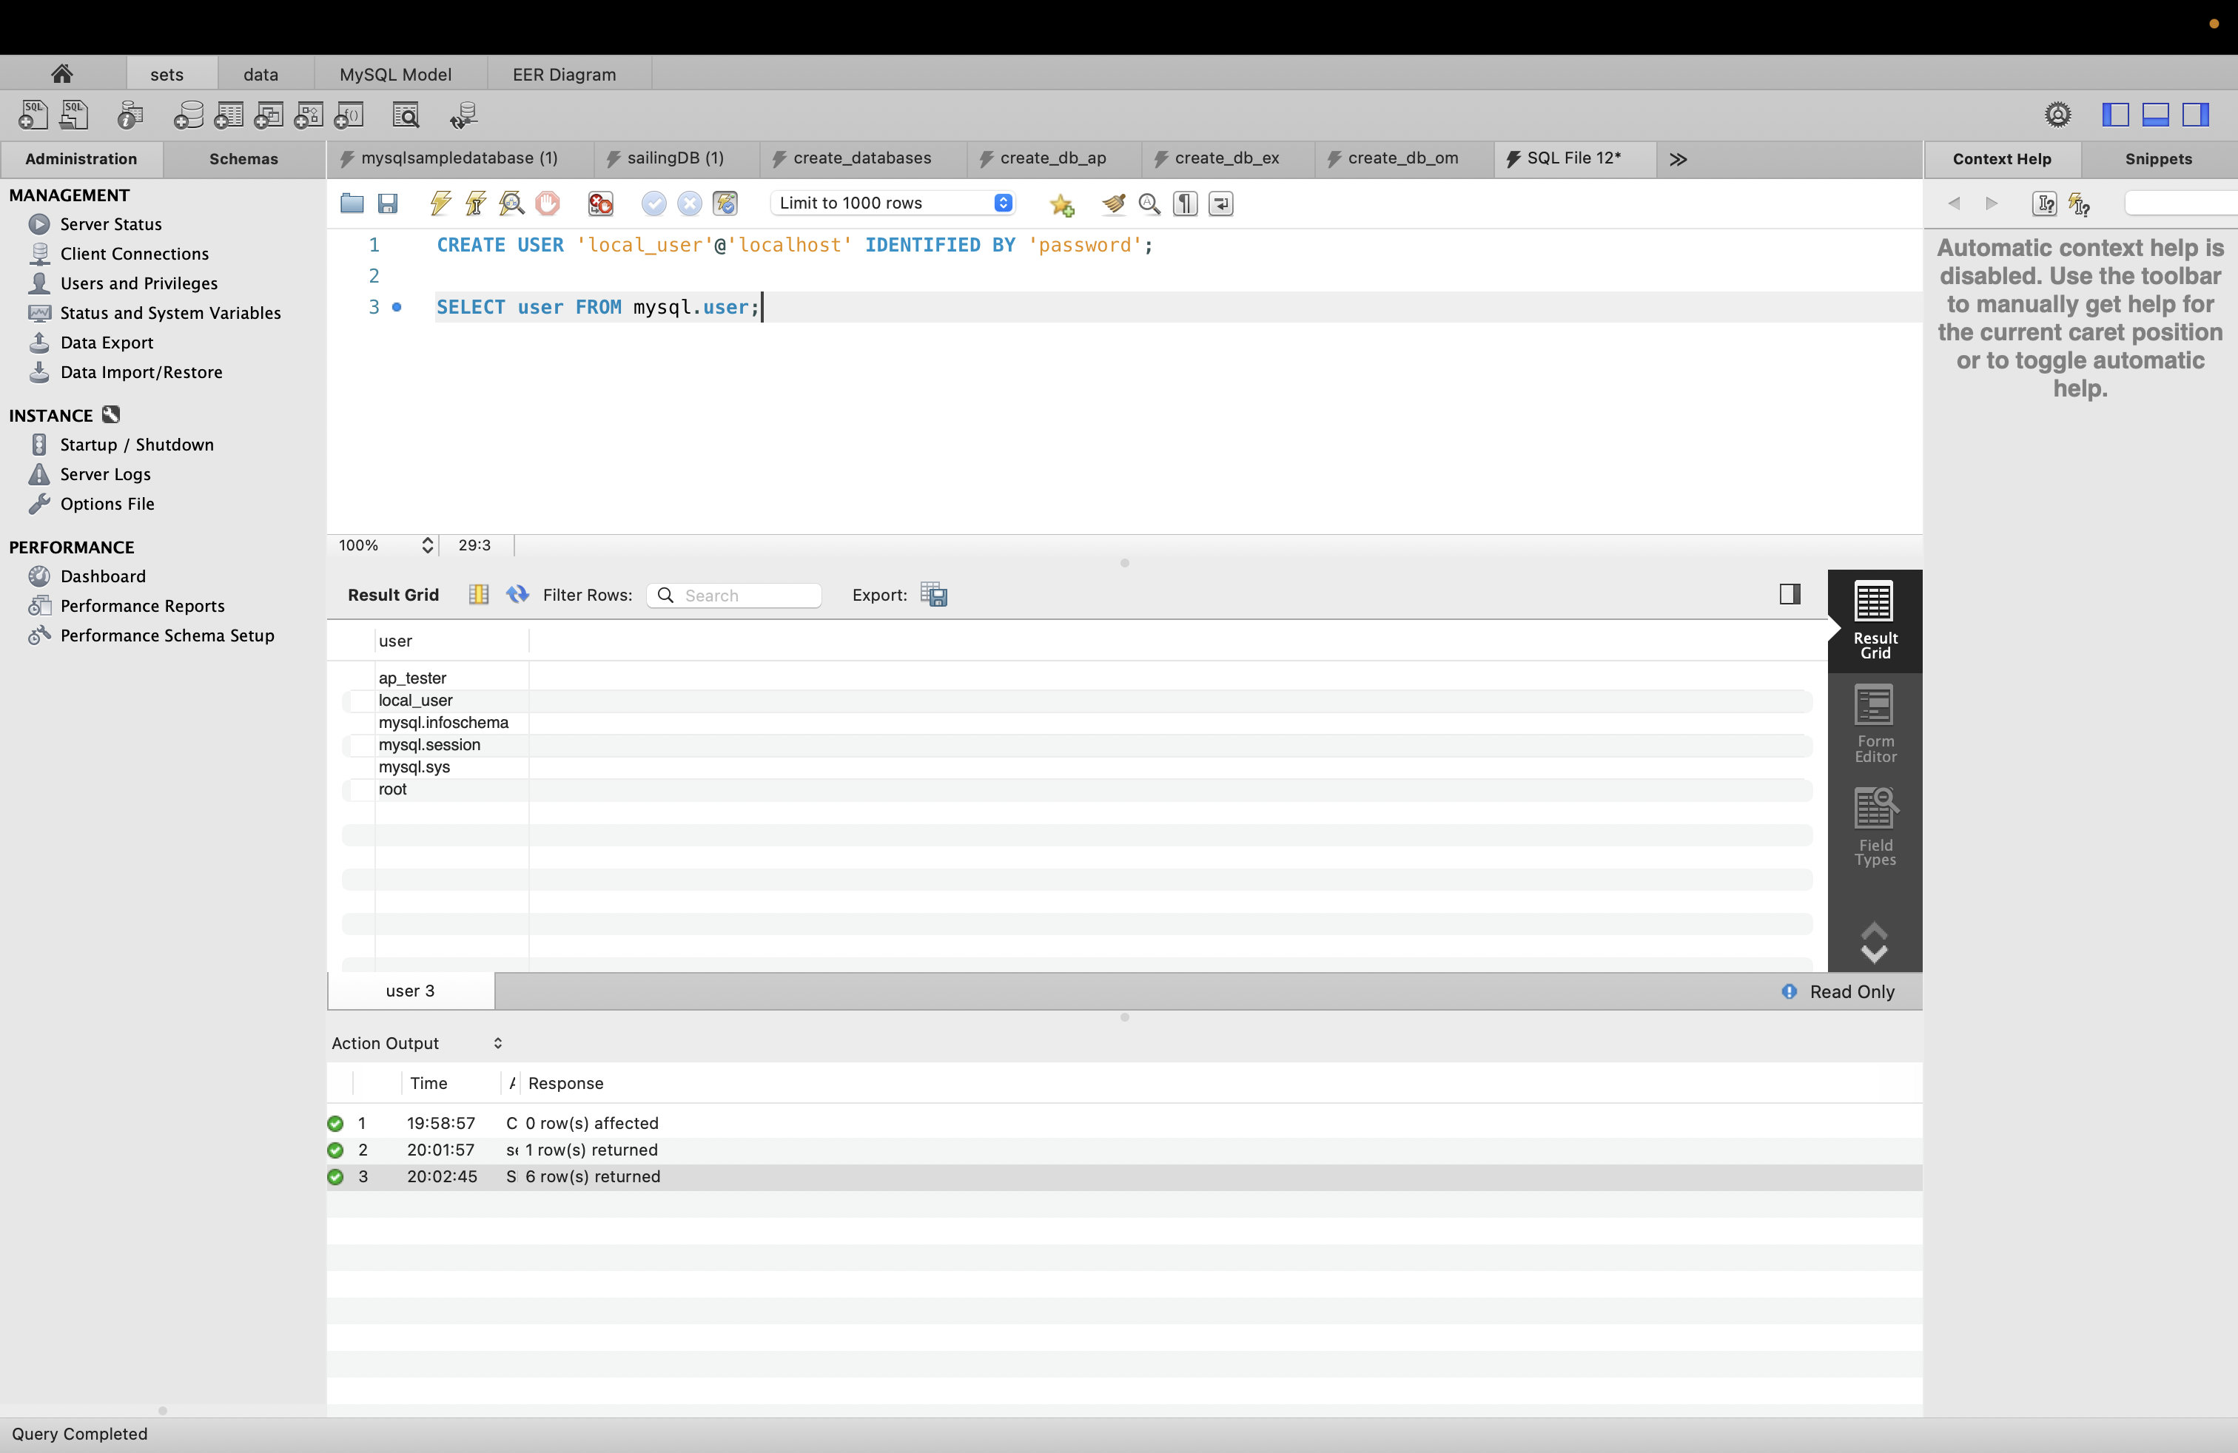

Creating new user with name doctor_admin and password doctor which default role is EMR_role

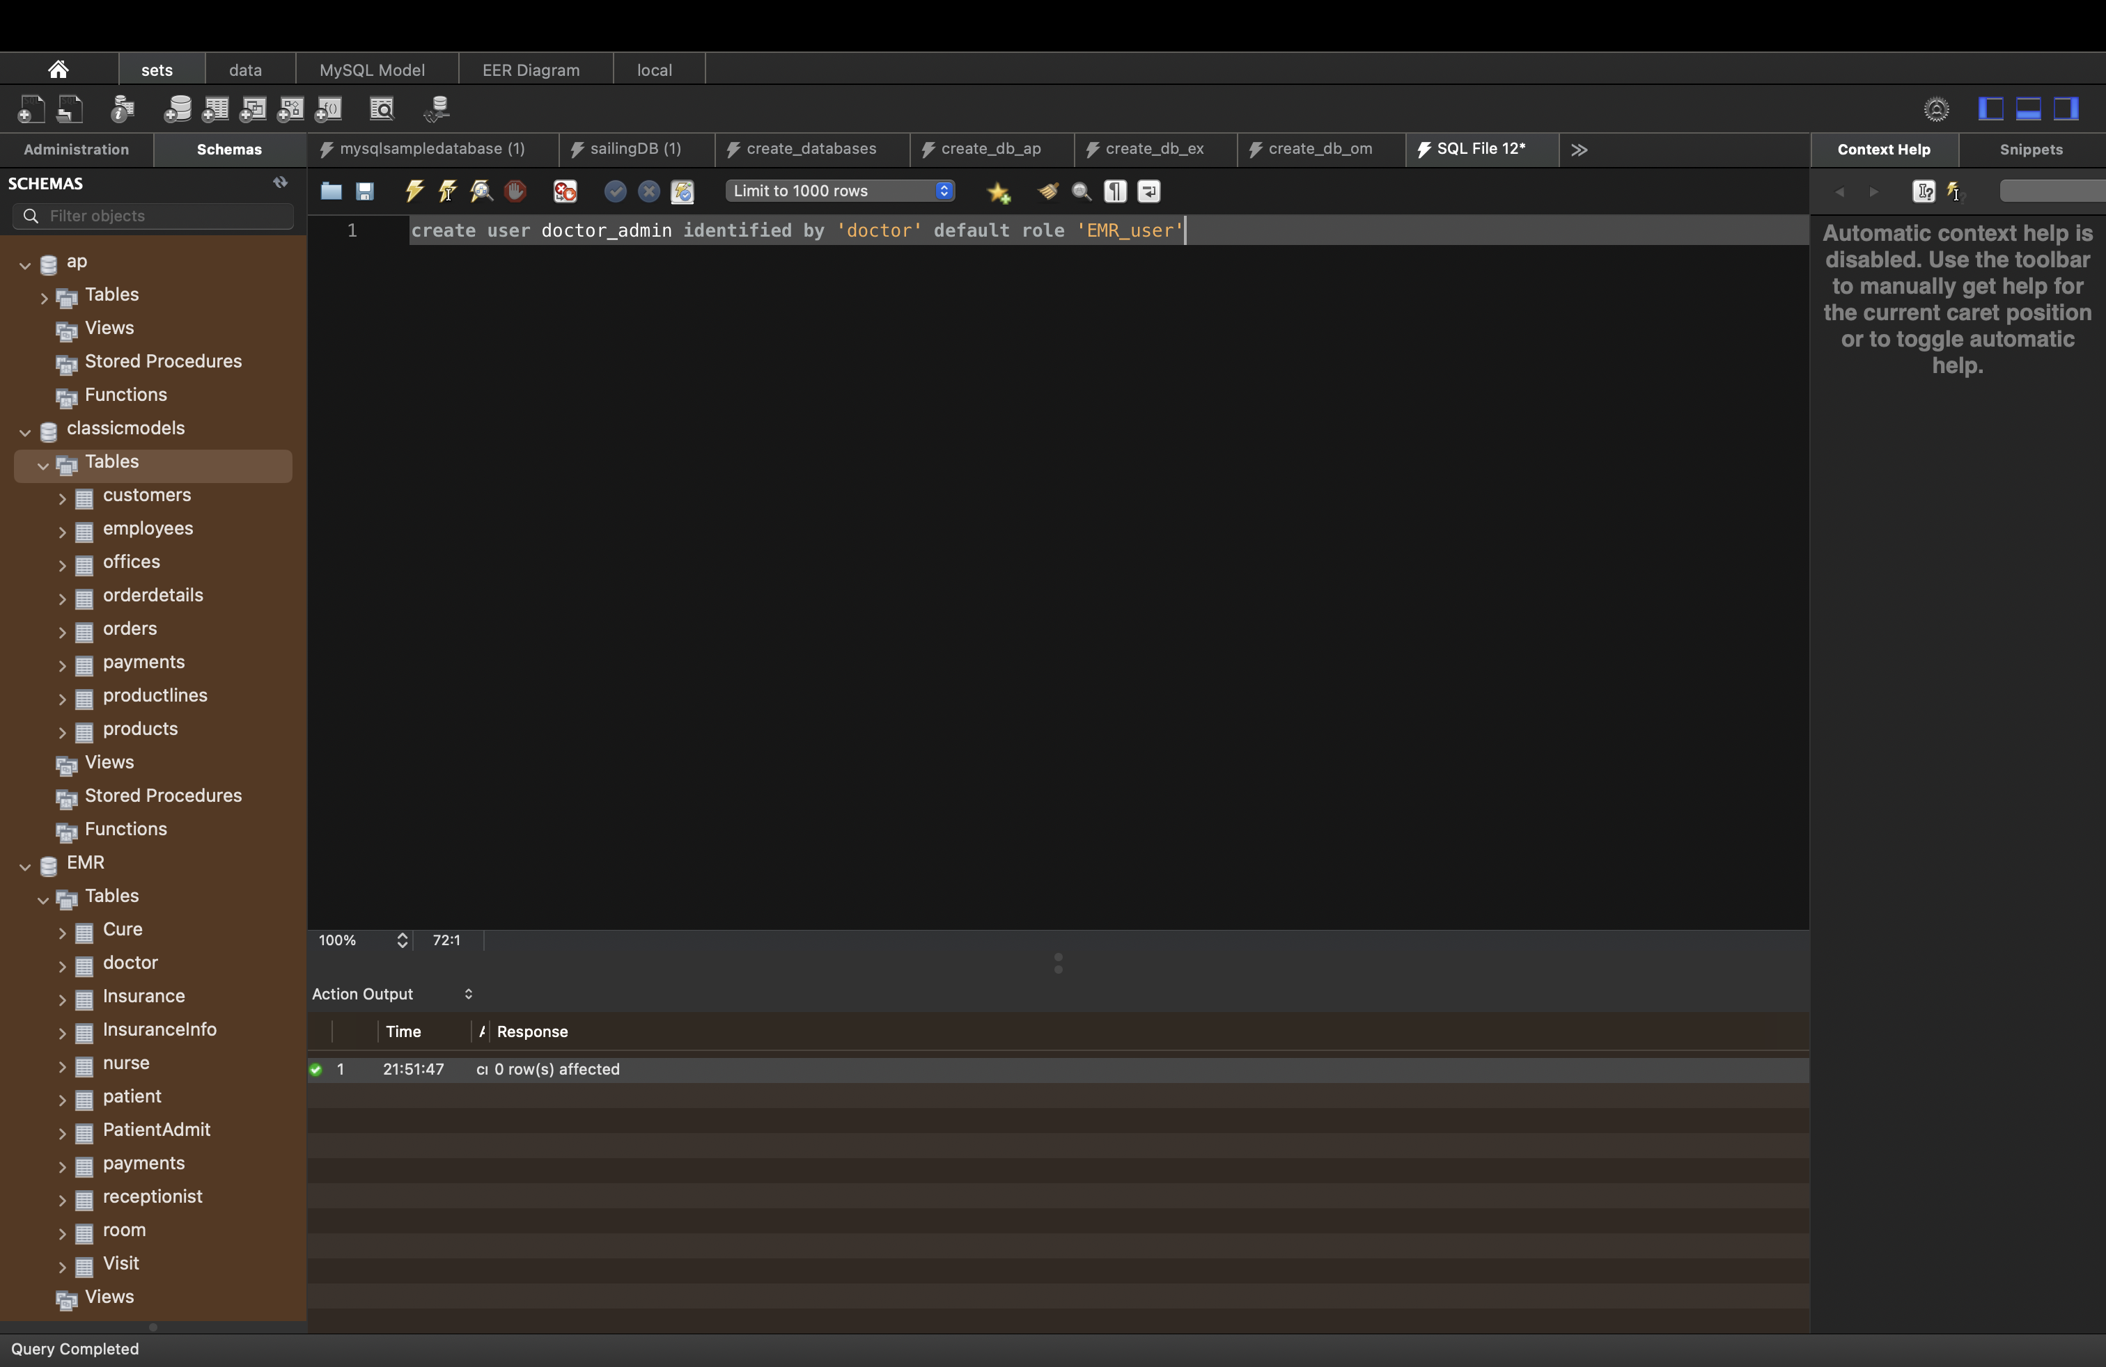

Create a connection user ’doctor_admin’

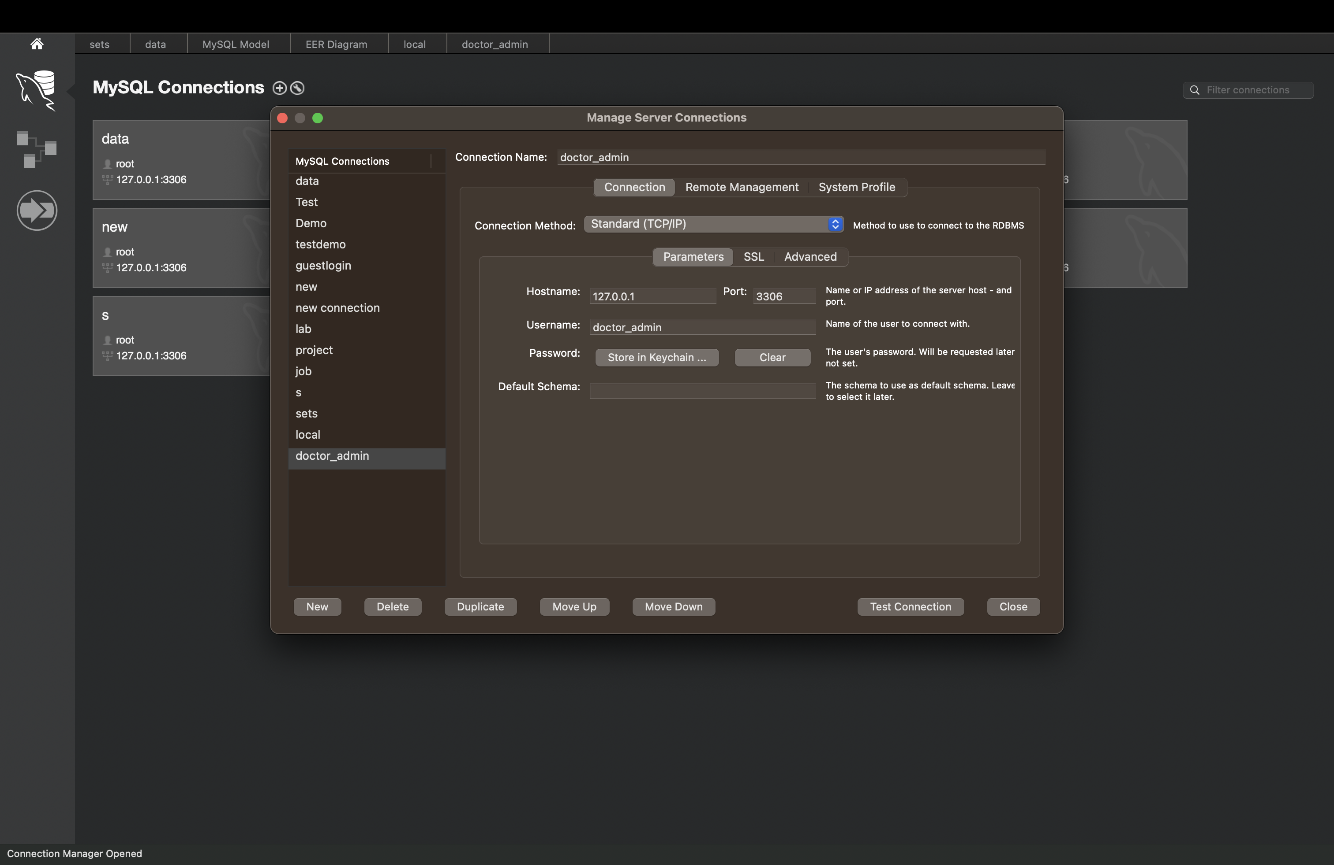

This user has access to only EMR database and doctor table

Granting Privileges to Doctor_admin user

Granting SELECT,UPDATE,DELETE privilegs on doctor_admin user

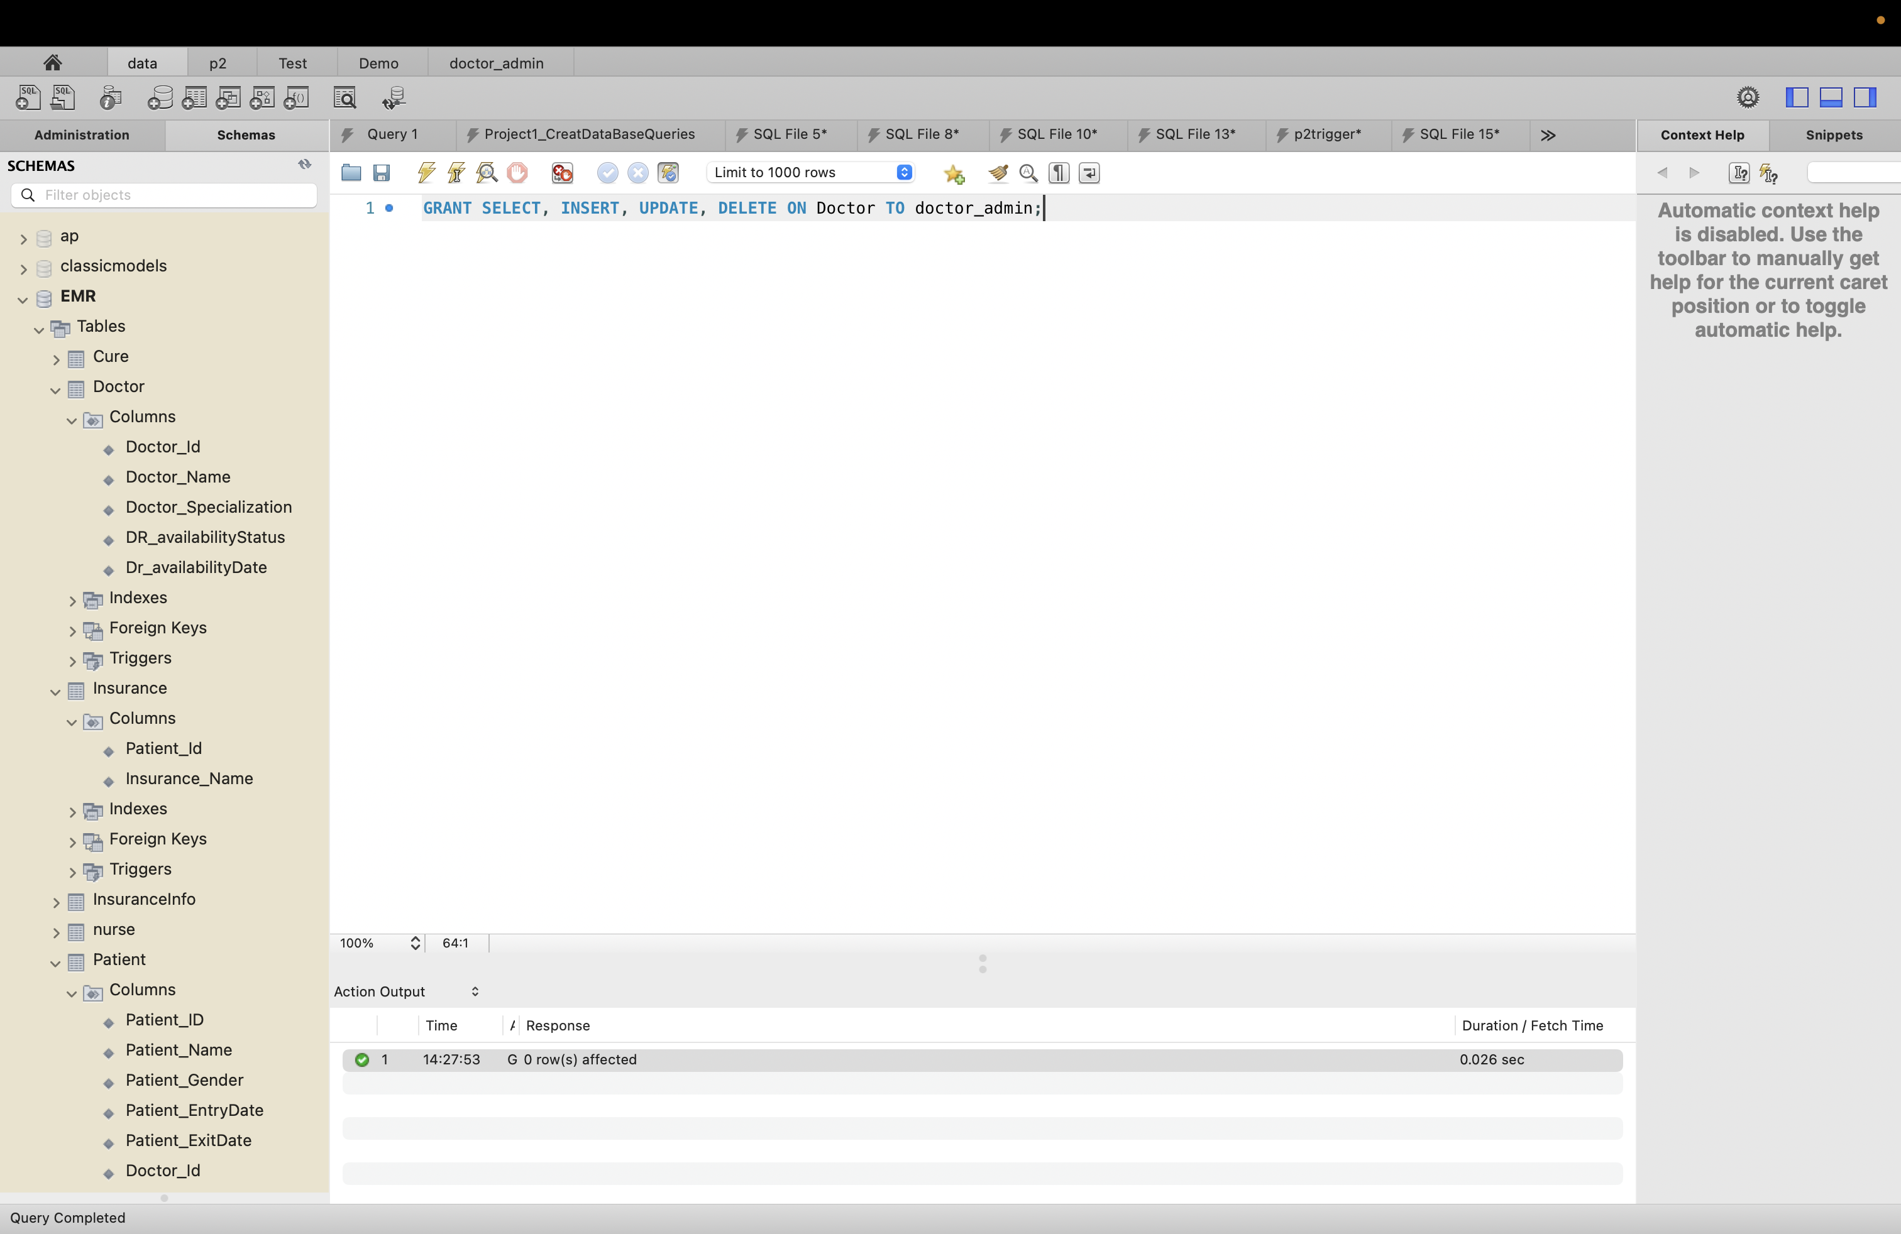

Creating user Patient_admin

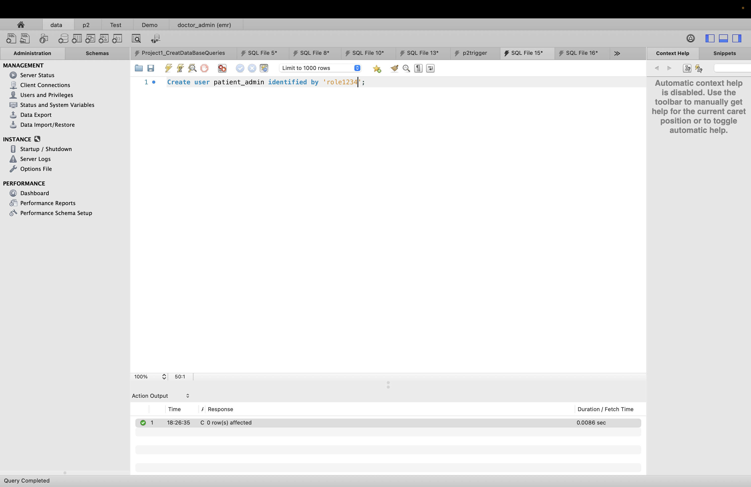

Conneting to that user:

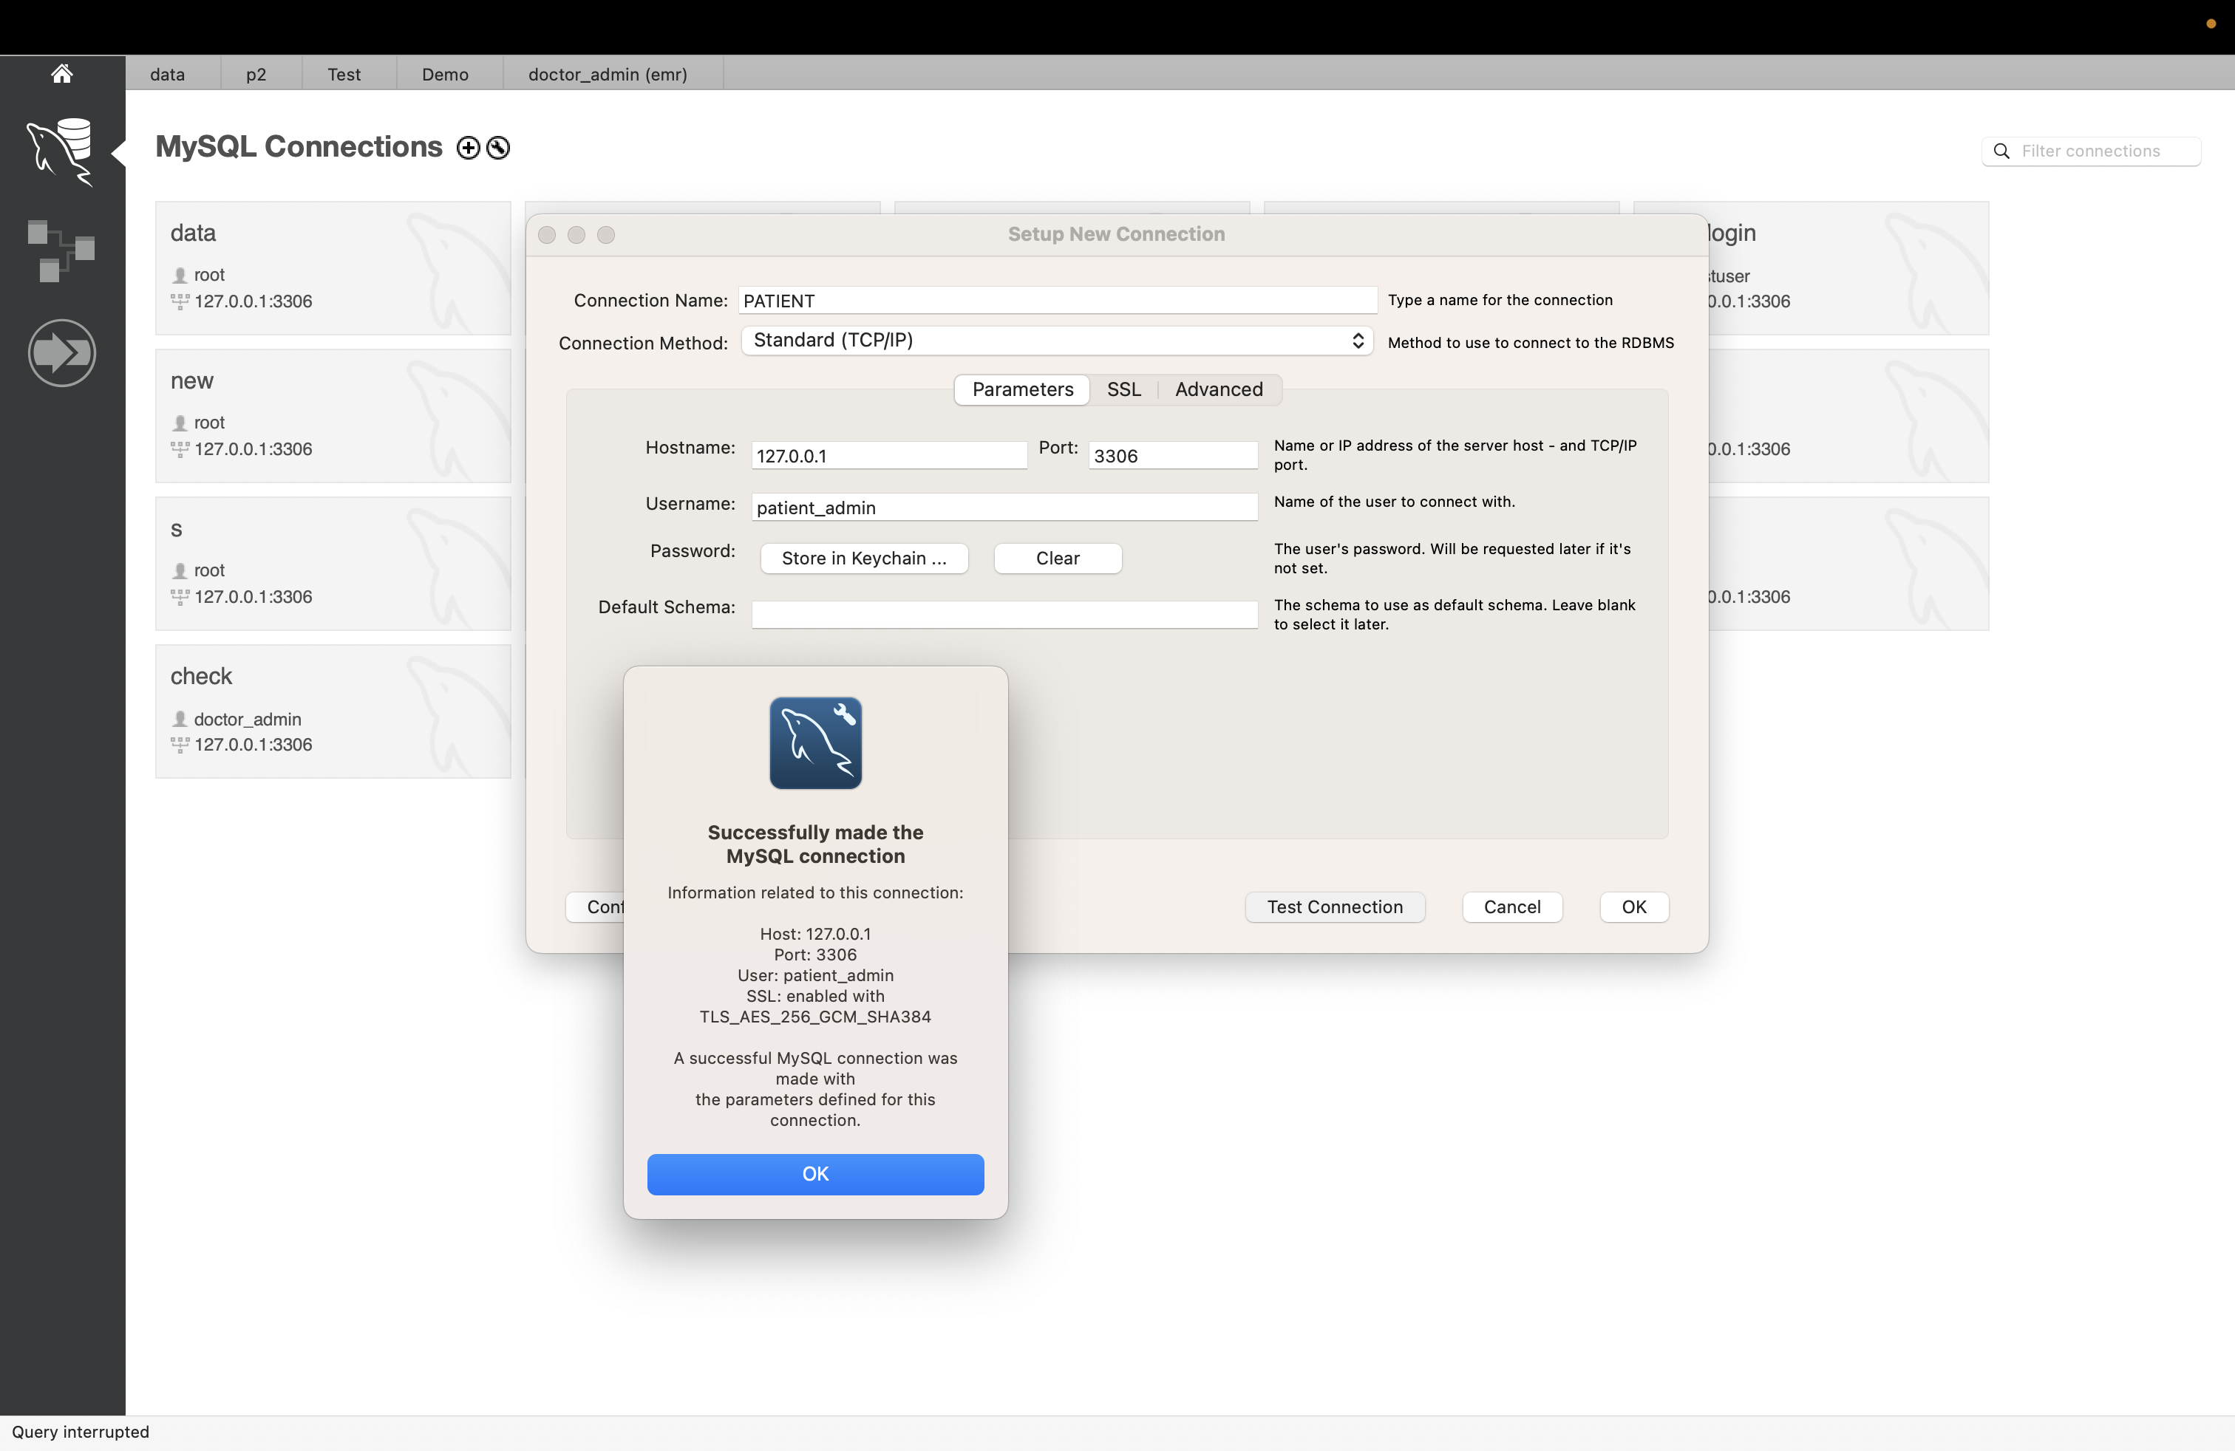

# Section 8: Views

Created View which are frequently used SQL Statements

1. View name: PatientReasonOfVisit

SQL:

Create view PatientReasonOfVisit as

Select p.Patient_id,p.Patient_name,v.ReasonOfVisit from Patient p join Visit v

on p.patient_Id = v.Patient_id ;

Result:

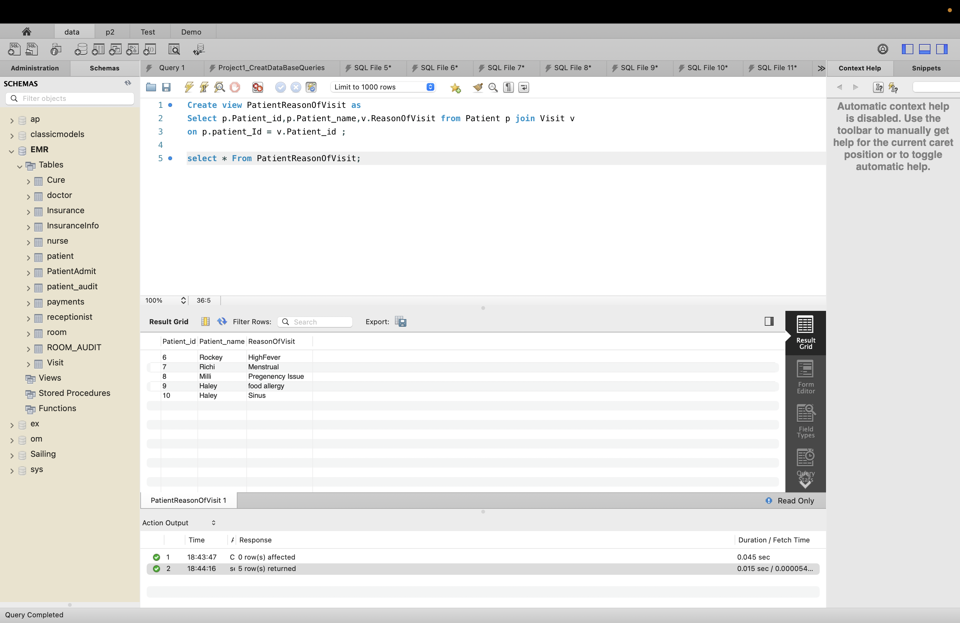

1. View Name : PatientDoctor

SQL:

Create view PatientDoctor as

Select p.Patient_name,v.ReasonOfVisit,d.doctor_Name from Patient p join Visit v

on p.patient_Id = v.Patient_id join doctor d

on p.doctor_id = d.doctor_id;

Result:

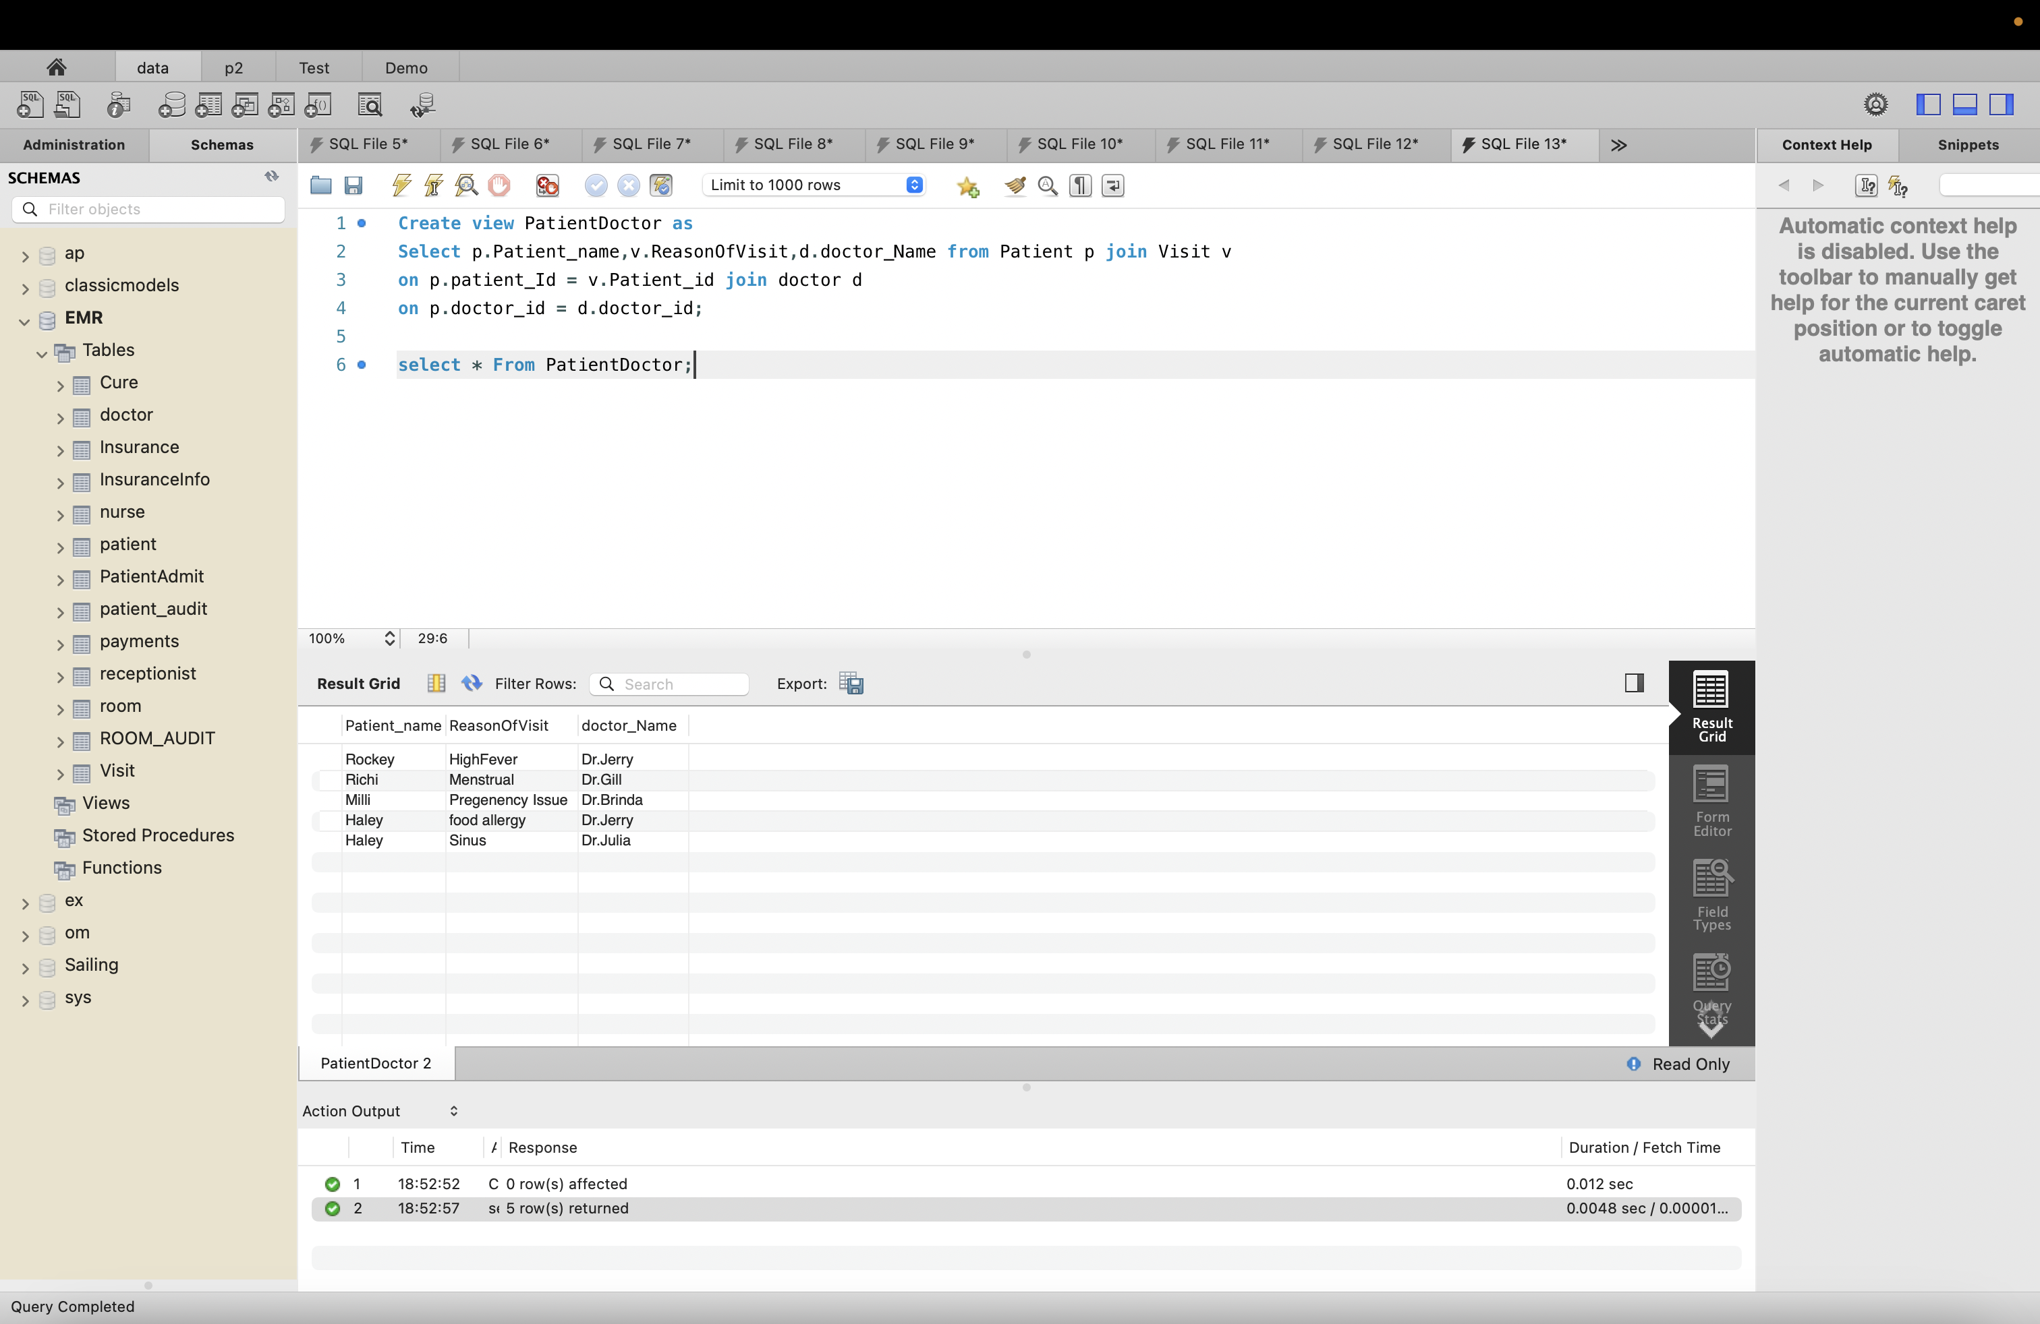

1. View Name : PatientSymptoms

SQL:

Create view PatientSymptoms as

Select p.Patient_Name,v.Reasonofvisit,v.Sympotoms,d.Doctor_specialization,d.Doctor_Name

from patient p join visit v

on p.patient_id = v.patient_id join doctor d

on p.doctor_id = d.doctor_id;

RESULT:

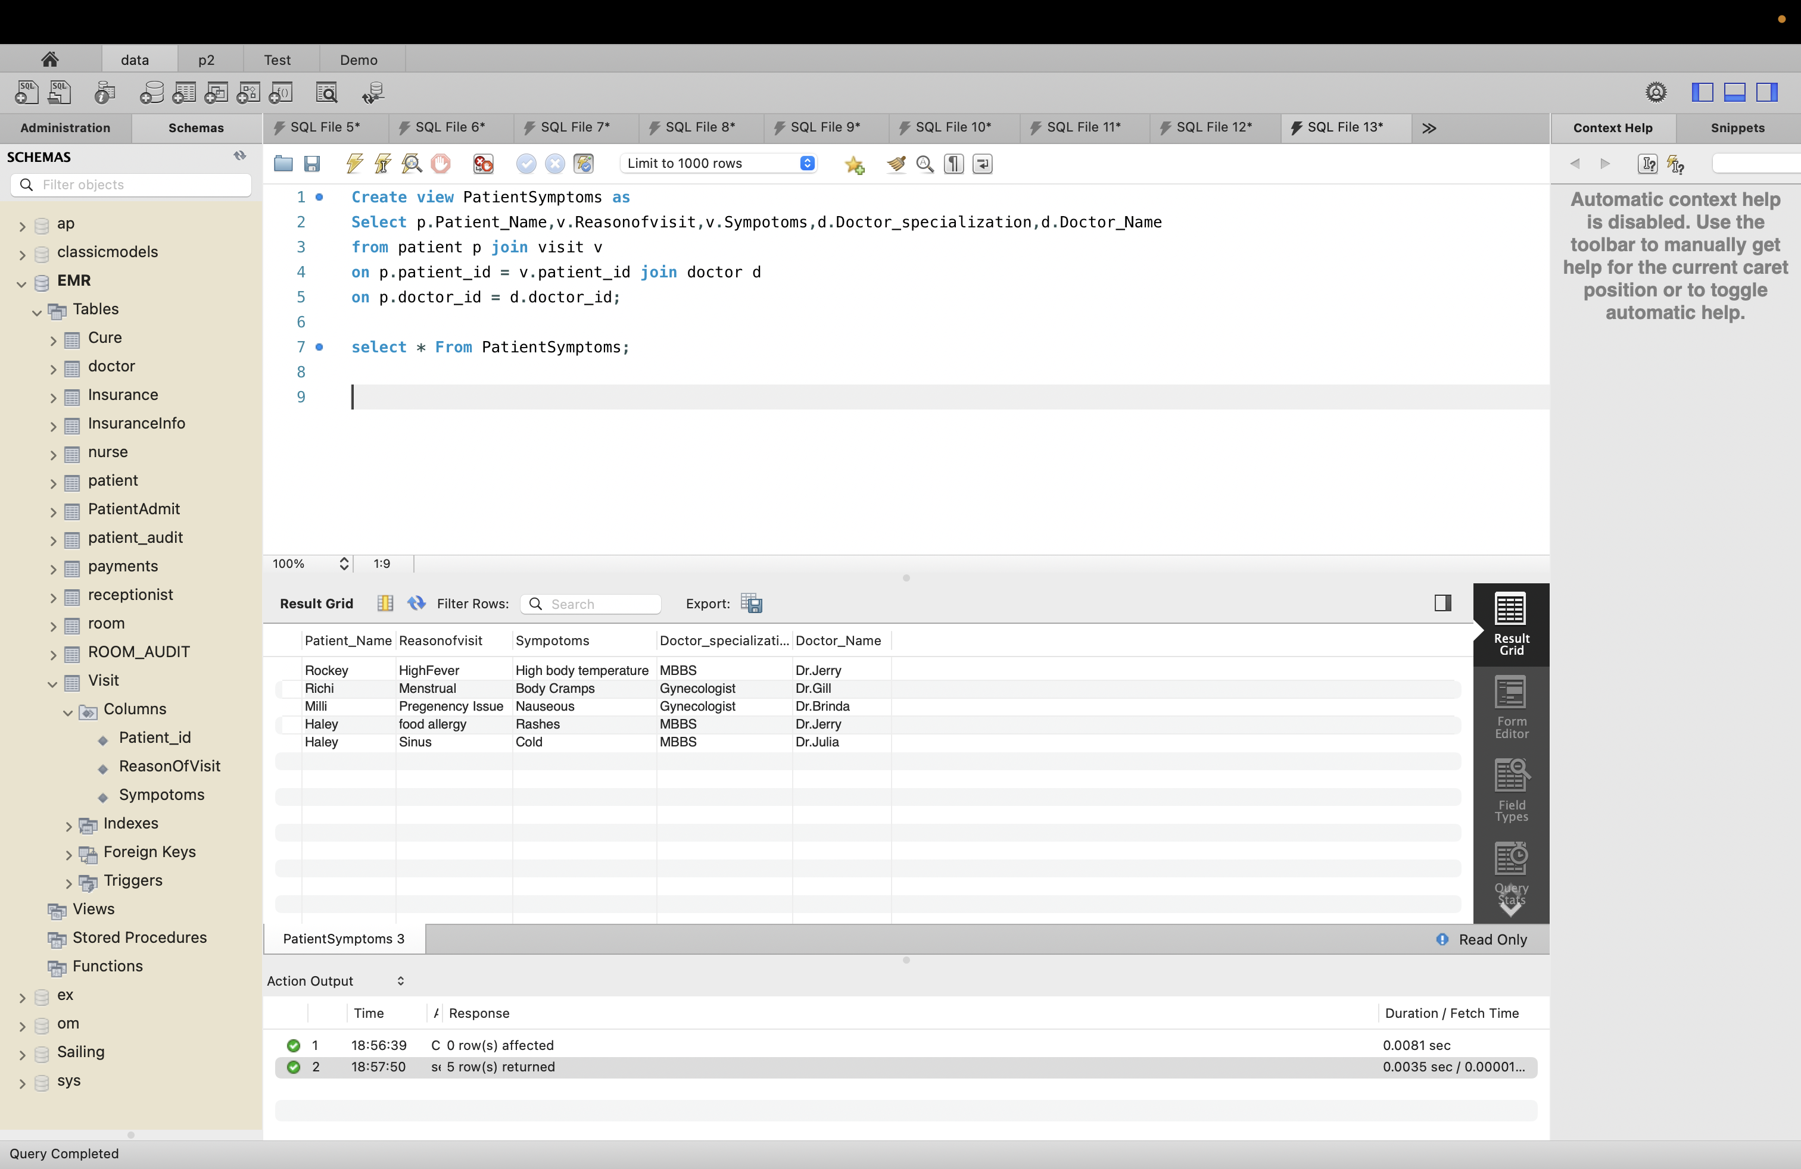

1. View Name: PatientCure

SQL:

Create view PatientCure as

Select p.Patient_Name,v.Reasonofvisit,v.Sympotoms,c.cure_Action,c.Cure_Result

from patient p join visit v

on p.patient_id = v.patient_id join cure c

on p.patient_id = c.patient_id;

Result:

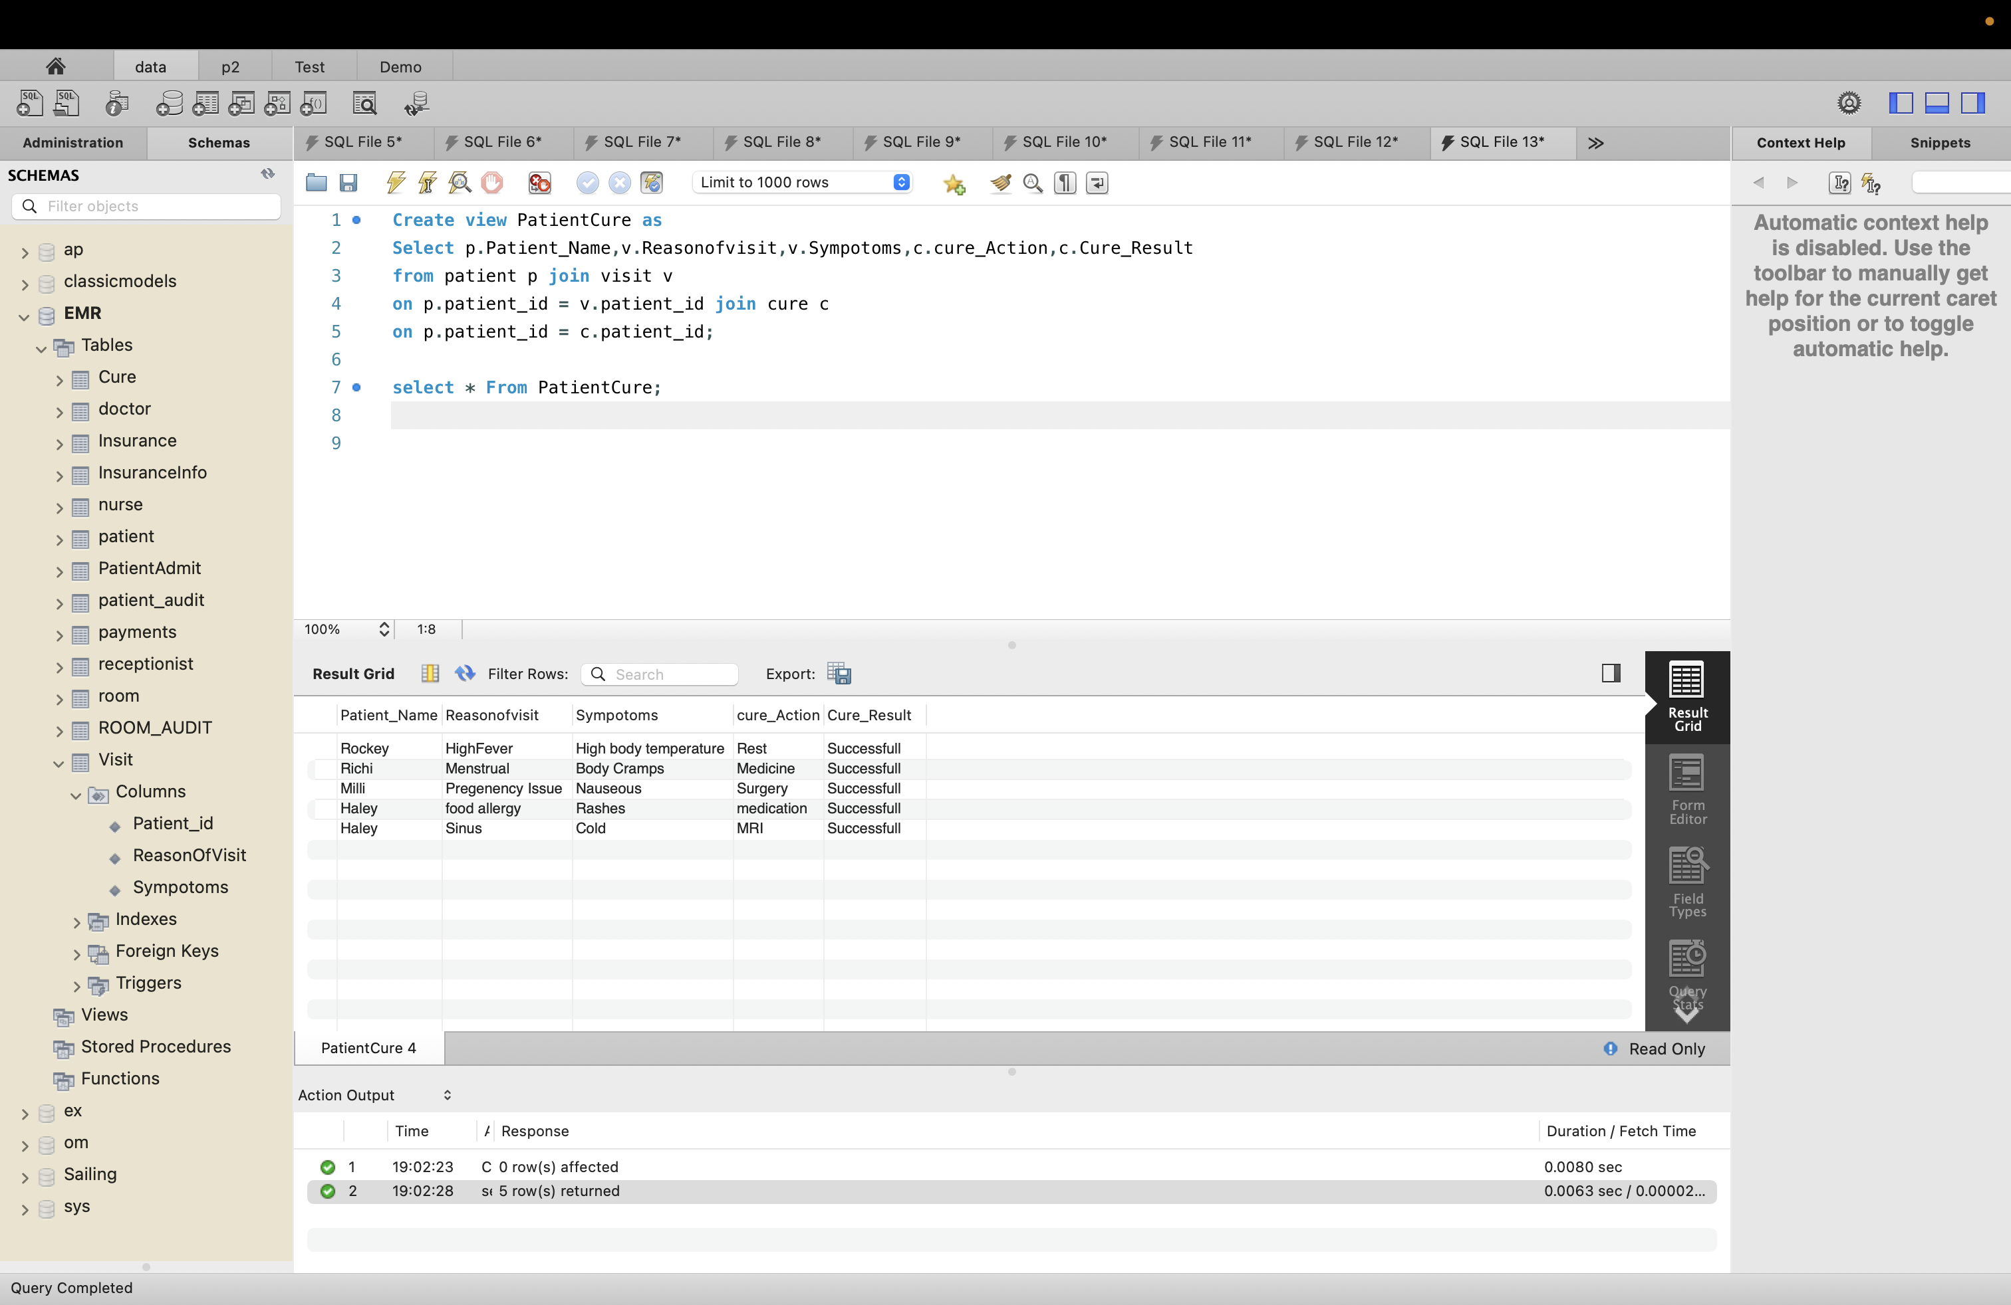

1. View Name: PatientBillAmount

SQL:

Create view PatientBillAmount as

select p.patient_id,p.patient_name,a.Bill_amount from patient p join payments a

on p.patient_id = a.patient_id

where a.bill_amount > 500

order by a.bill_amount desc;

Result:

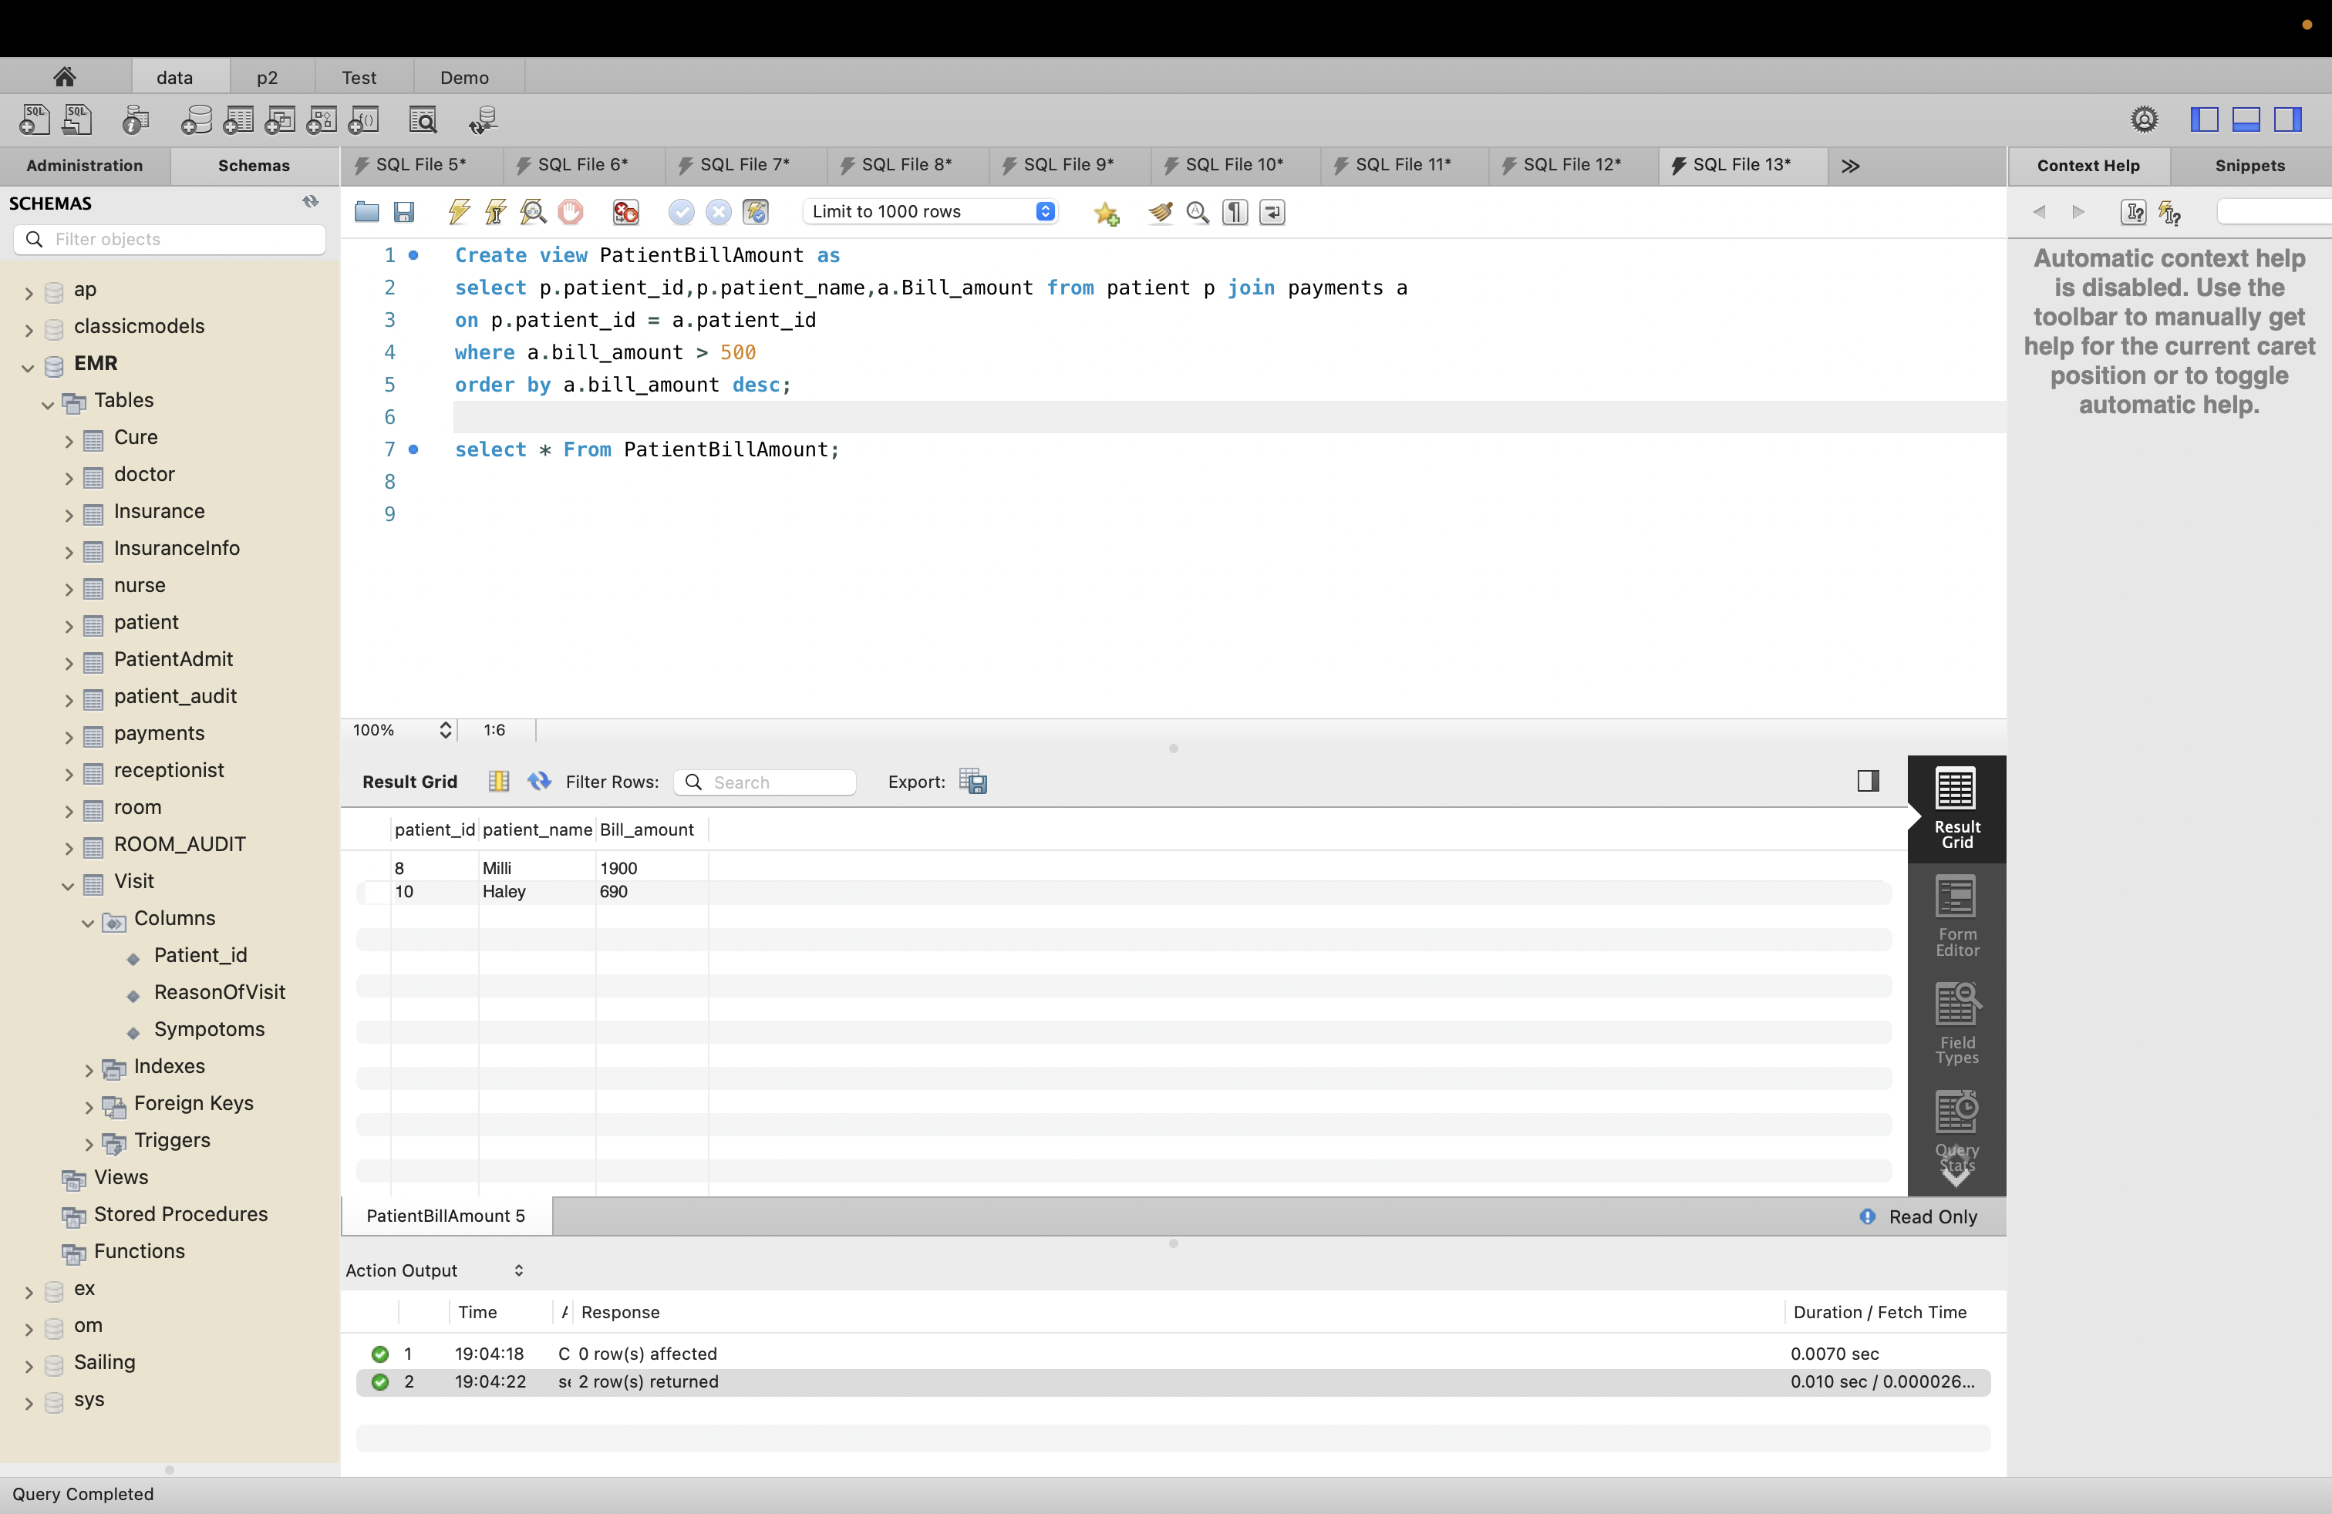

# Section 9: Indexes

Creating Index

1. Index Name: Patient_Patient_id

SQL:

CREATE INDEX Patient_Patient_id

ON Patient (Patient_Id,Patient_Name);

Result:

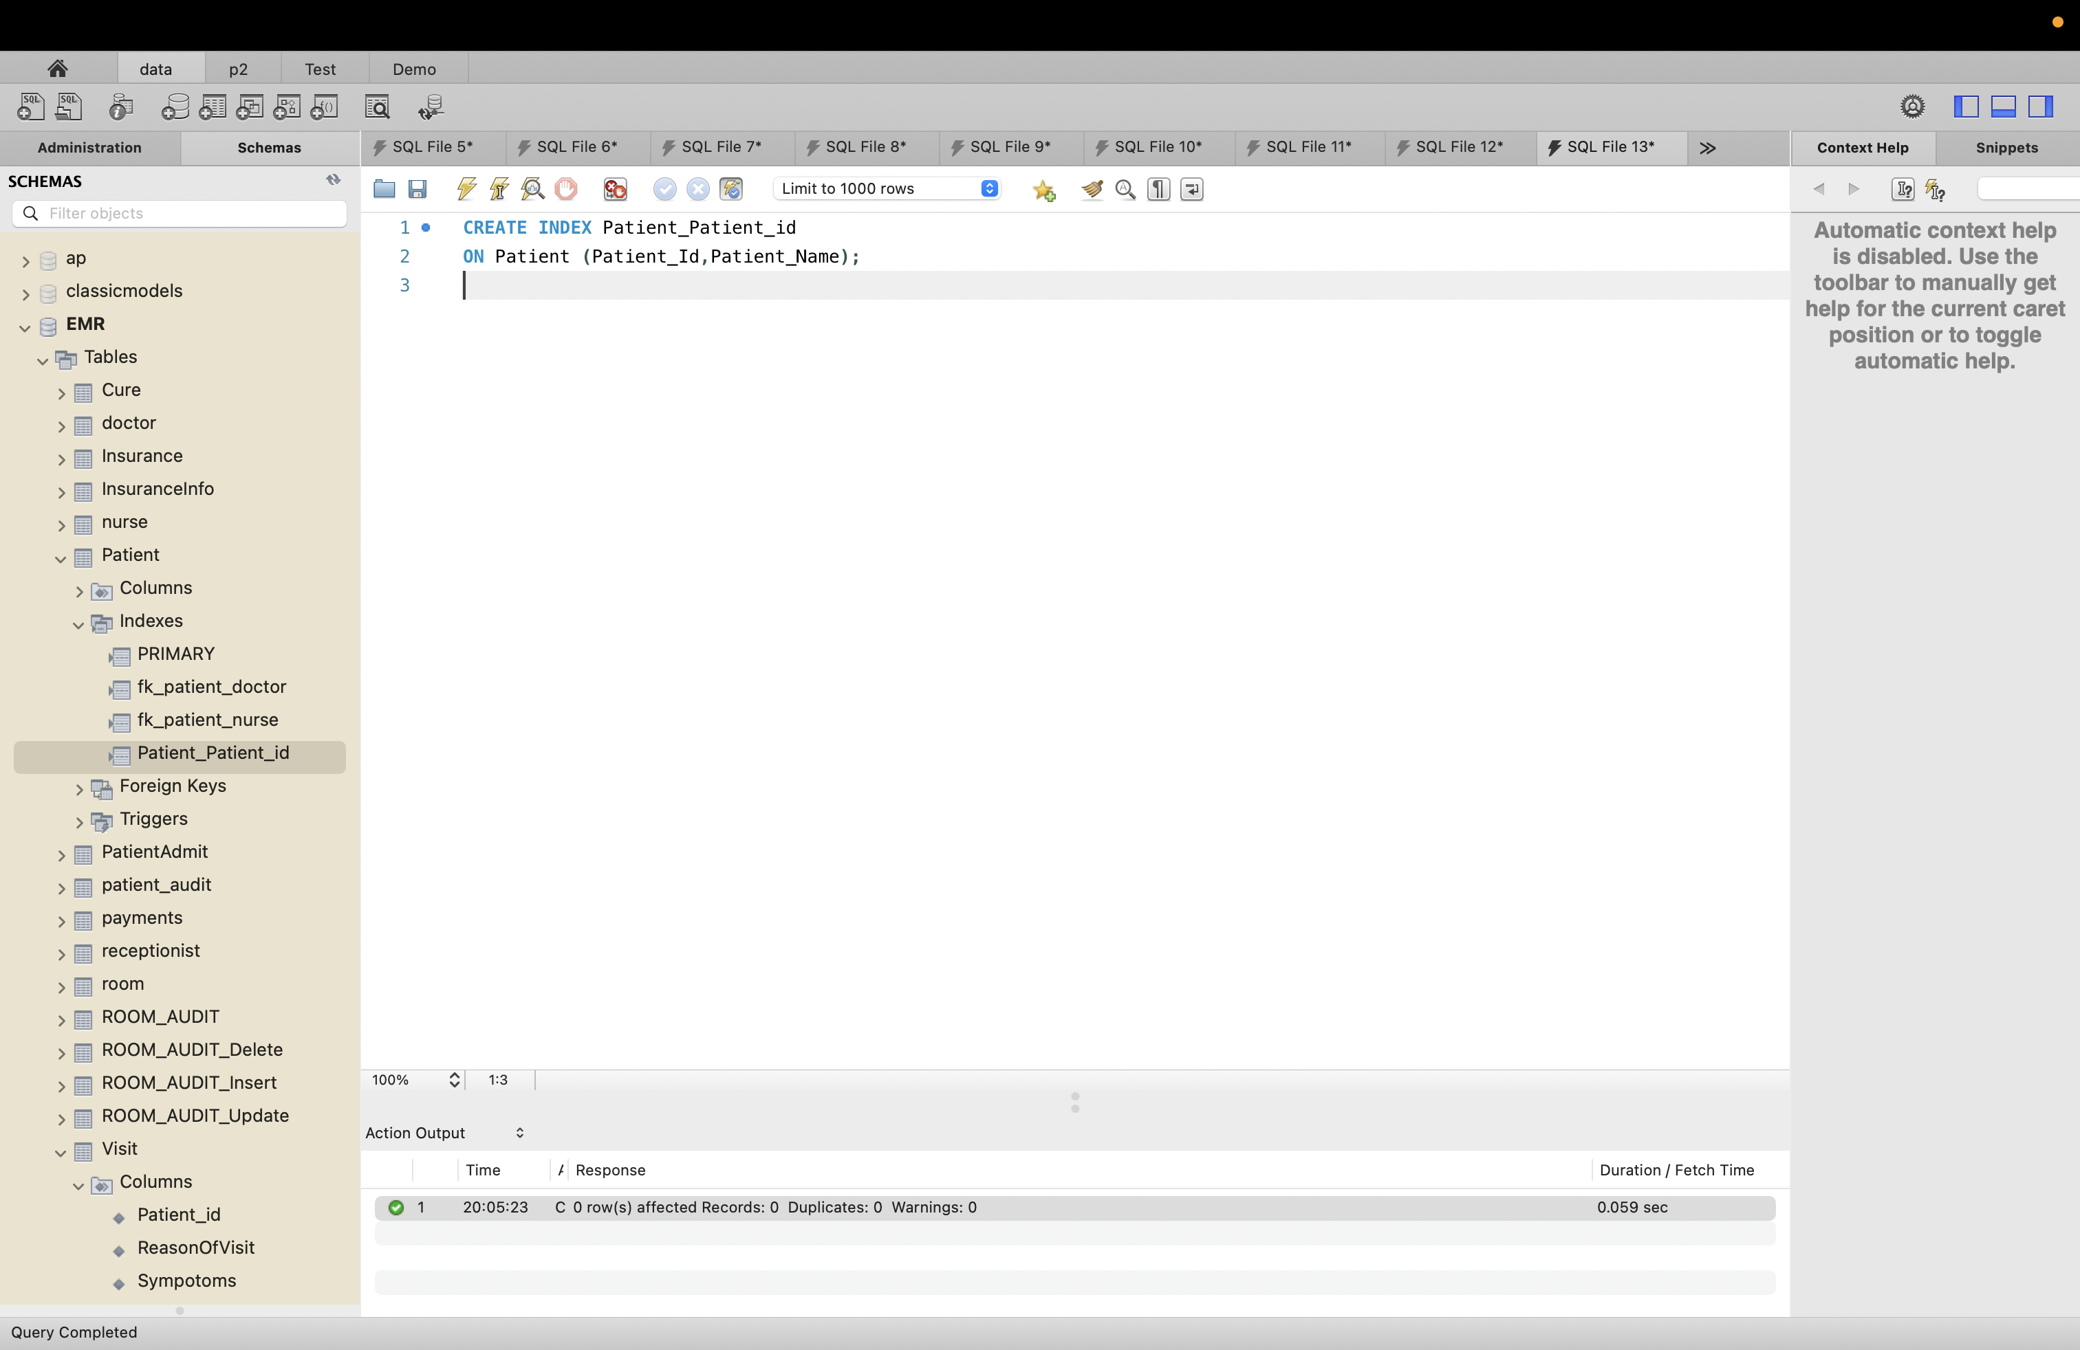

1. Index_name : Doctor_Doctor_Name

SQL:

CREATE INDEX Doctor_Doctor_Name

ON Doctor (Doctor_Name);

Result:

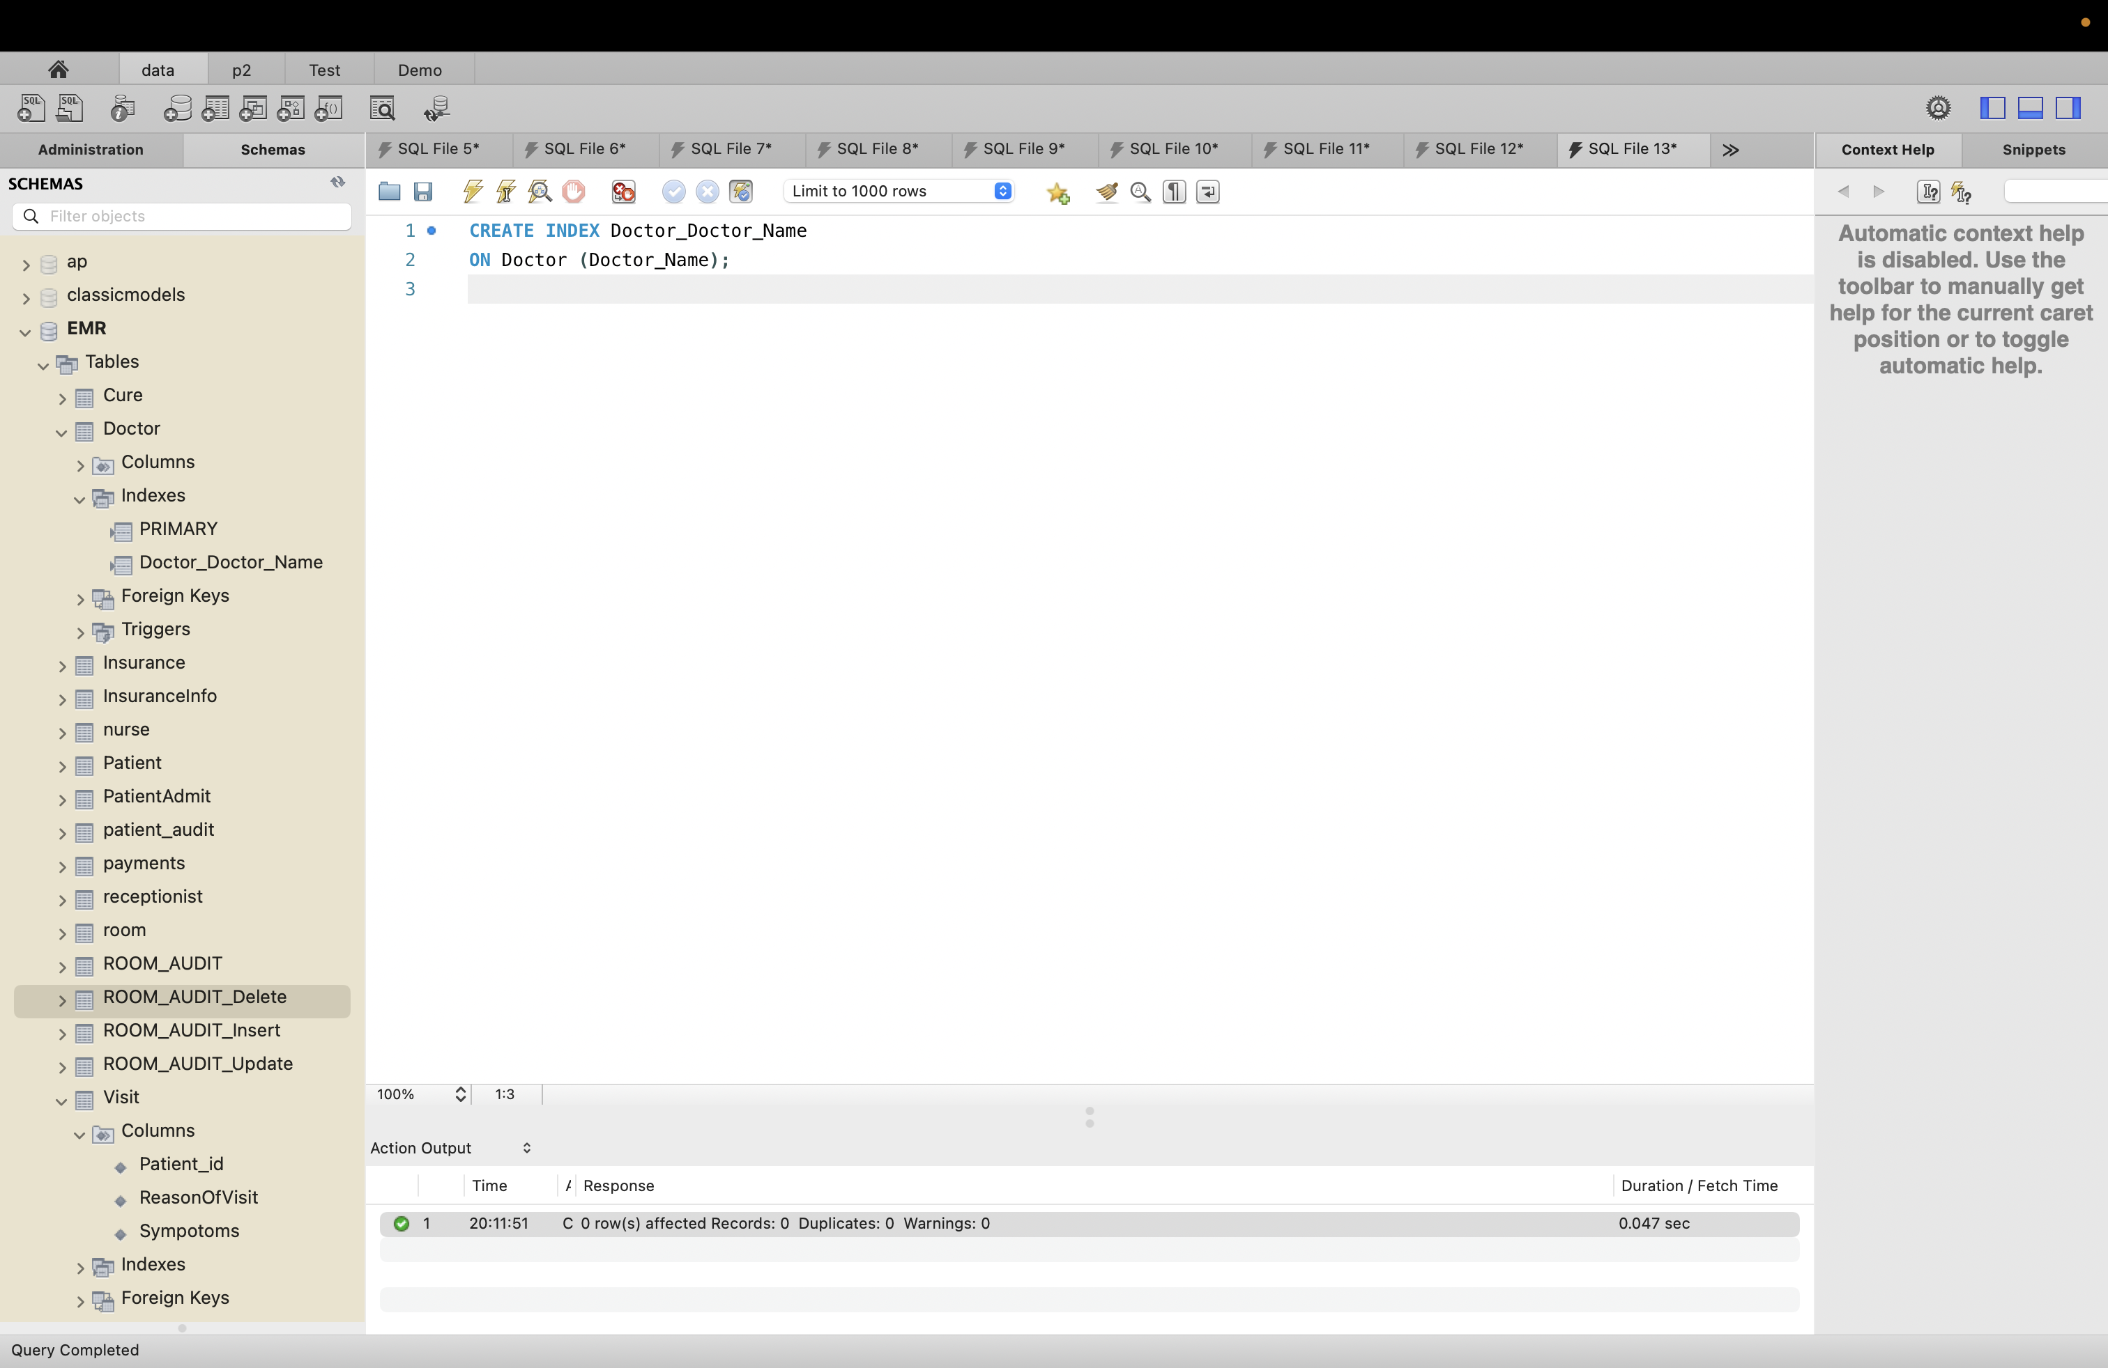

1. Index Name : Visit_ReasonOfVisit

SQL:

CREATE INDEX Visit_ReasonOfVisit

ON Visit (ReasonOfVisit);

Result:

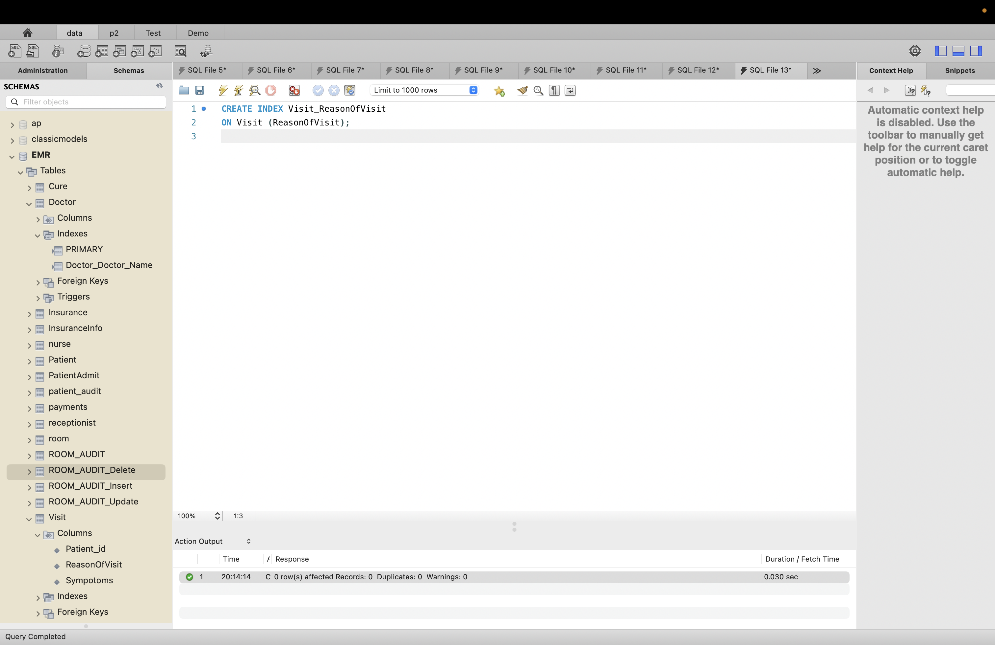

1. Index Name : Room_Room_Number

SQL:

CREATE INDEX Room_Room_Number

ON Room (Room_Number);

Result:

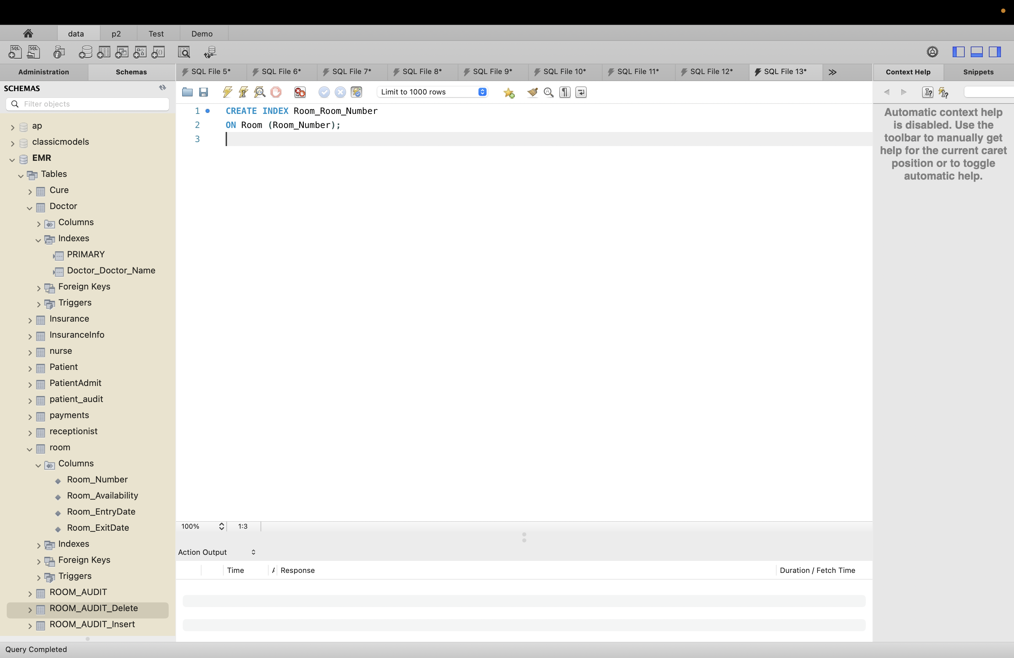

1. Index Name : Payment_Bill_Amount

SQL:

CREATE INDEX Payment_Bill_Amount

ON payments (Bill_Amount);

Result:

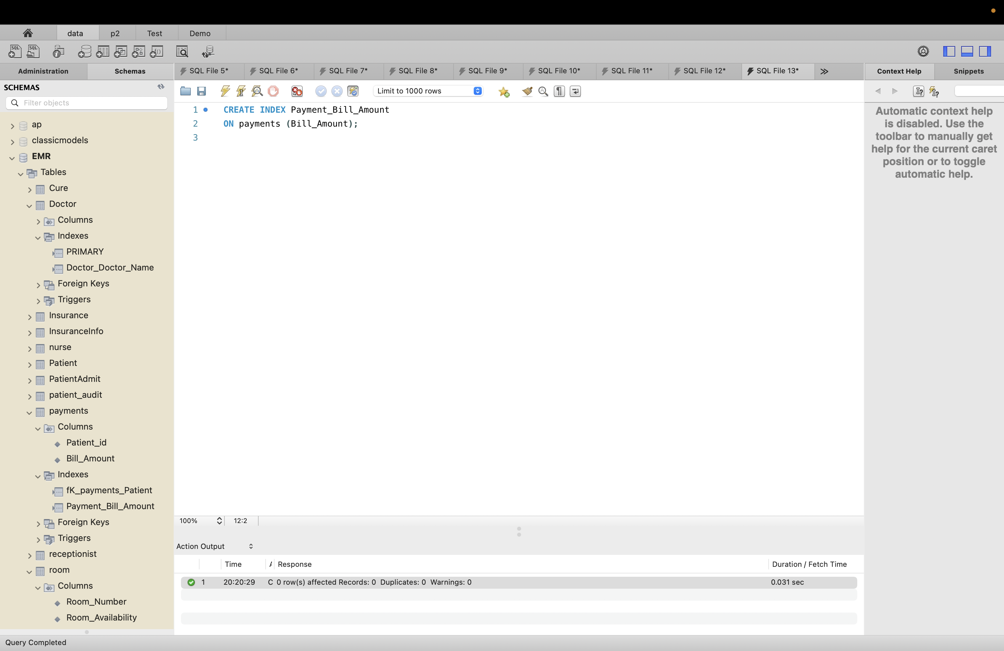

# Section 10: Role_Based Access:

Create role EMR_user

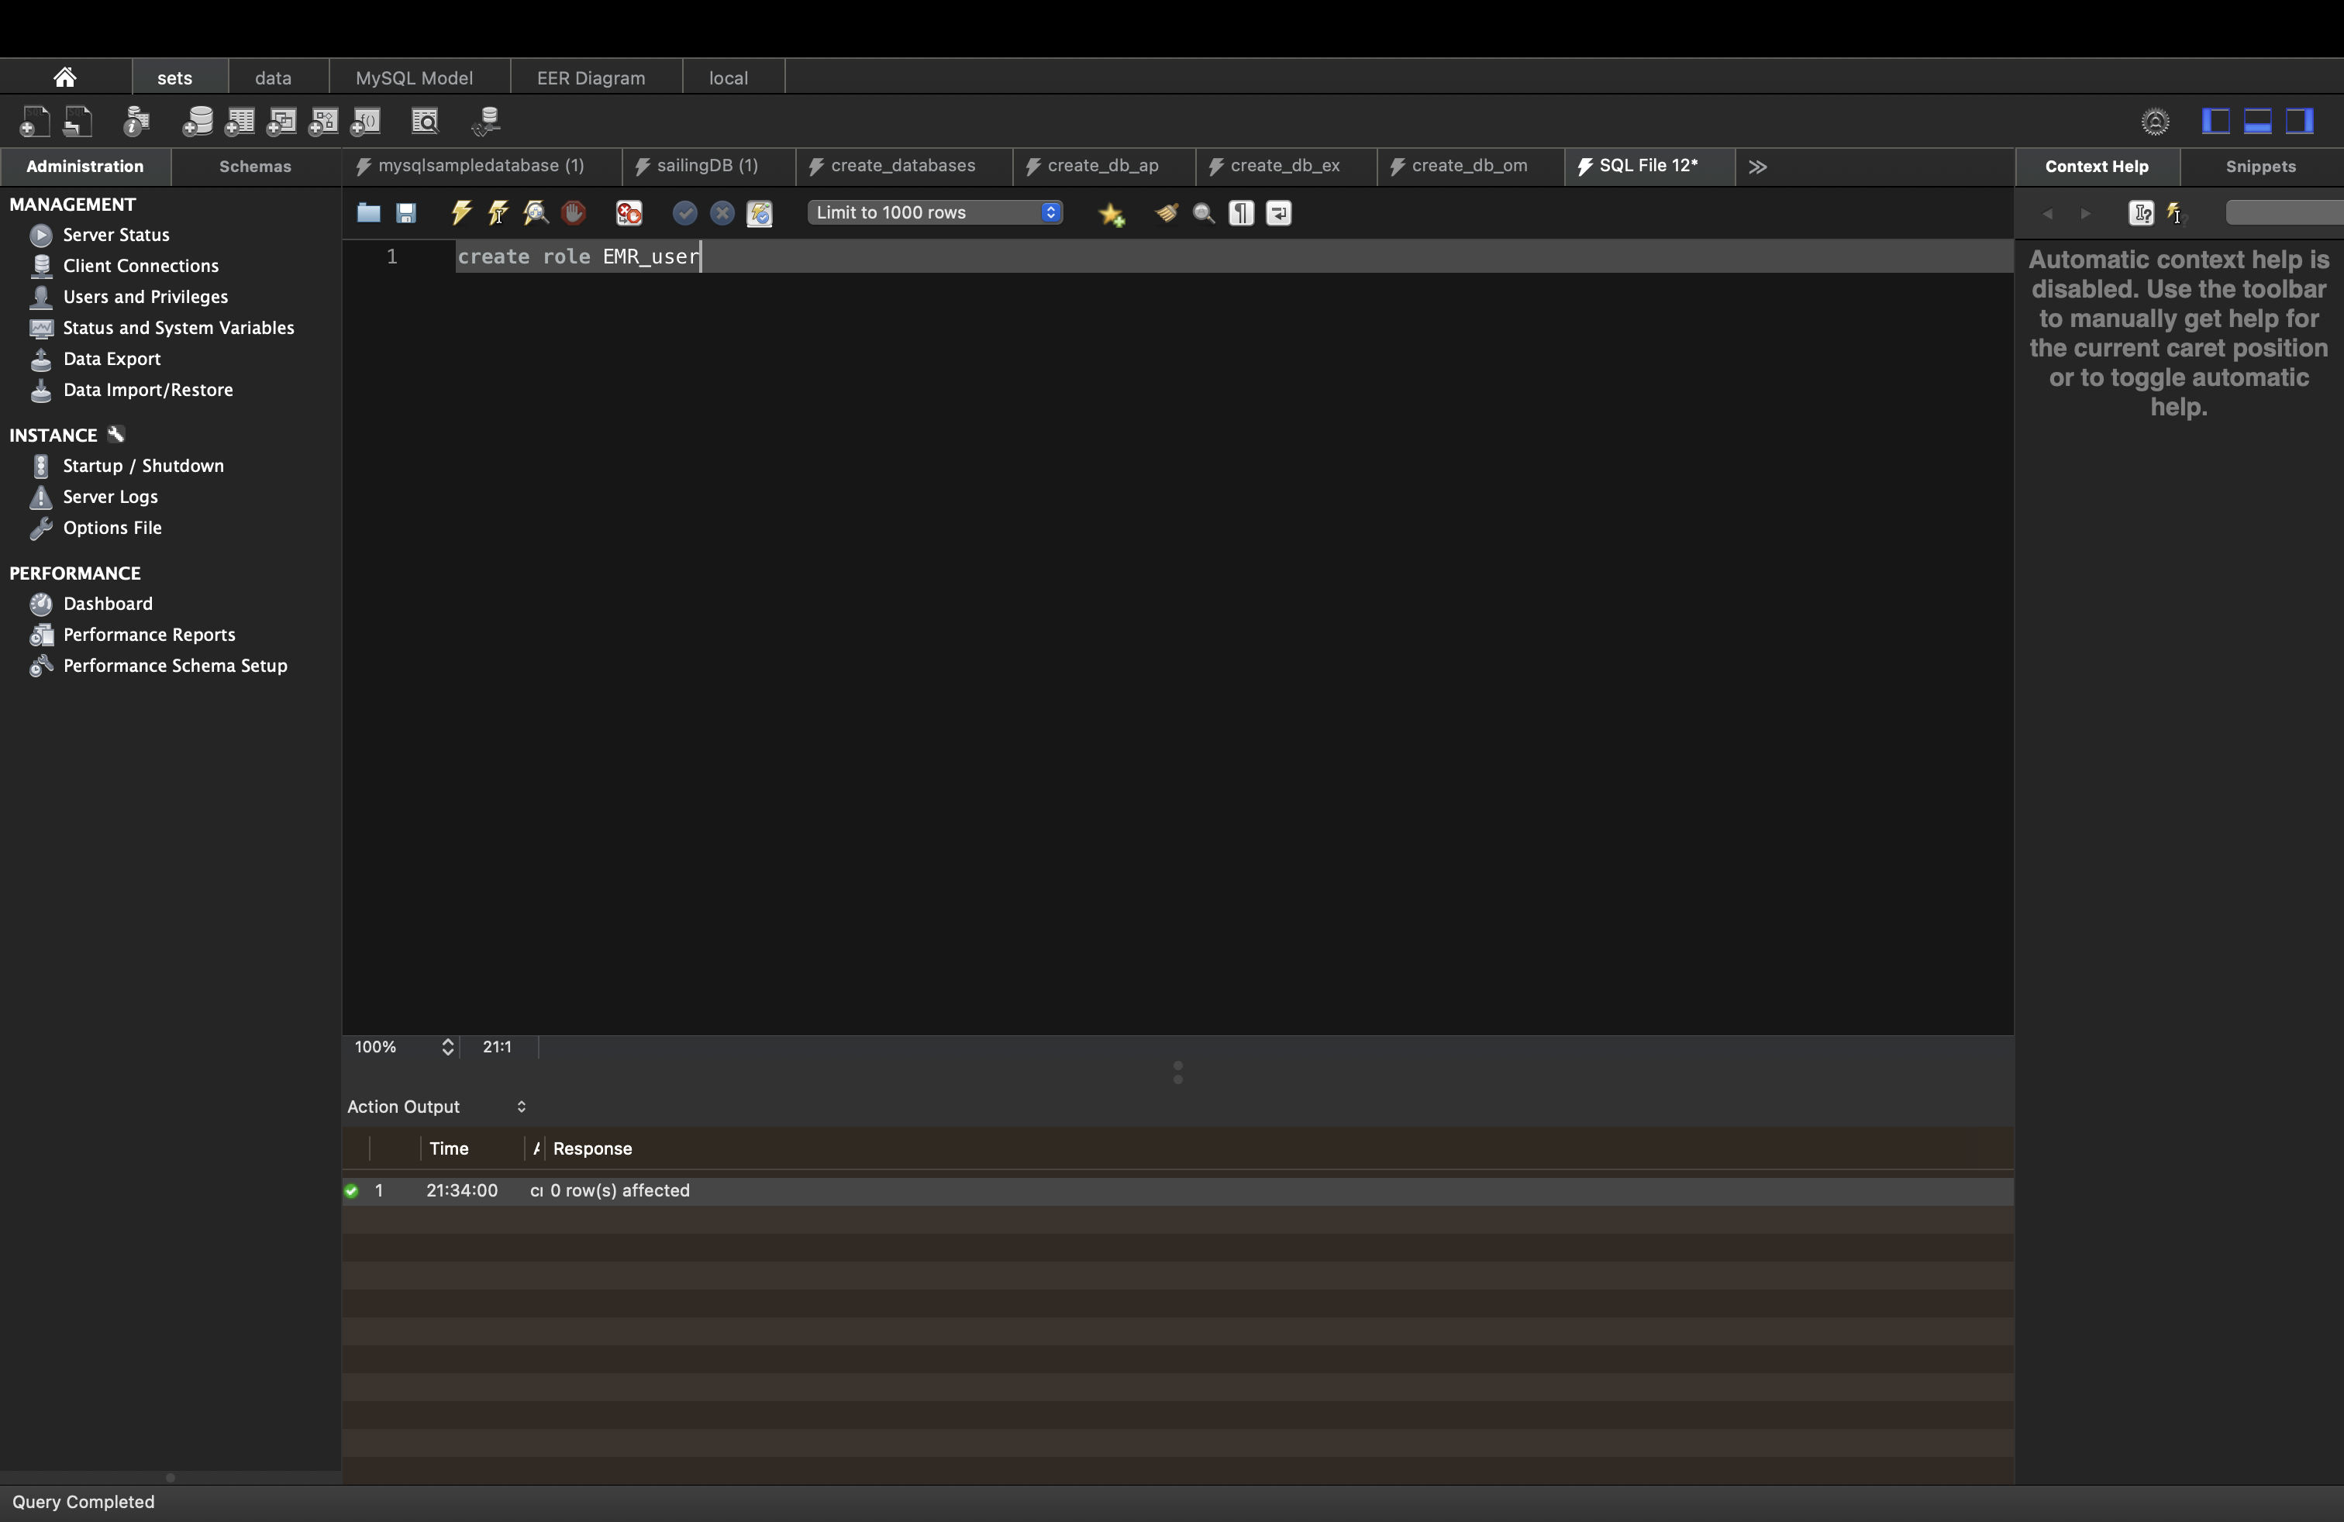

Grant select and update on doctor

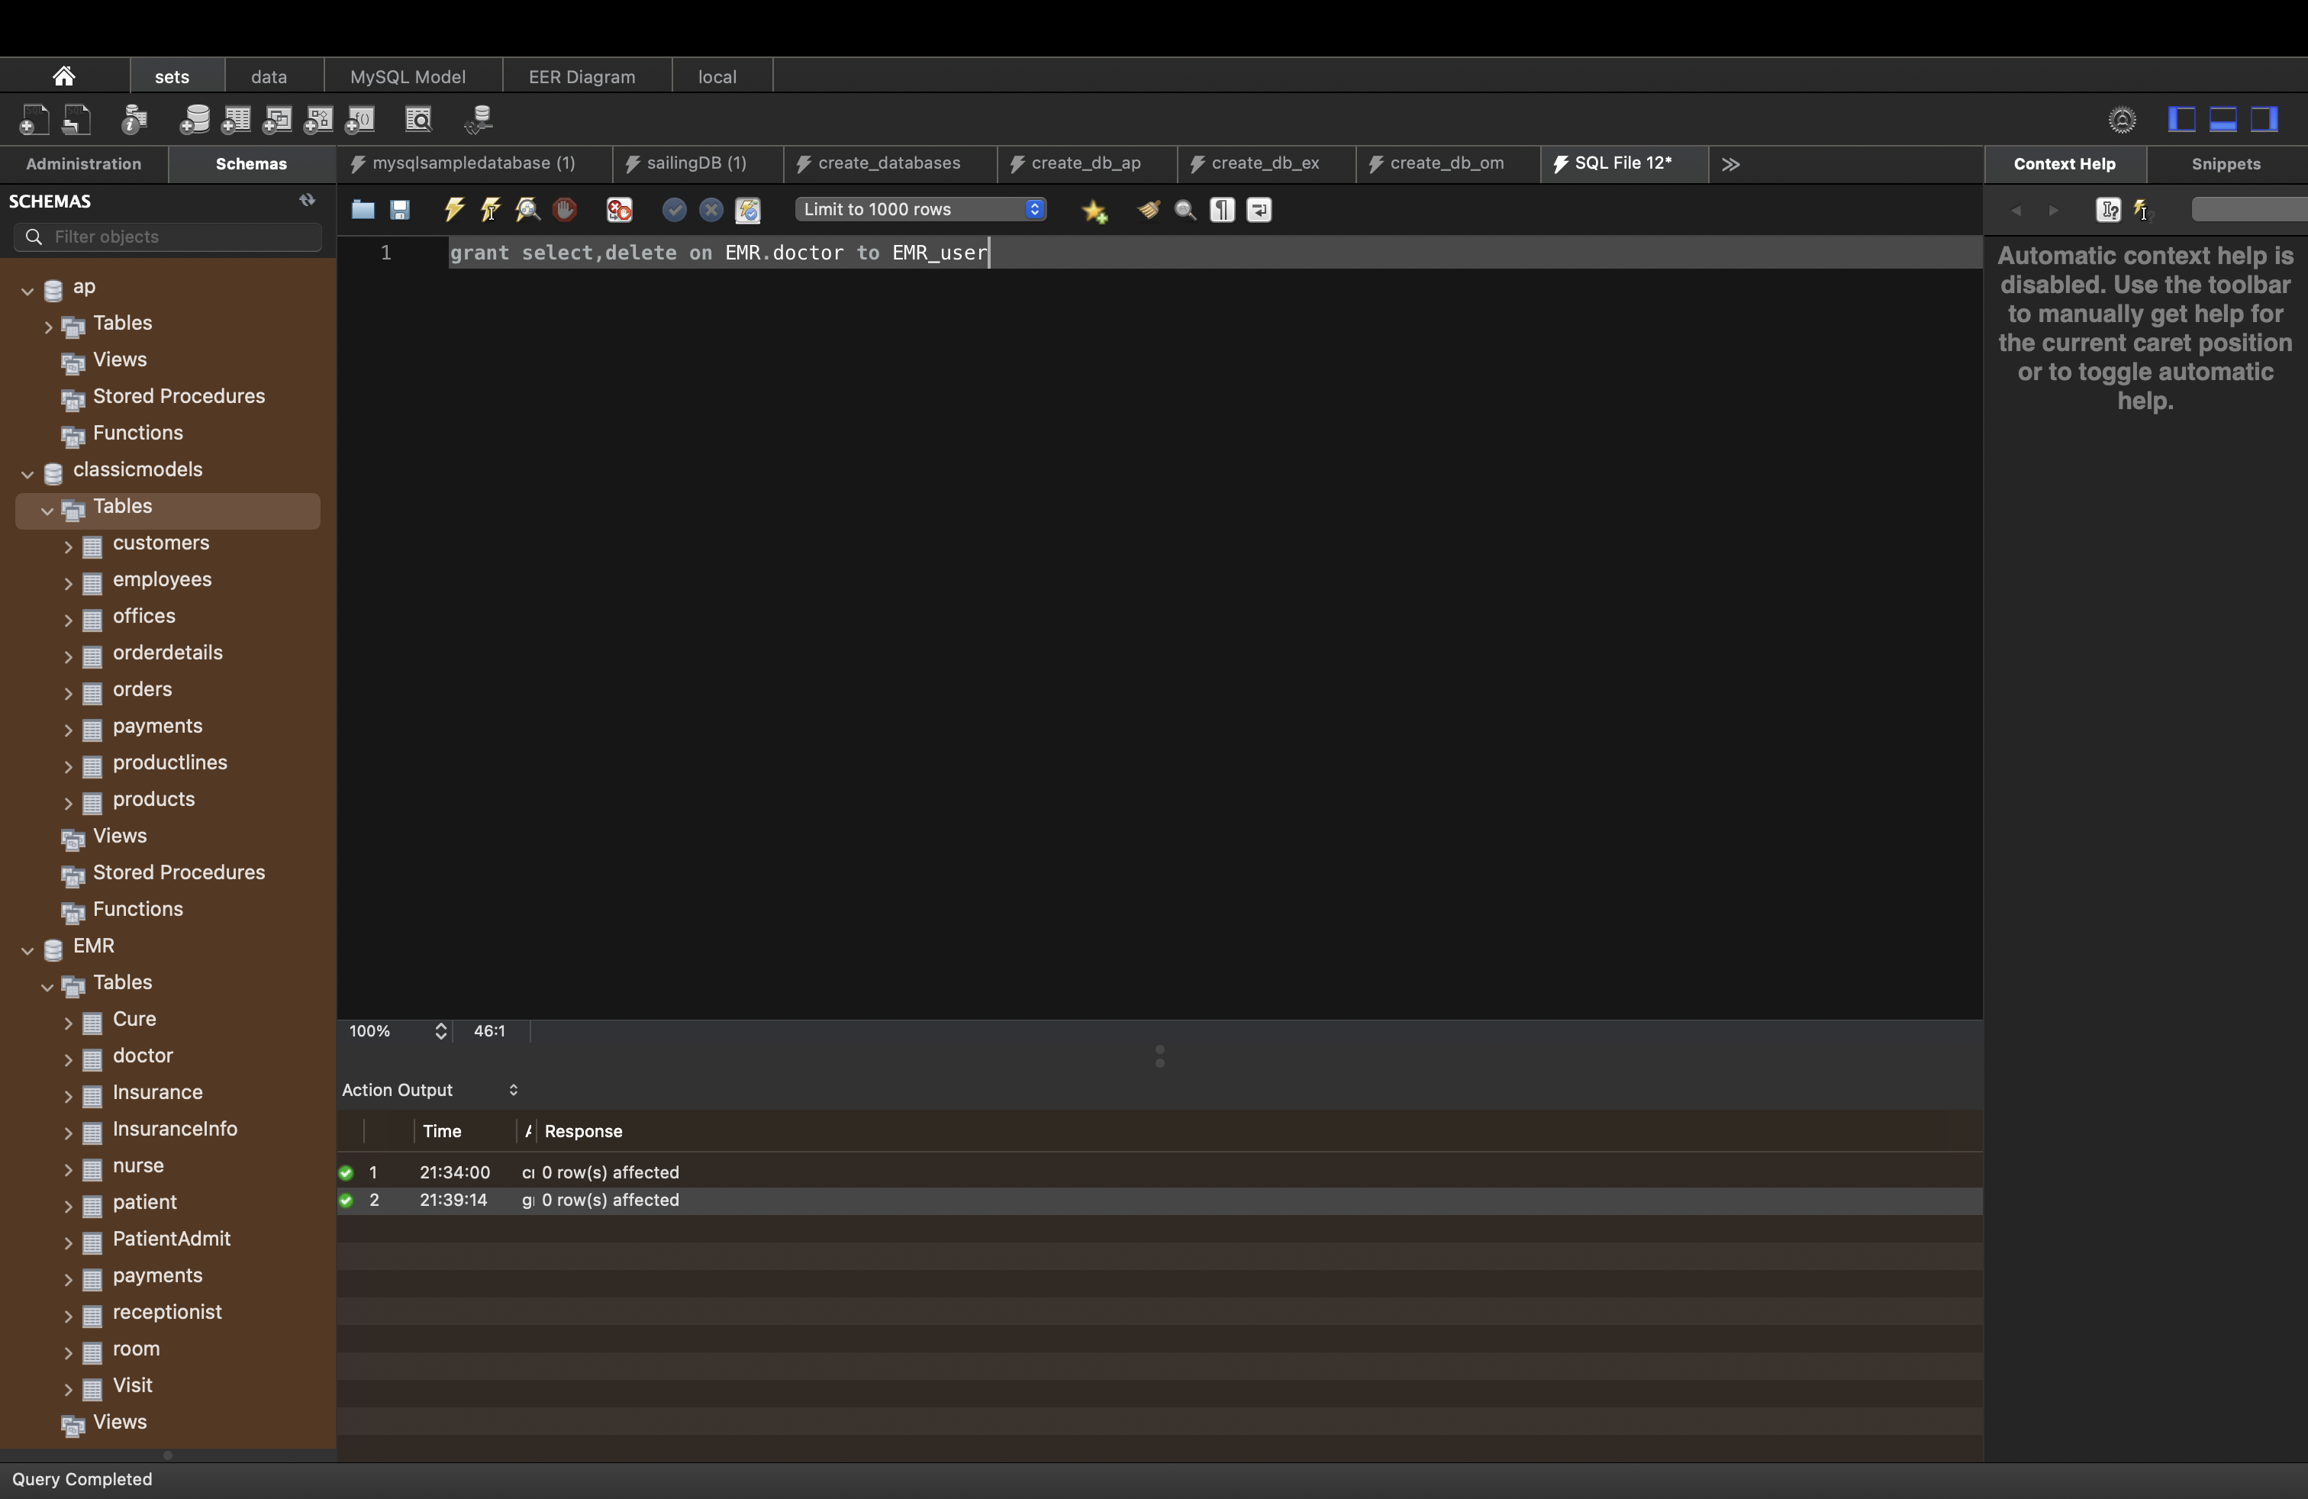

It can update values

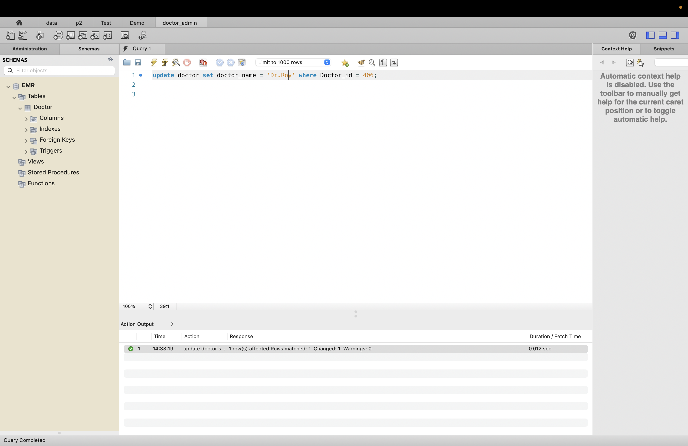

Only doctor can update value, if Patient try to update it throws error because we grant permission only to doctor not patient

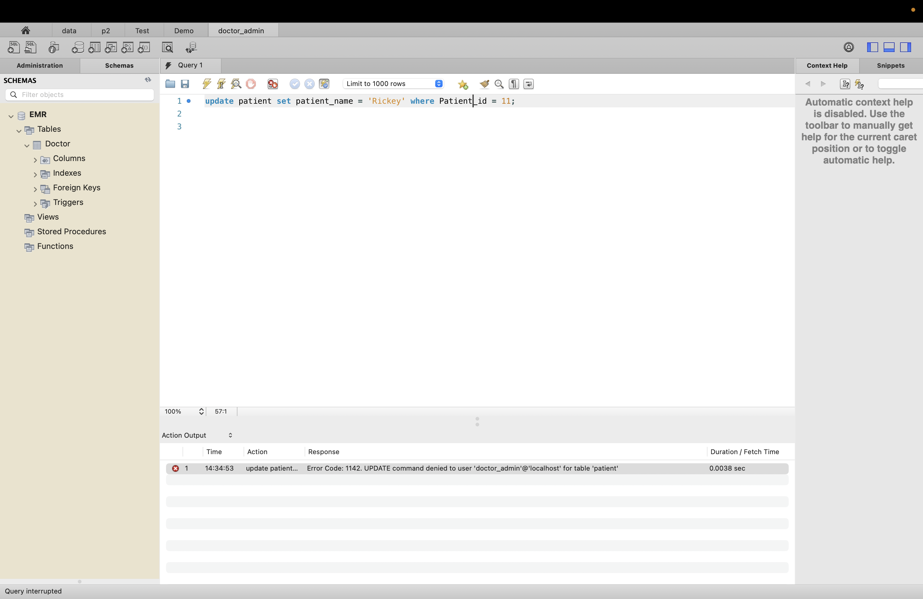

Create role EMR_Patient

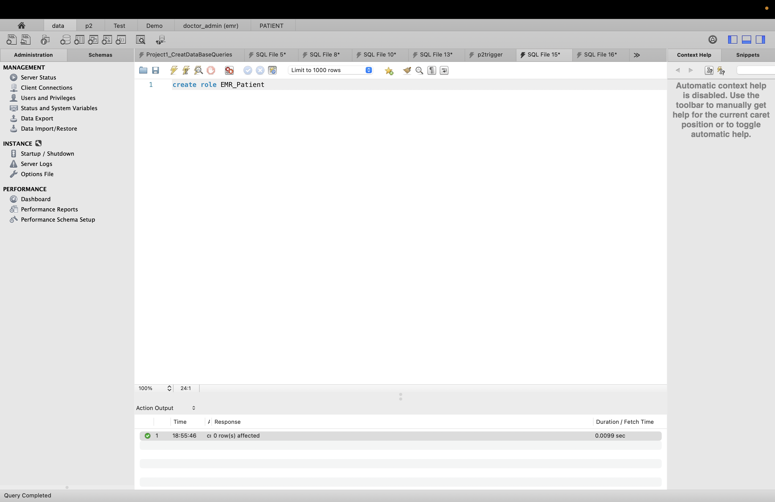

Granting only select privilege.

Grant select on EMR.patient to EMR_Patient

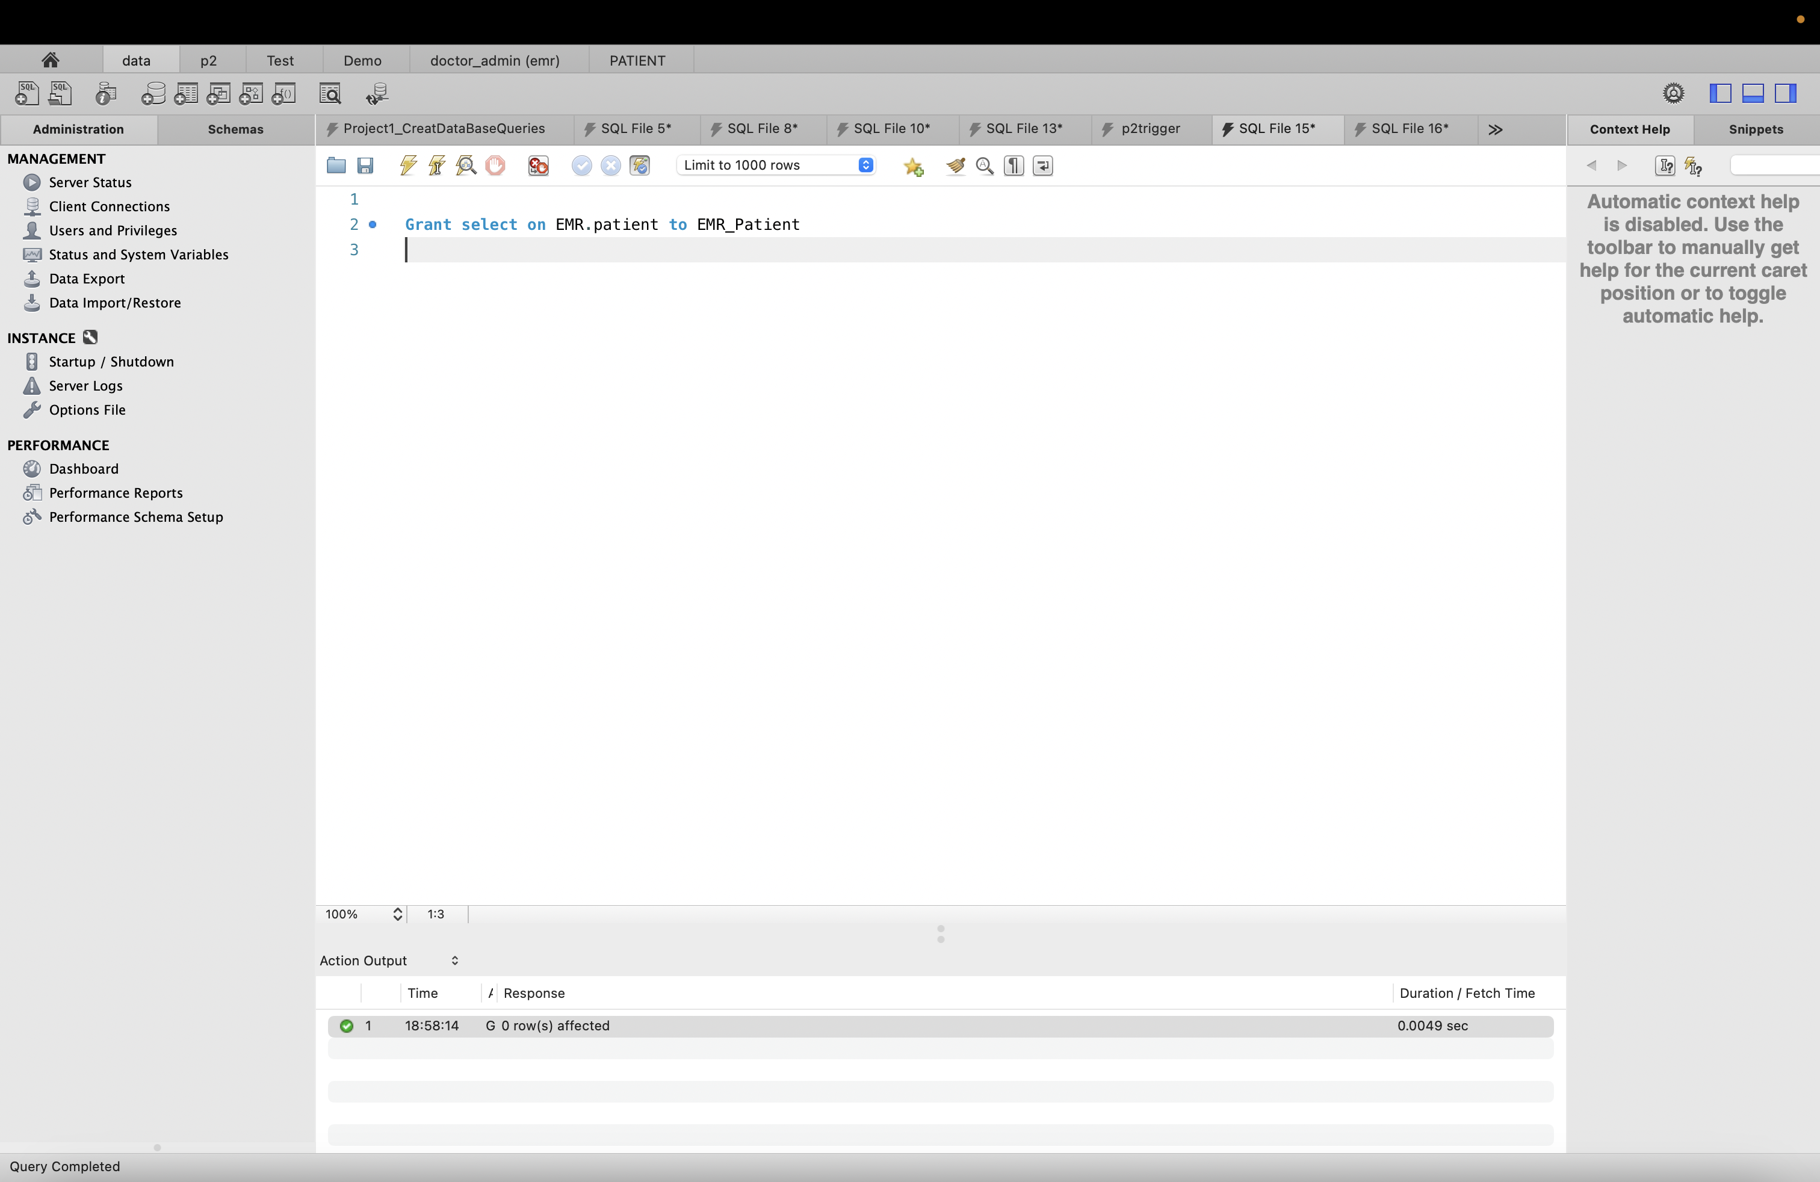

List of Users:

SELECT user,host FROM mysql.user;

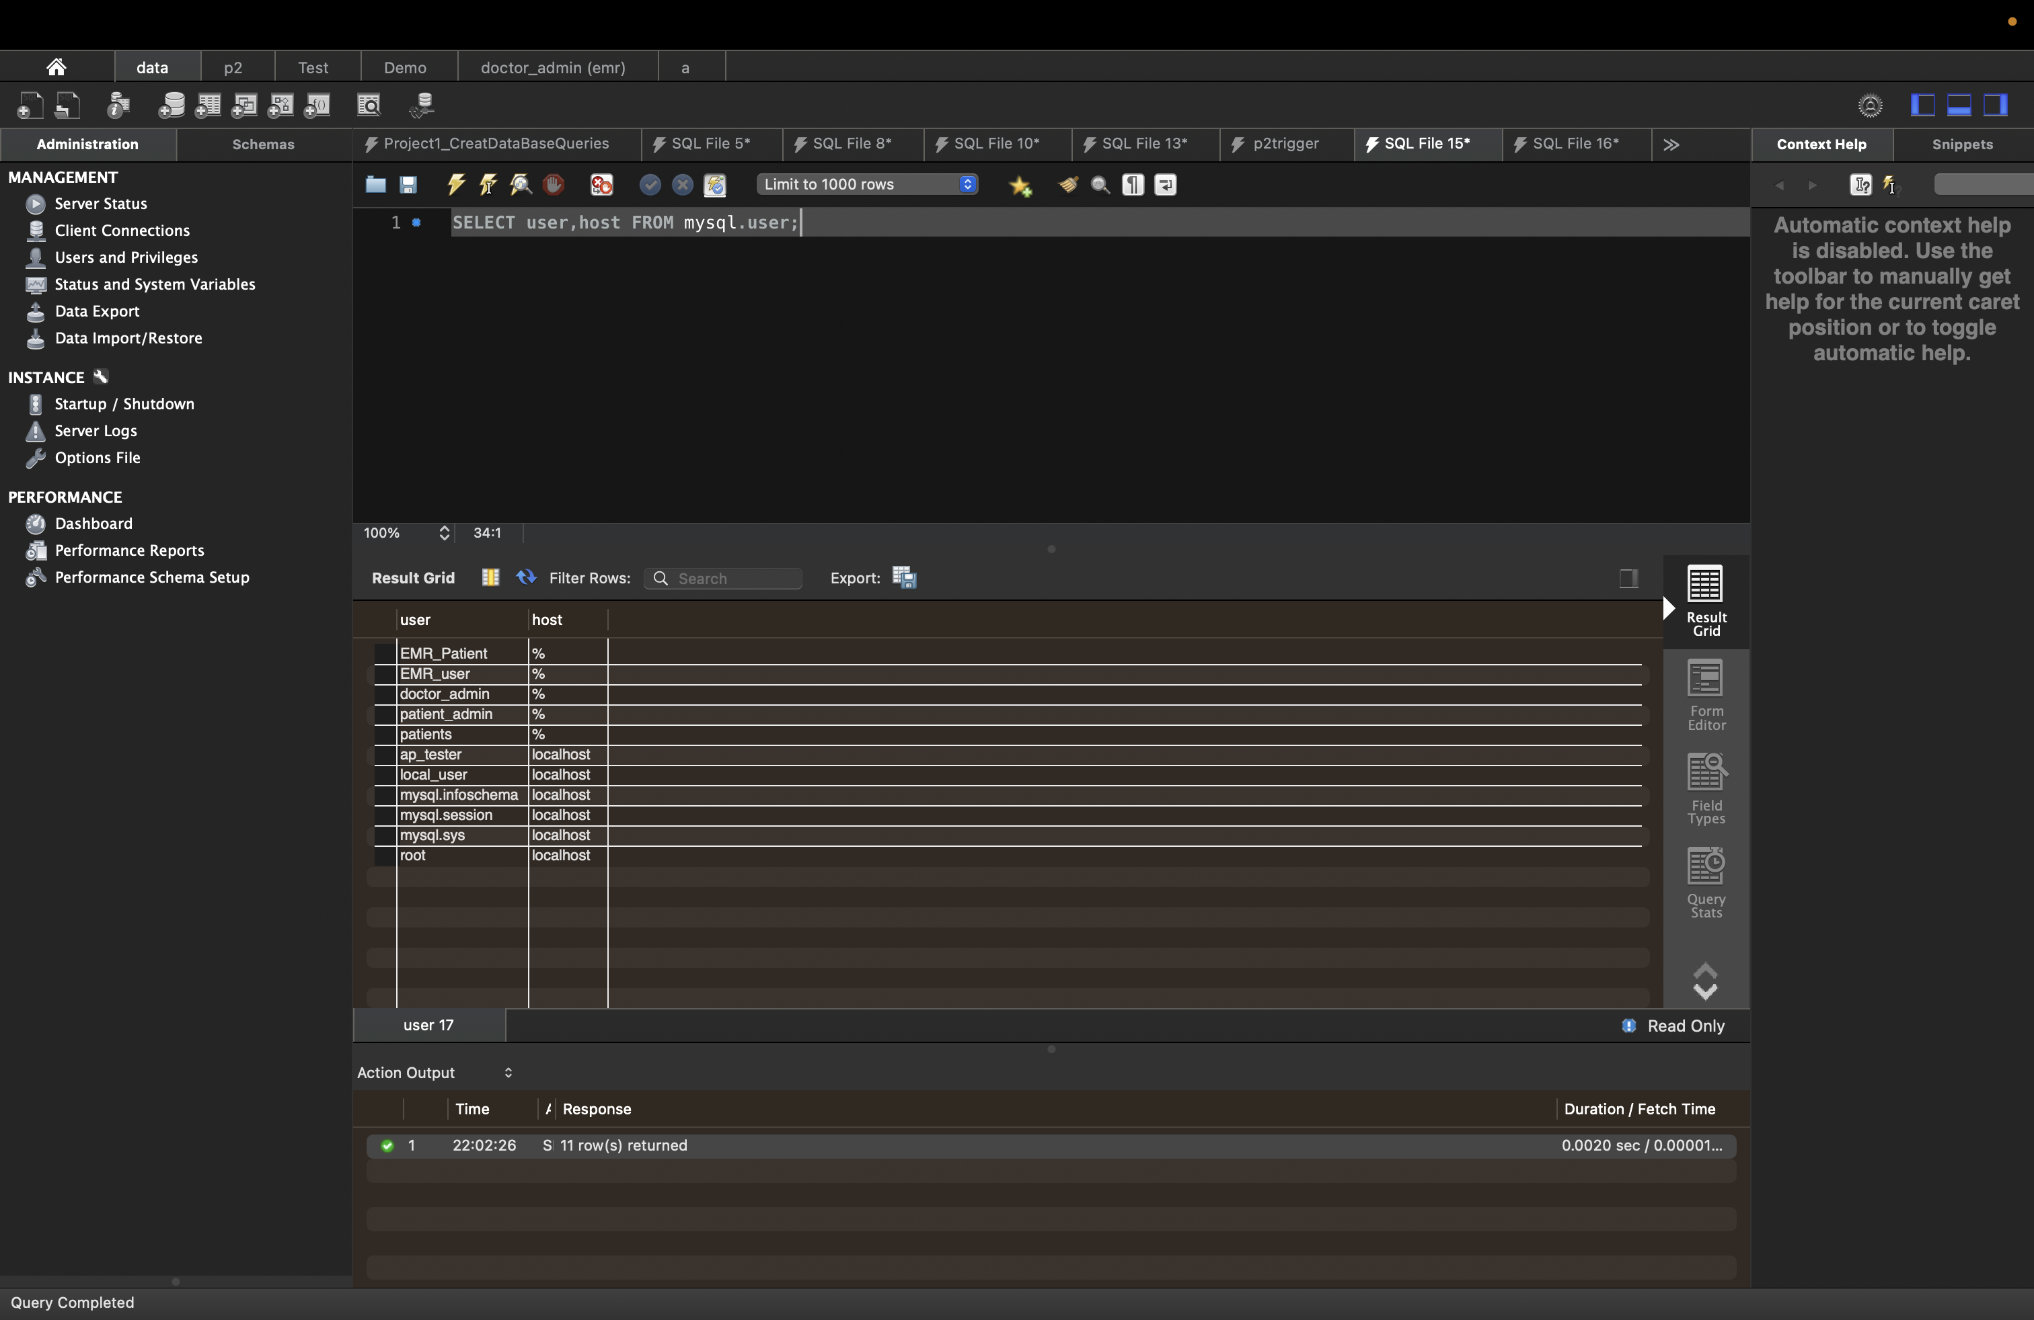

Show what privileges have doctor_Admin user.

SHOW GRANTS for doctor_admin;

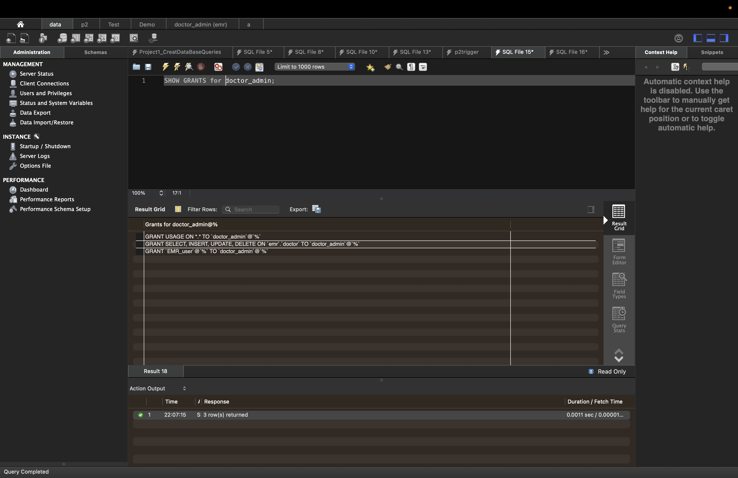

# Section 11: Audit Trail

Creating Audit Trail on Room Table

This SQL code creates an audit tables called " ROOM_AUDIT_Insert","ROOM_AUDIT_Update"," ROOM_AUDIT_Delete "and a triggers called "AUTDITOFROOMUPDATE","AUTDITOFROOMInsert","AUTDITOFROOMDelete".The trigger is activated whenever a row is inserted, updated, or deleted in the "Room" table.

When the trigger is activated, it inserts a new row into the " ROOM_AUDIT_Insert","ROOM_AUDIT_Update"," ROOM_AUDIT_Delete " respective with action tables with information about the change that was made. The "action" column specifies the type of change (INSERT, UPDATE, or DELETE), the "change_time" column records the time the change was made, and the "old_data" and "new_data" columns contain the data before and after the change, respectively.

Audit for Room Table

1. Table Name : ROOM_AUDIT_Insert

SQL:

CREATE TABLE ROOM_AUDIT_Insert(

New_ROOM_NUMBER INT,

New_Room_Availability varchar(100),

New_Room_EntryDate date,

New_Room_ExitDate date,

ACTION VARCHAR(200),

Chage_time Timestamp,

User VARCHAR(100));

Result:

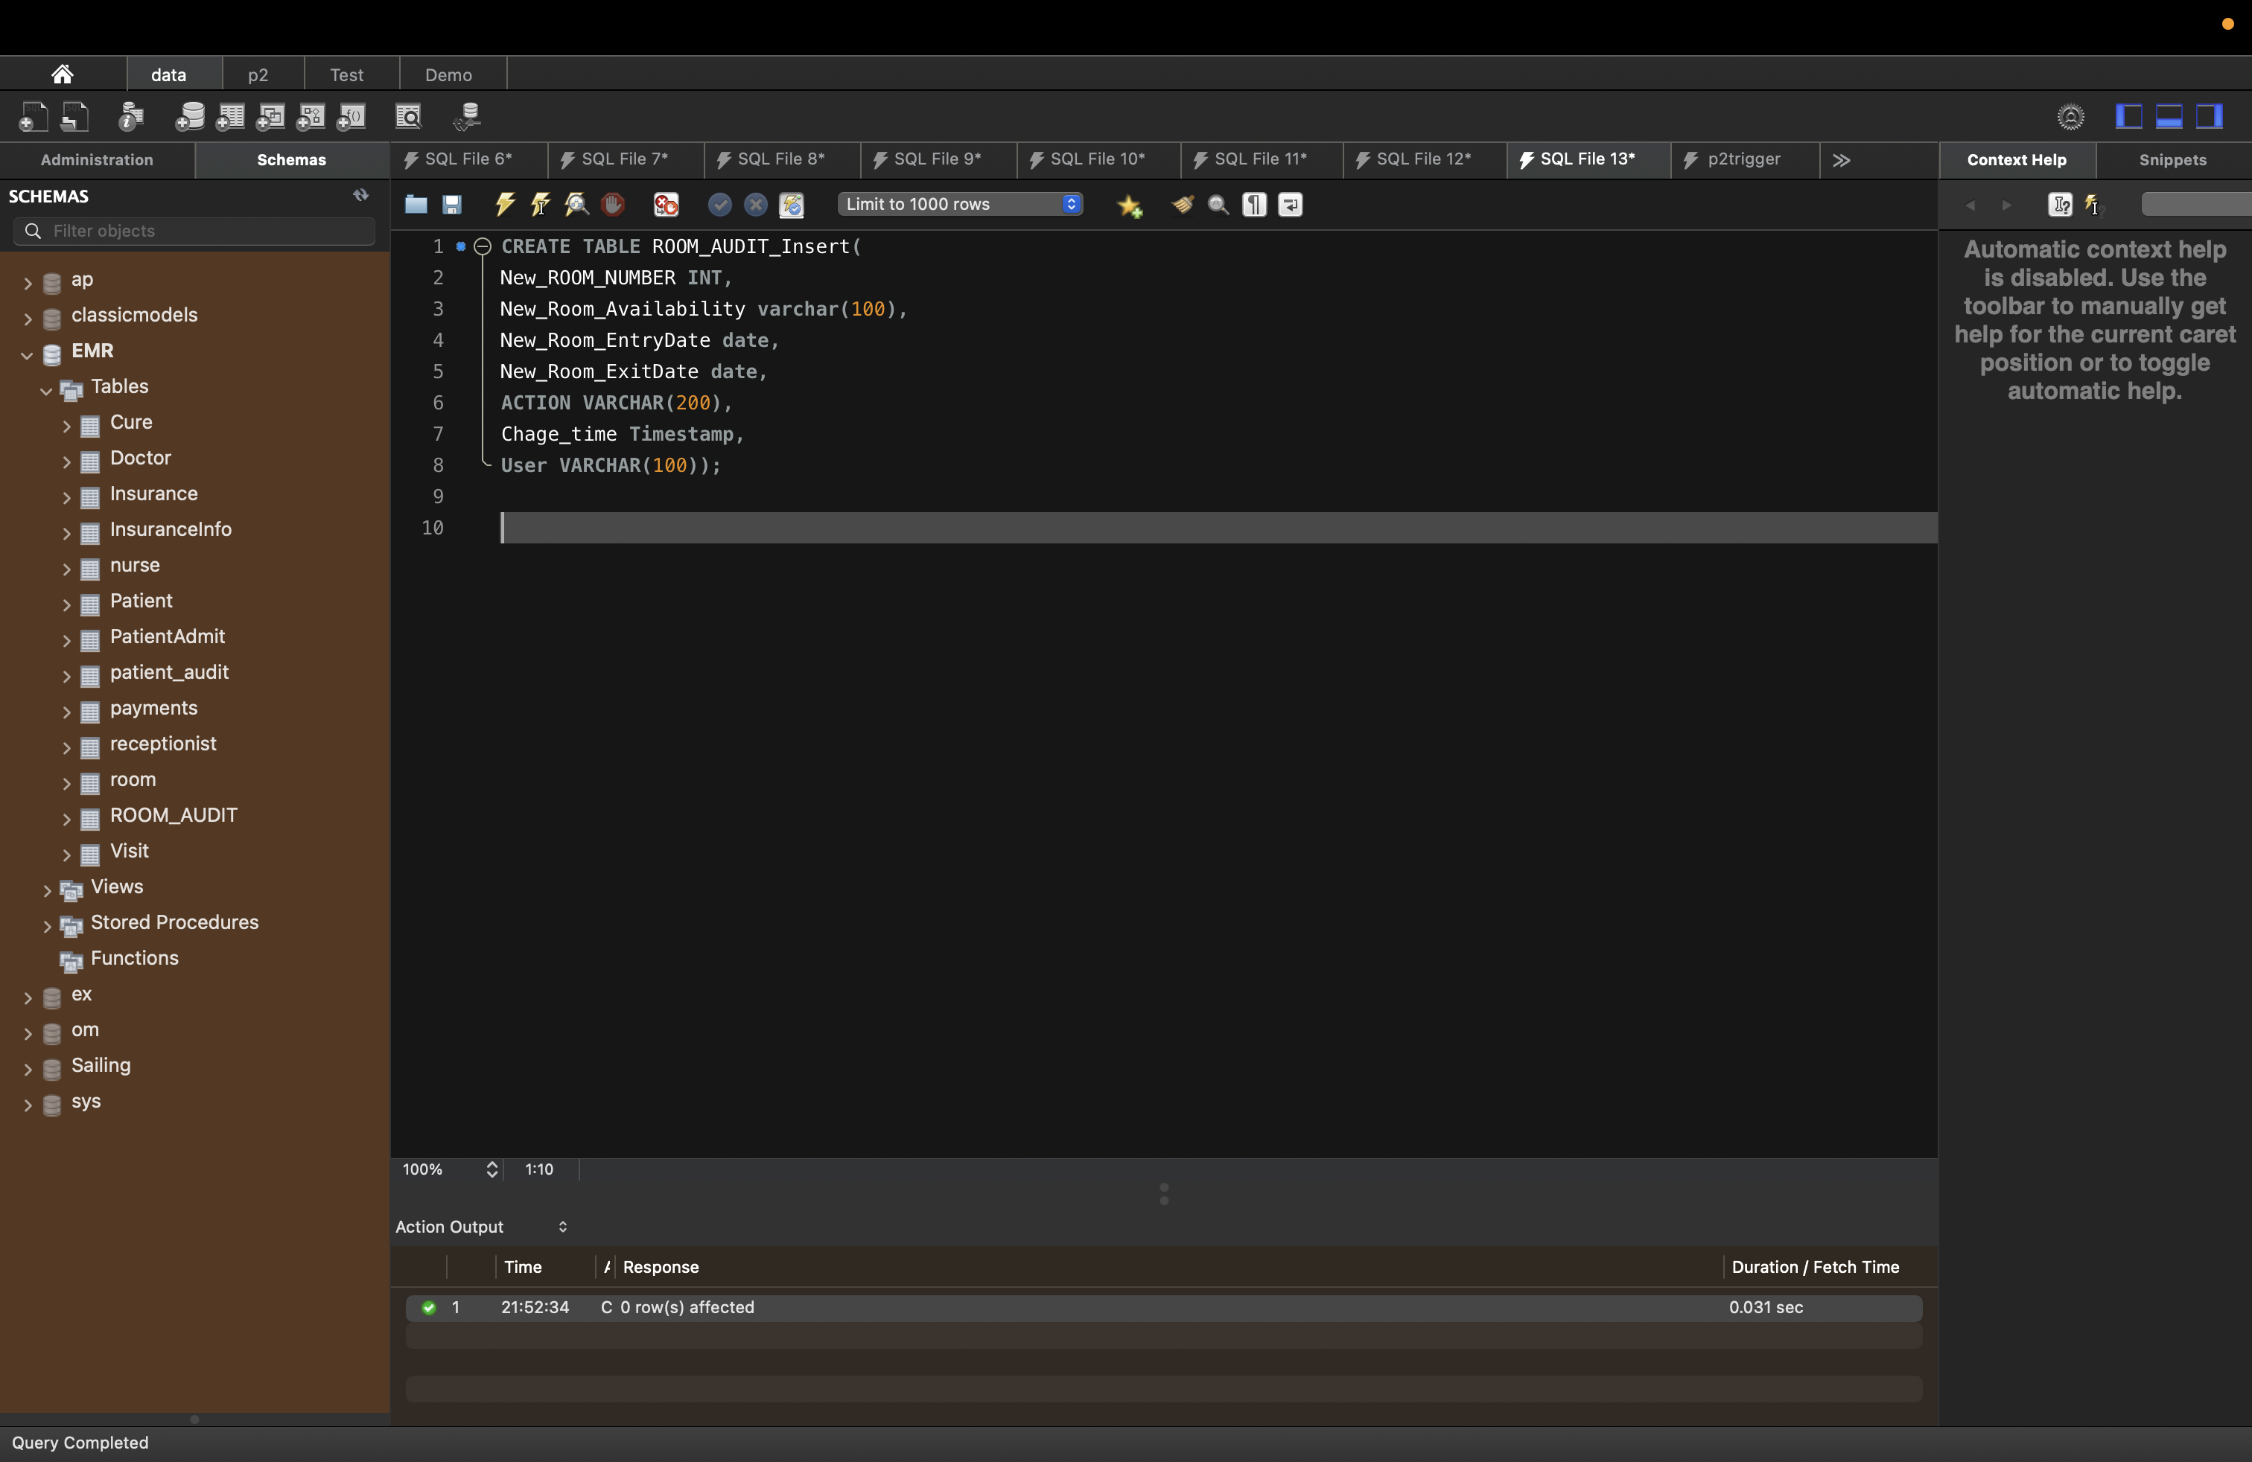

1. Table name: ROOM_AUDIT_Update

SQL:

CREATE TABLE ROOM_AUDIT_Update(

Old_ROOM_NUMBER INT,

Old_Room_Availability varchar(100),

Old_Room_EntryDate date,

Old_Room_ExitDate date,

New_ROOM_NUMBER INT,

New_Room_Availability varchar(100),

New_Room_EntryDate date,

New_Room_ExitDate date,

ACTION VARCHAR(200),

Chage_time Timestamp,

User VARCHAR(100)

);

Result:

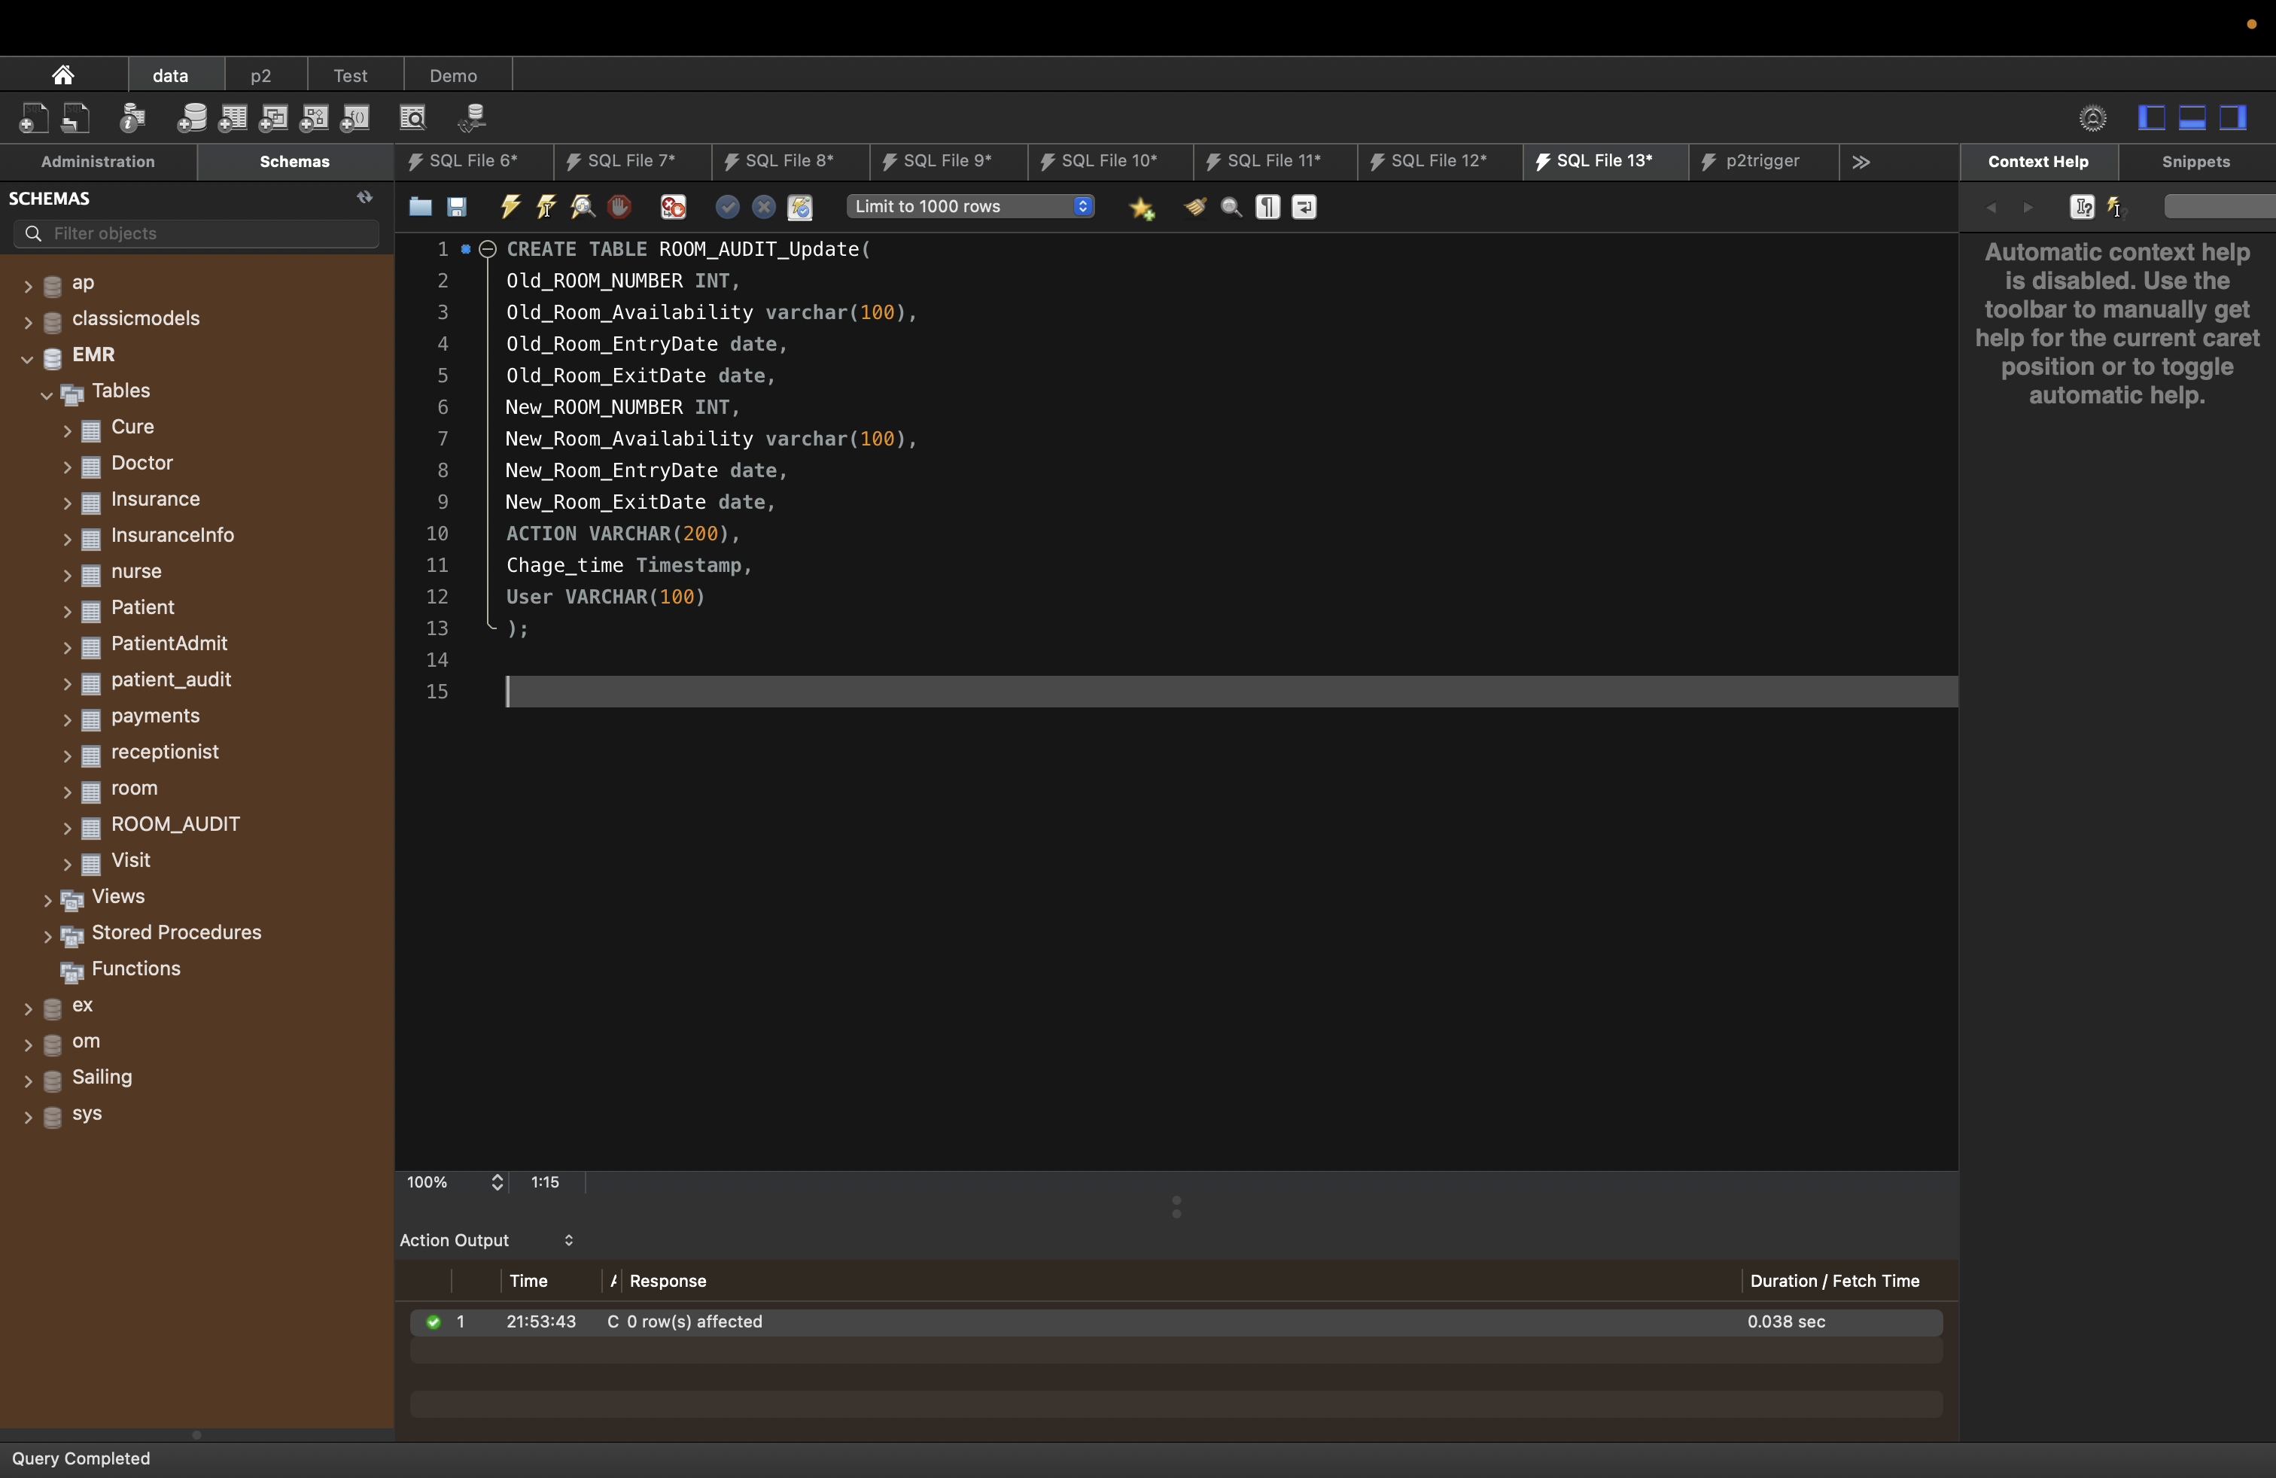

1. Table Name : ROOM_AUDIT_Delete

SQL:

CREATE TABLE ROOM_AUDIT_Delete(

old_ROOM_NUMBER INT,

old_Room_Availability varchar(100),

old_Room_EntryDate date,

old_Room_ExitDate date,

ACTION VARCHAR(200),

Chage_time Timestamp,

User VARCHAR(100)

);

Result:

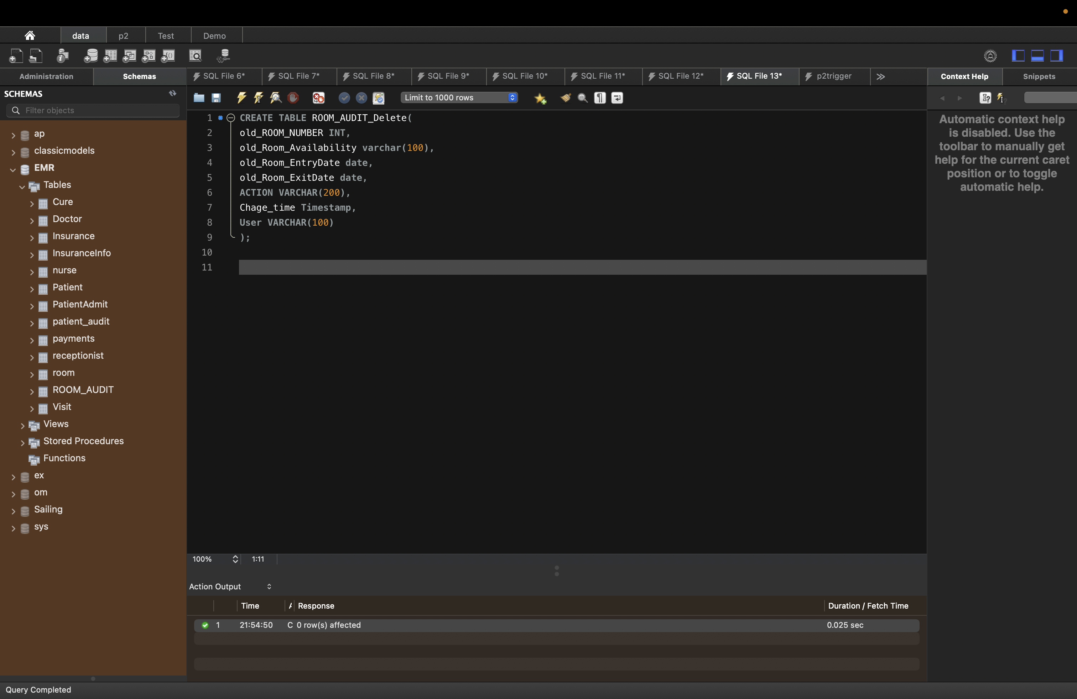

Creating Triggers for Audit Trails on Room Table:

1. This Trigger capture every Insert happens on Room Table:

SQL:

CREATE TRIGGER AUTDITOFROOMInsert

After Insert

ON ROOM

FOR EACH ROW

INSERT INTO ROOM_AUDIT_Insert SELECT NEW.ROOM_NUMBER,new.Room_Availability,new.Room_EntryDate,new.Room_ExitDate,'Insert',

NOW(), user() FROM ROOM;

Result:

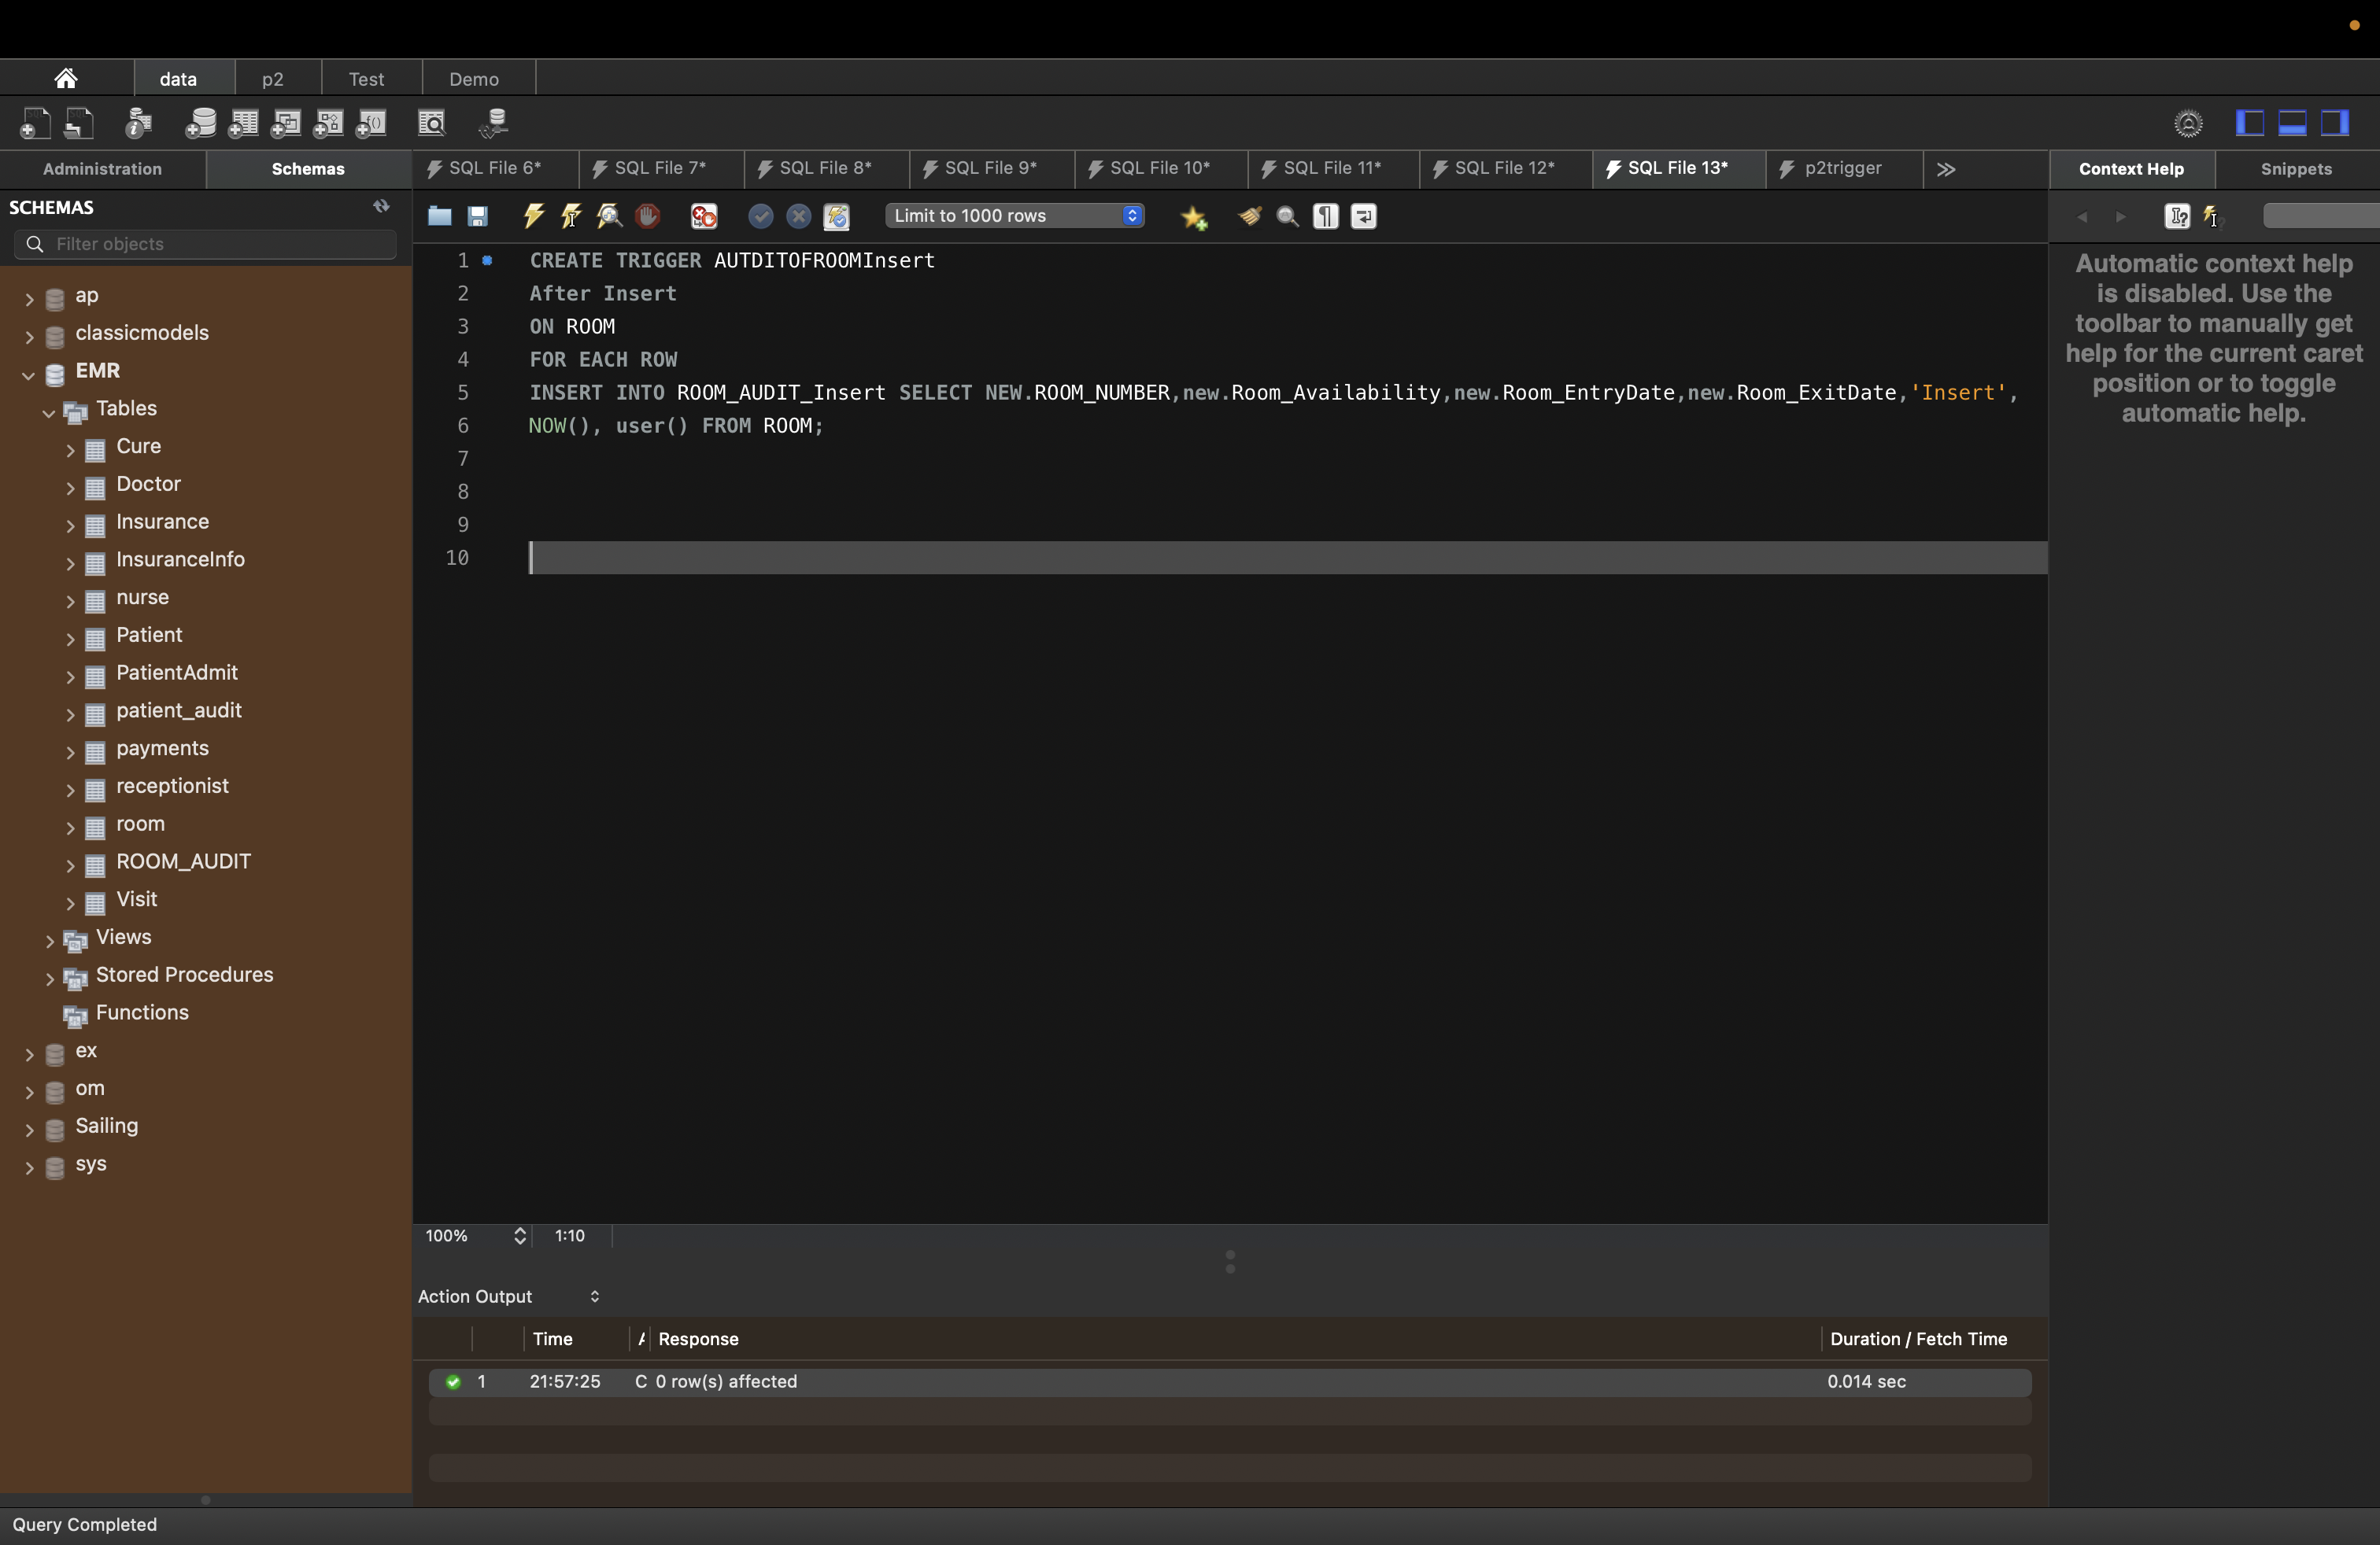

1. This Trigger capture every Update happens on Room Table:

SQL:

CREATE TRIGGER AUTDITOFROOMUPDATE

After UPDATE ON ROOM

for each row

INSERT INTO ROOM_AUDIT_Update SELECT old.Room_Number,old.Room_Availability,old.Room_EntryDate,Old.Room_ExitDate,

NEW.ROOM_NUMBER,new.Room_Availability,new.Room_EntryDate,new.Room_ExitDate,'UPDATE', NOW(),user()

FROM ROOM;

Result:

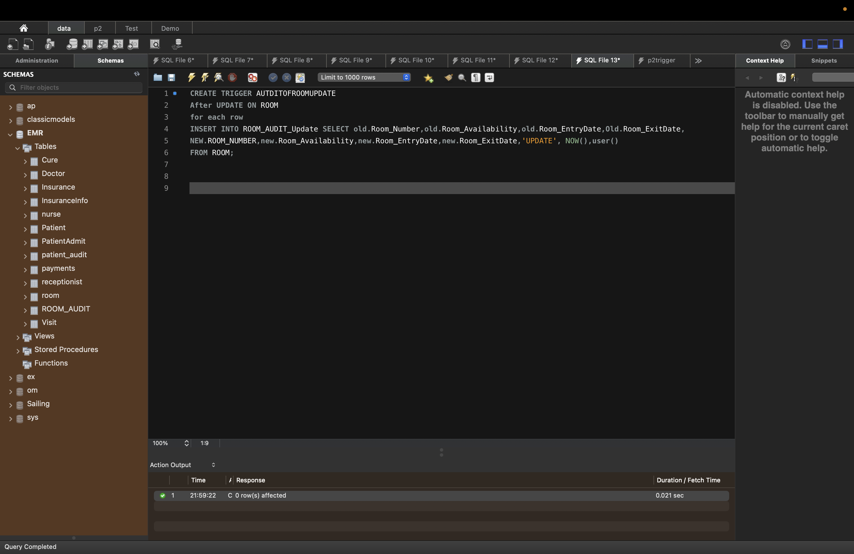

1. This Trigger capture every Delete happens on Room Table:

SQL:

CREATE TRIGGER AUTDITOFROOMDelete

After Delete

ON ROOM

FOR EACH ROW

INSERT INTO ROOM_AUDIT_Insert SELECT old.ROOM_NUMBER,old.Room_Availability,old.Room_EntryDate,old.Room_ExitDate,'Delete',

NOW(), user() FROM ROOM;

Result:

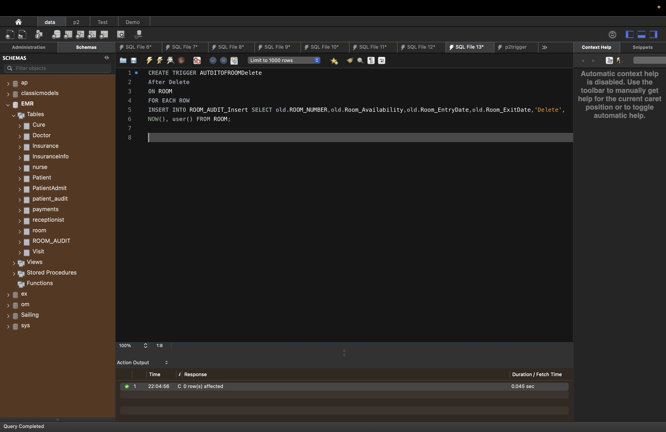

To Check if its work:

Inserting new row in room table:

SQL: insert into Room (Room_Number,Room_Availability,Room_EntryDate,Room_ExitDate)

values ('222','No','2022-05-18','2022-05-20')

Result:

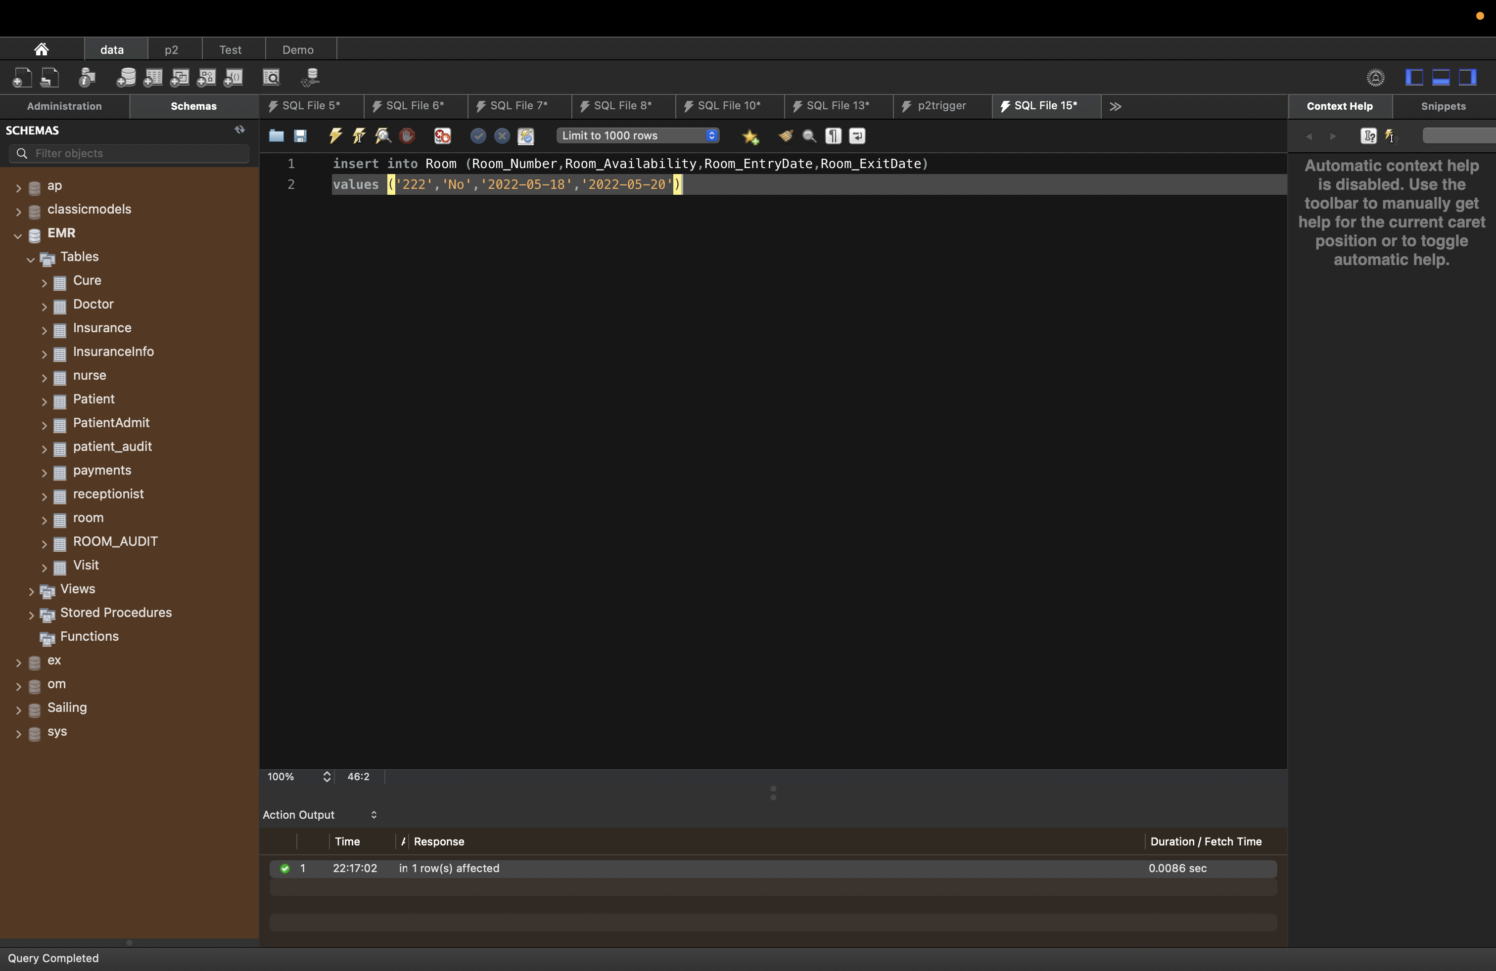

After inserting row in room table, trigger which we created inserted a new row in Audit table with following details like time of insertion, user

Result:

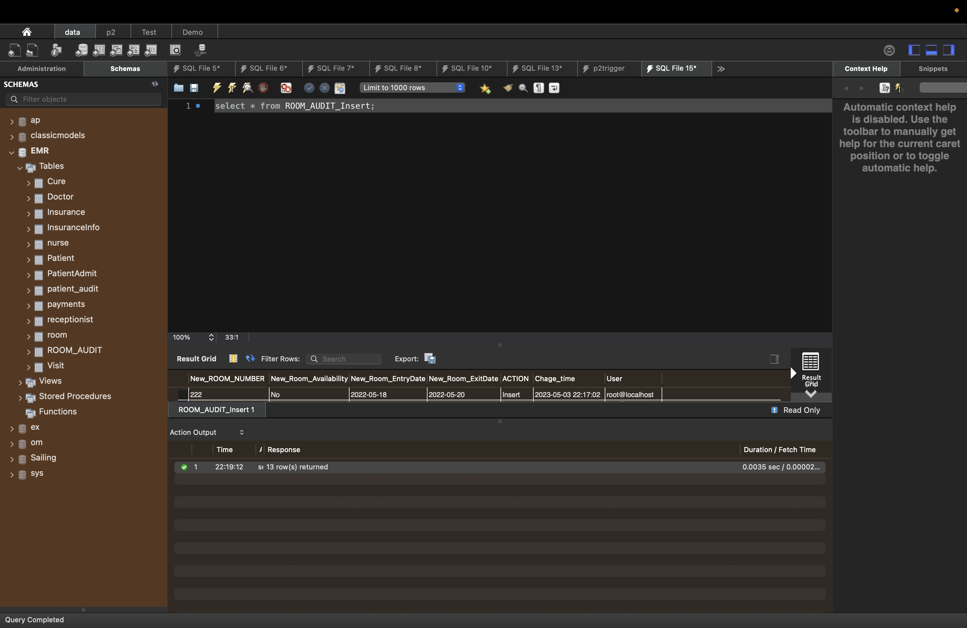

After Updating row in room table, trigger which we created inserted a new row with following details like time of insertion, user, old date and new details inserted in Audit trail table we created ROOM_AUDIT_Update

Result:

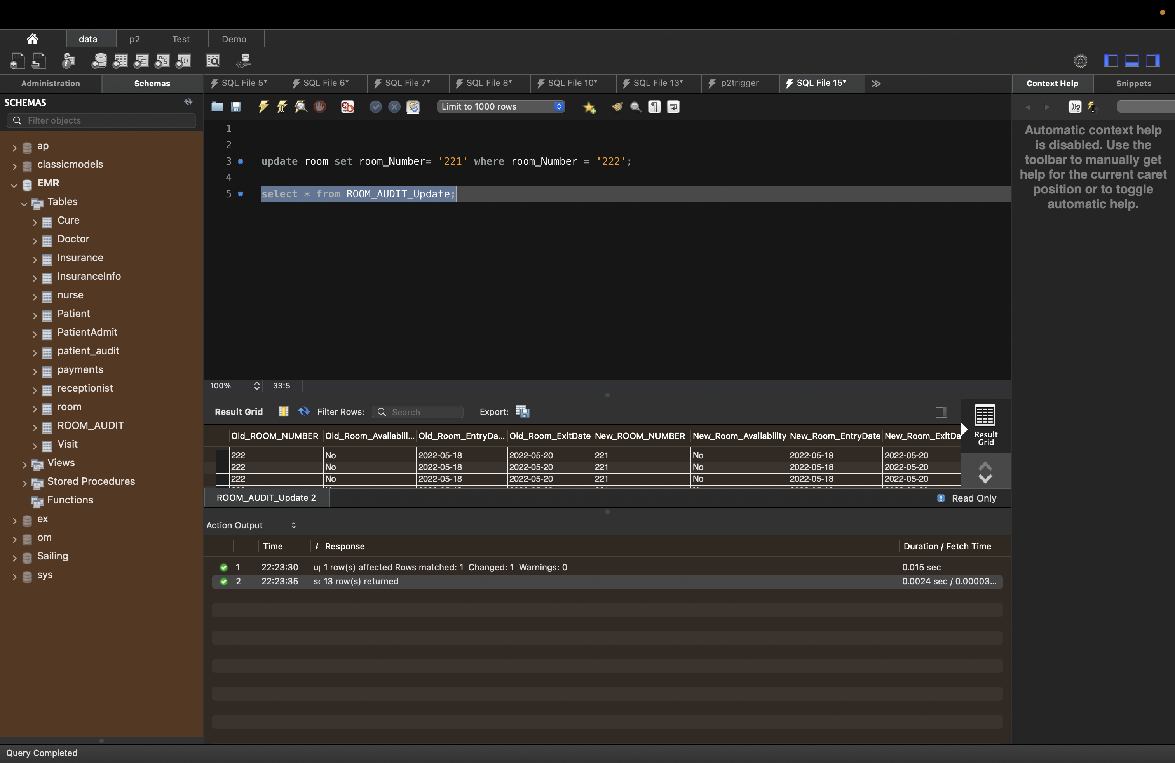

After Deleting row in room table trigger which we created inserted a new row with following details like time of insertion, user, old date and new detail’s inserted in Audit trail table we created ROOM_AUDIT_Delete

Result:

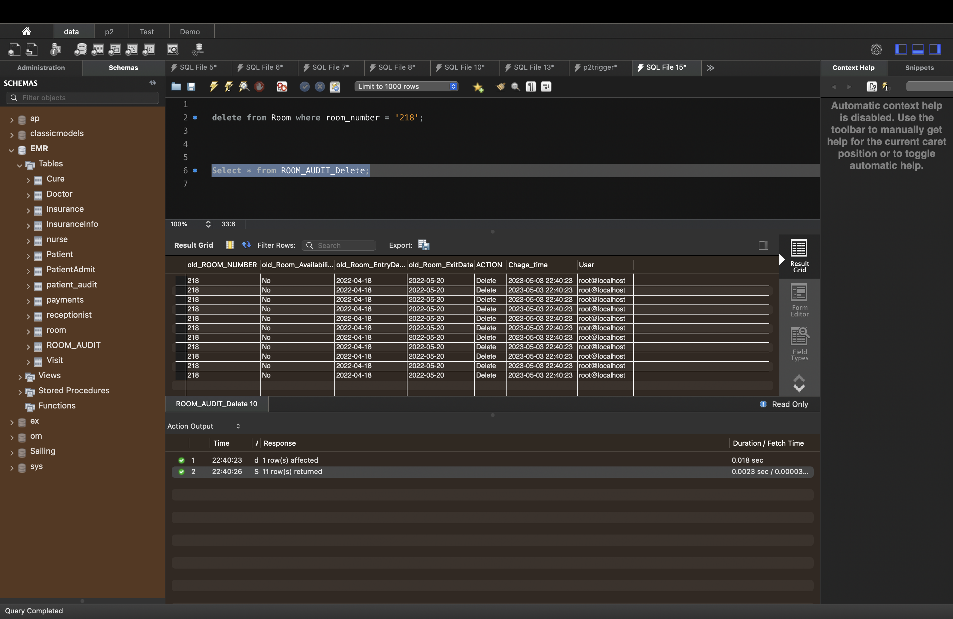

Creating Audit trail for Payments table in similar way

This SQL code creates an audit tables called " Payments_AUDIT_Insert","Payments_AUDIT_Update"," Payments_AUDIT_Delete "and a triggers called "AUTDITOFPAYMENTSUPDATE","AUTDITOFPAYMENTSInsert","AUTDITOPAYMENTSDelete".The trigger is activated whenever a row is inserted, updated, or deleted in the "PAYMENTS" table.

When the trigger is activated, it inserts a new row into the " PAYMENTS_AUDIT_Insert","PAYMENTS_AUDIT_Update"," PAYMENTS_AUDIT_Delete " tables with information about the change that was made. The "action" column specifies the type of change (INSERT, UPDATE, or DELETE), the "change_time" column records the time the change was made, and the "old_data" and "new_data" columns contain the data before and after the change, respectively.

Audit for Payments tables

1. Table name : PAYMENTS_AUDIT_Insert

SQL:

CREATE TABLE PAYMENTS_AUDIT_Insert(

New_PATIENT_ID INT,

New_RBILL_AMOUNT INT,

ACTION VARCHAR(200),

Chage_time Timestamp,

User VARCHAR(100));

Result:

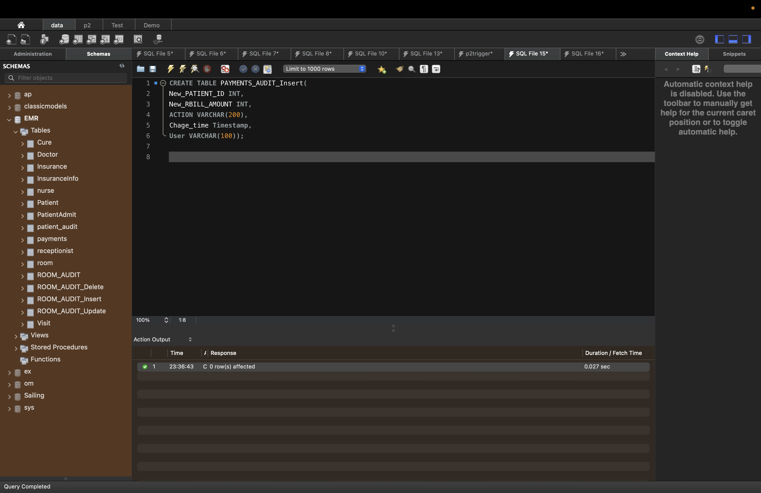

1. Table Name : PAYMENTS_AUDIT_Update

SQL;

CREATE TABLE PAYMENTS_AUDIT_Update(

Old_PATIENT_ID INT,

Old_RBILL_AMOUNT INT,

New_PATIENT_ID INT,

New_RBILL_AMOUNT INT,

ACTION VARCHAR(200),

Chage_time Timestamp,

User VARCHAR(100)

);

Result:

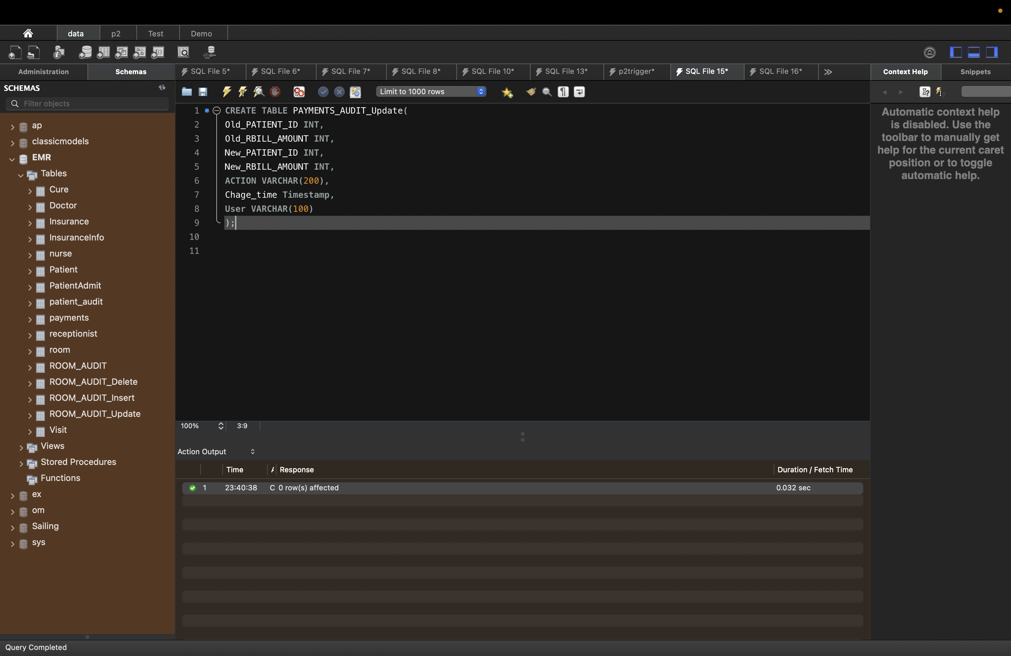

1. Table Name: PAYMENTS_AUDIT_Delete

SQL:

CREATE TABLE PAYMENTS_AUDIT_Delete(

Old_PATIENT_ID INT,

Old_RBILL_AMOUNT INT,

ACTION VARCHAR(200),

Chage_time Timestamp,

User VARCHAR(100)

);

Result:

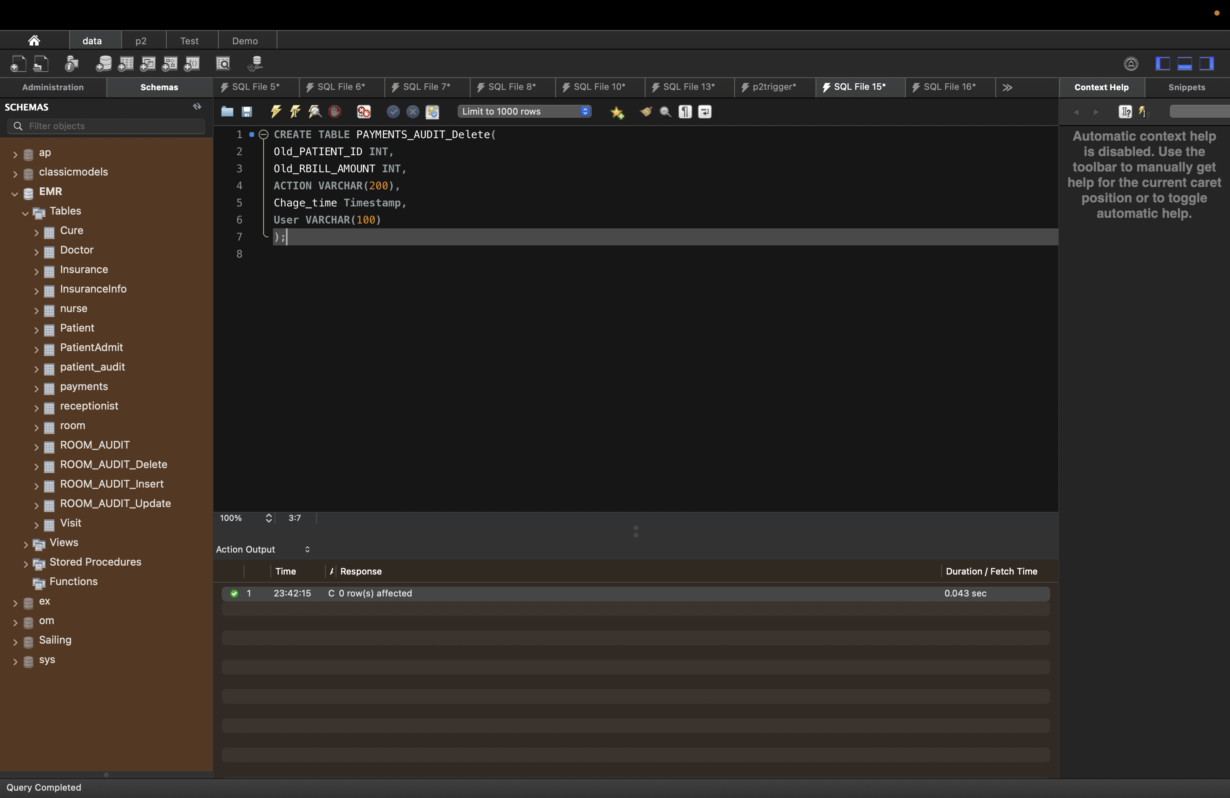

After inserting row in Payments table, trigger which we created inserted a new row with following details like time of insertion, user

Result:

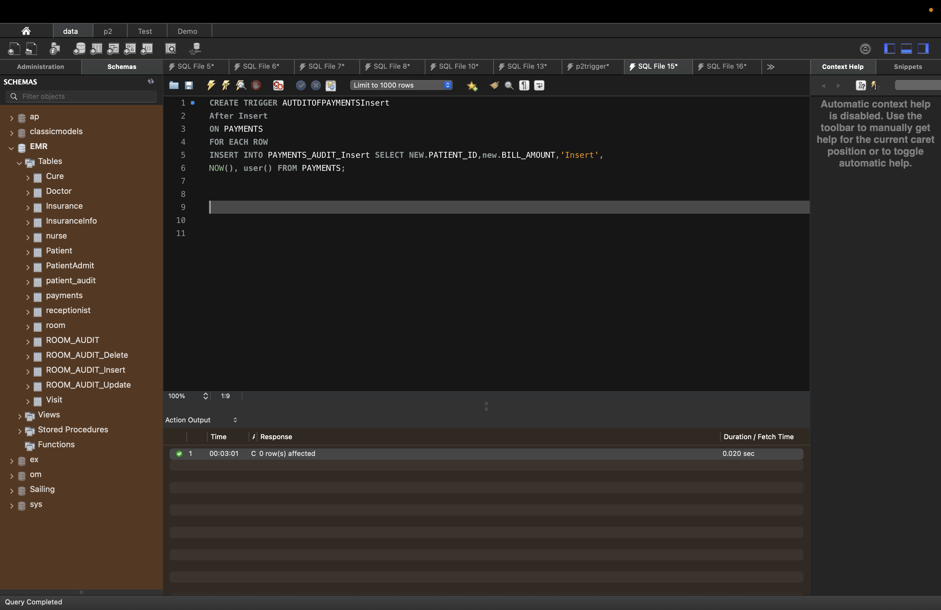

After Updating row in room table, trigger which we created inserted a new row with following details like time of insertion, user, old date and new details inserted in Audit trail table we created ROOM_AUDIT_Update

Result:

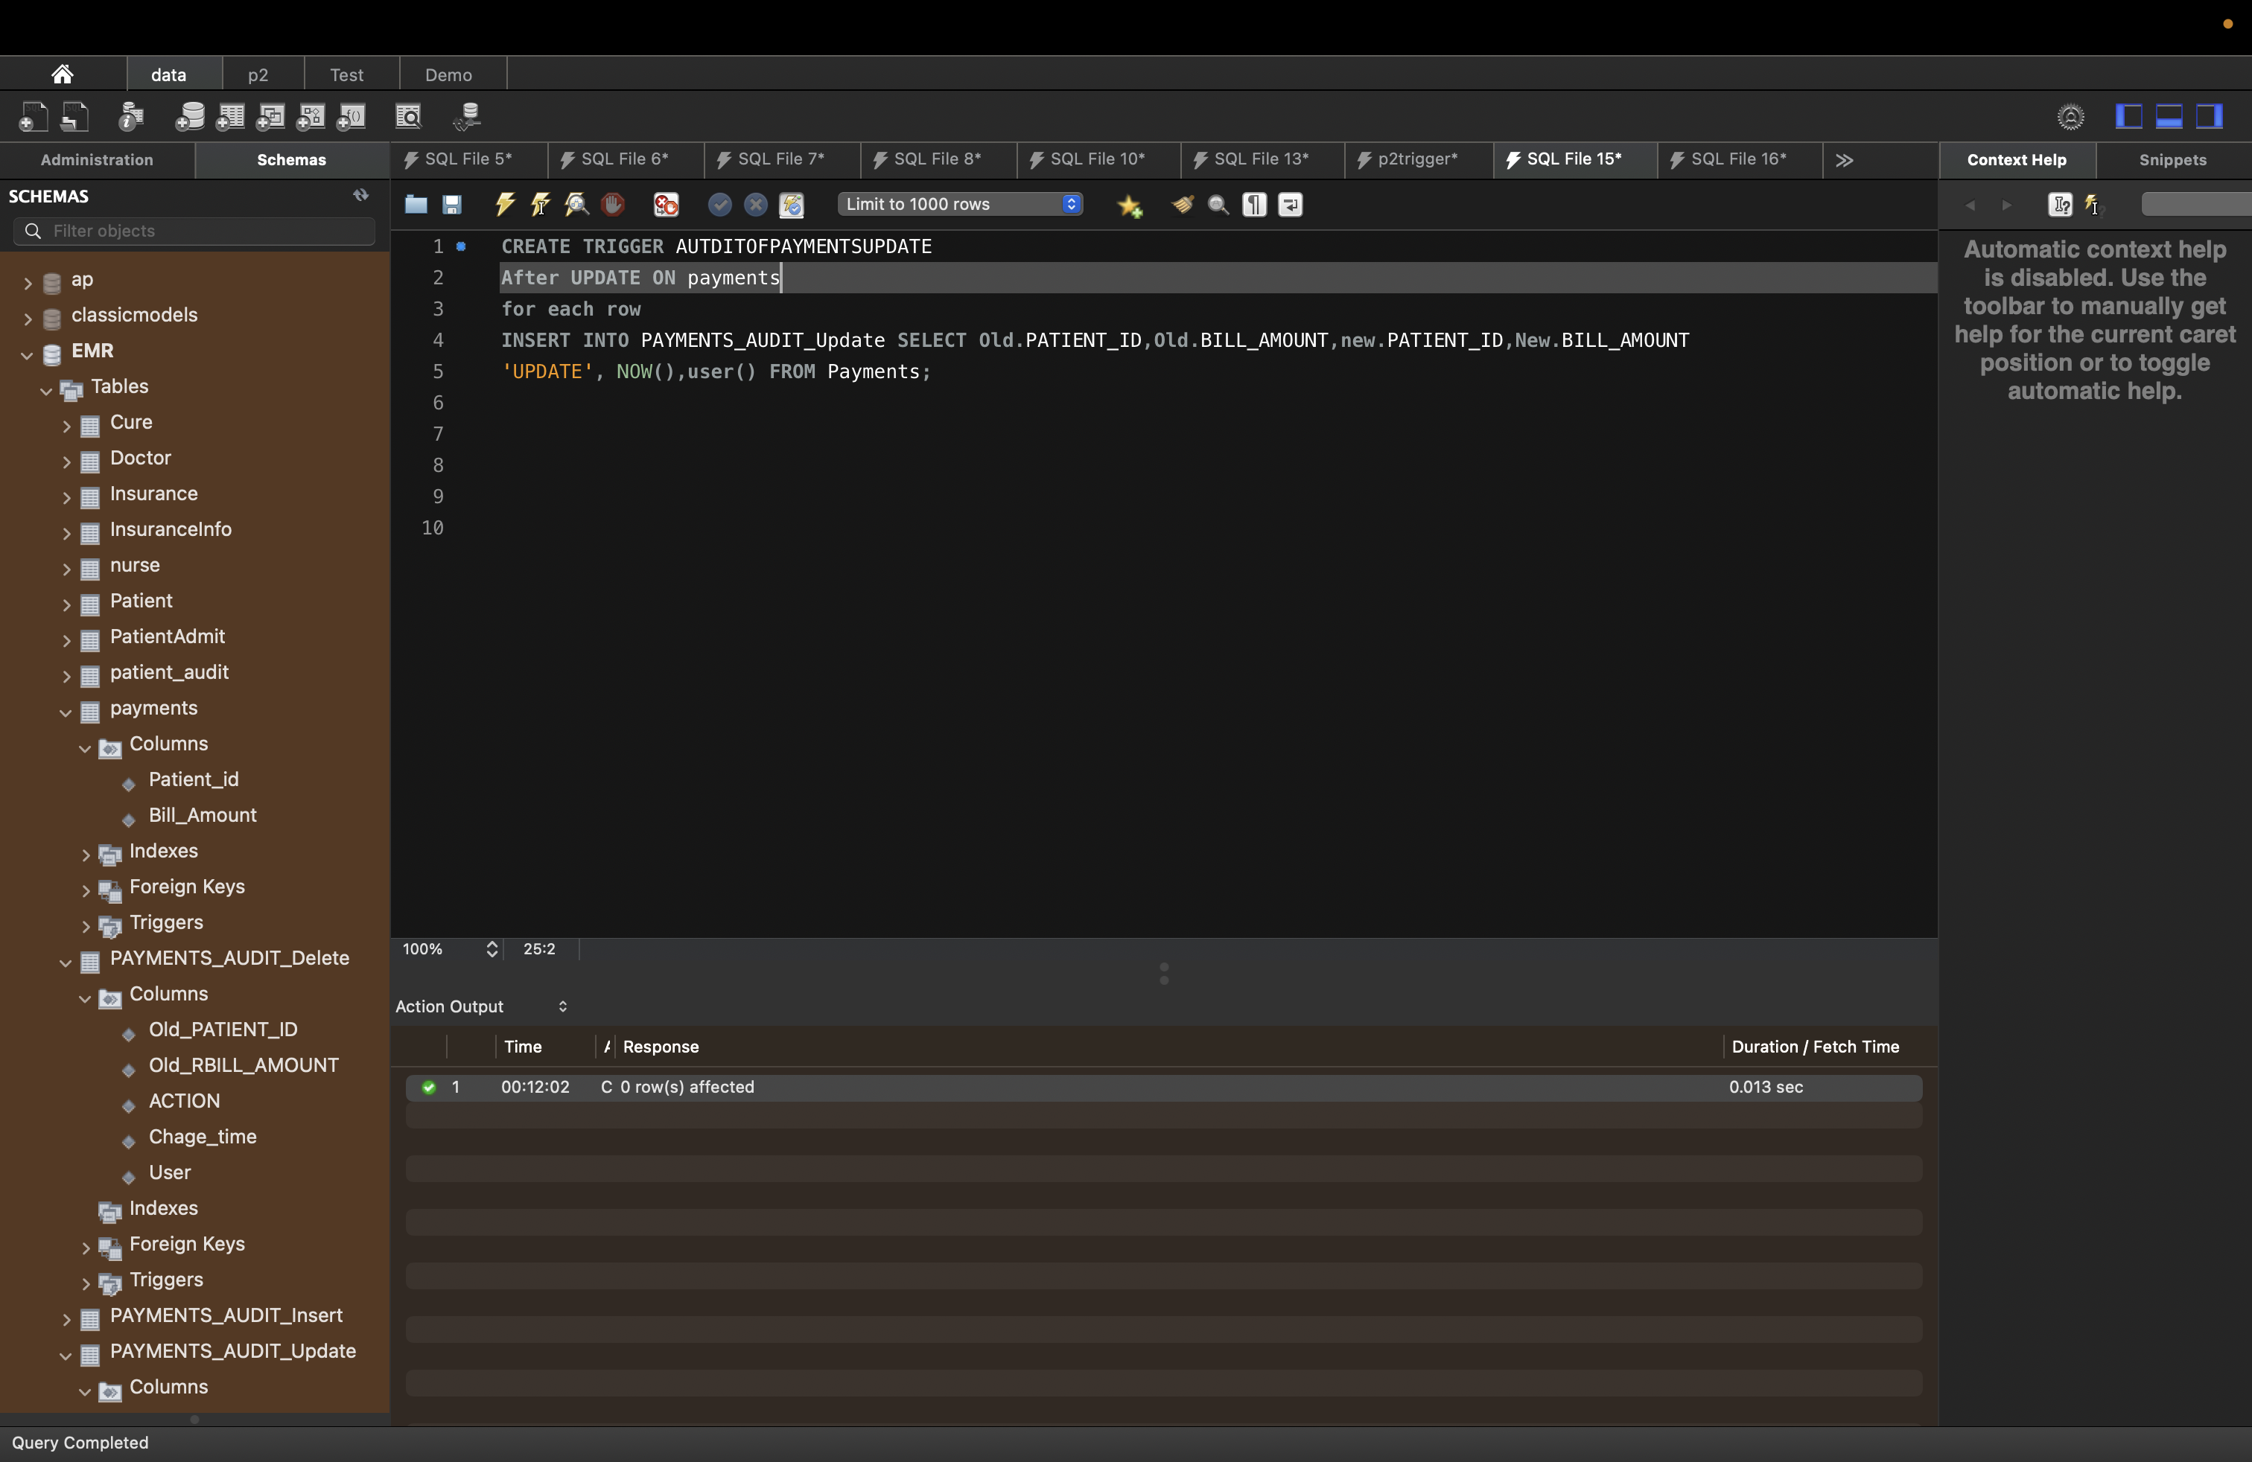

After Deleting row in room table, trigger which we created inserted a new row with following details like time of insertion, user, old date and new detail’s inserted in Audit trail table we created ROOM_AUDIT_Delete

Result

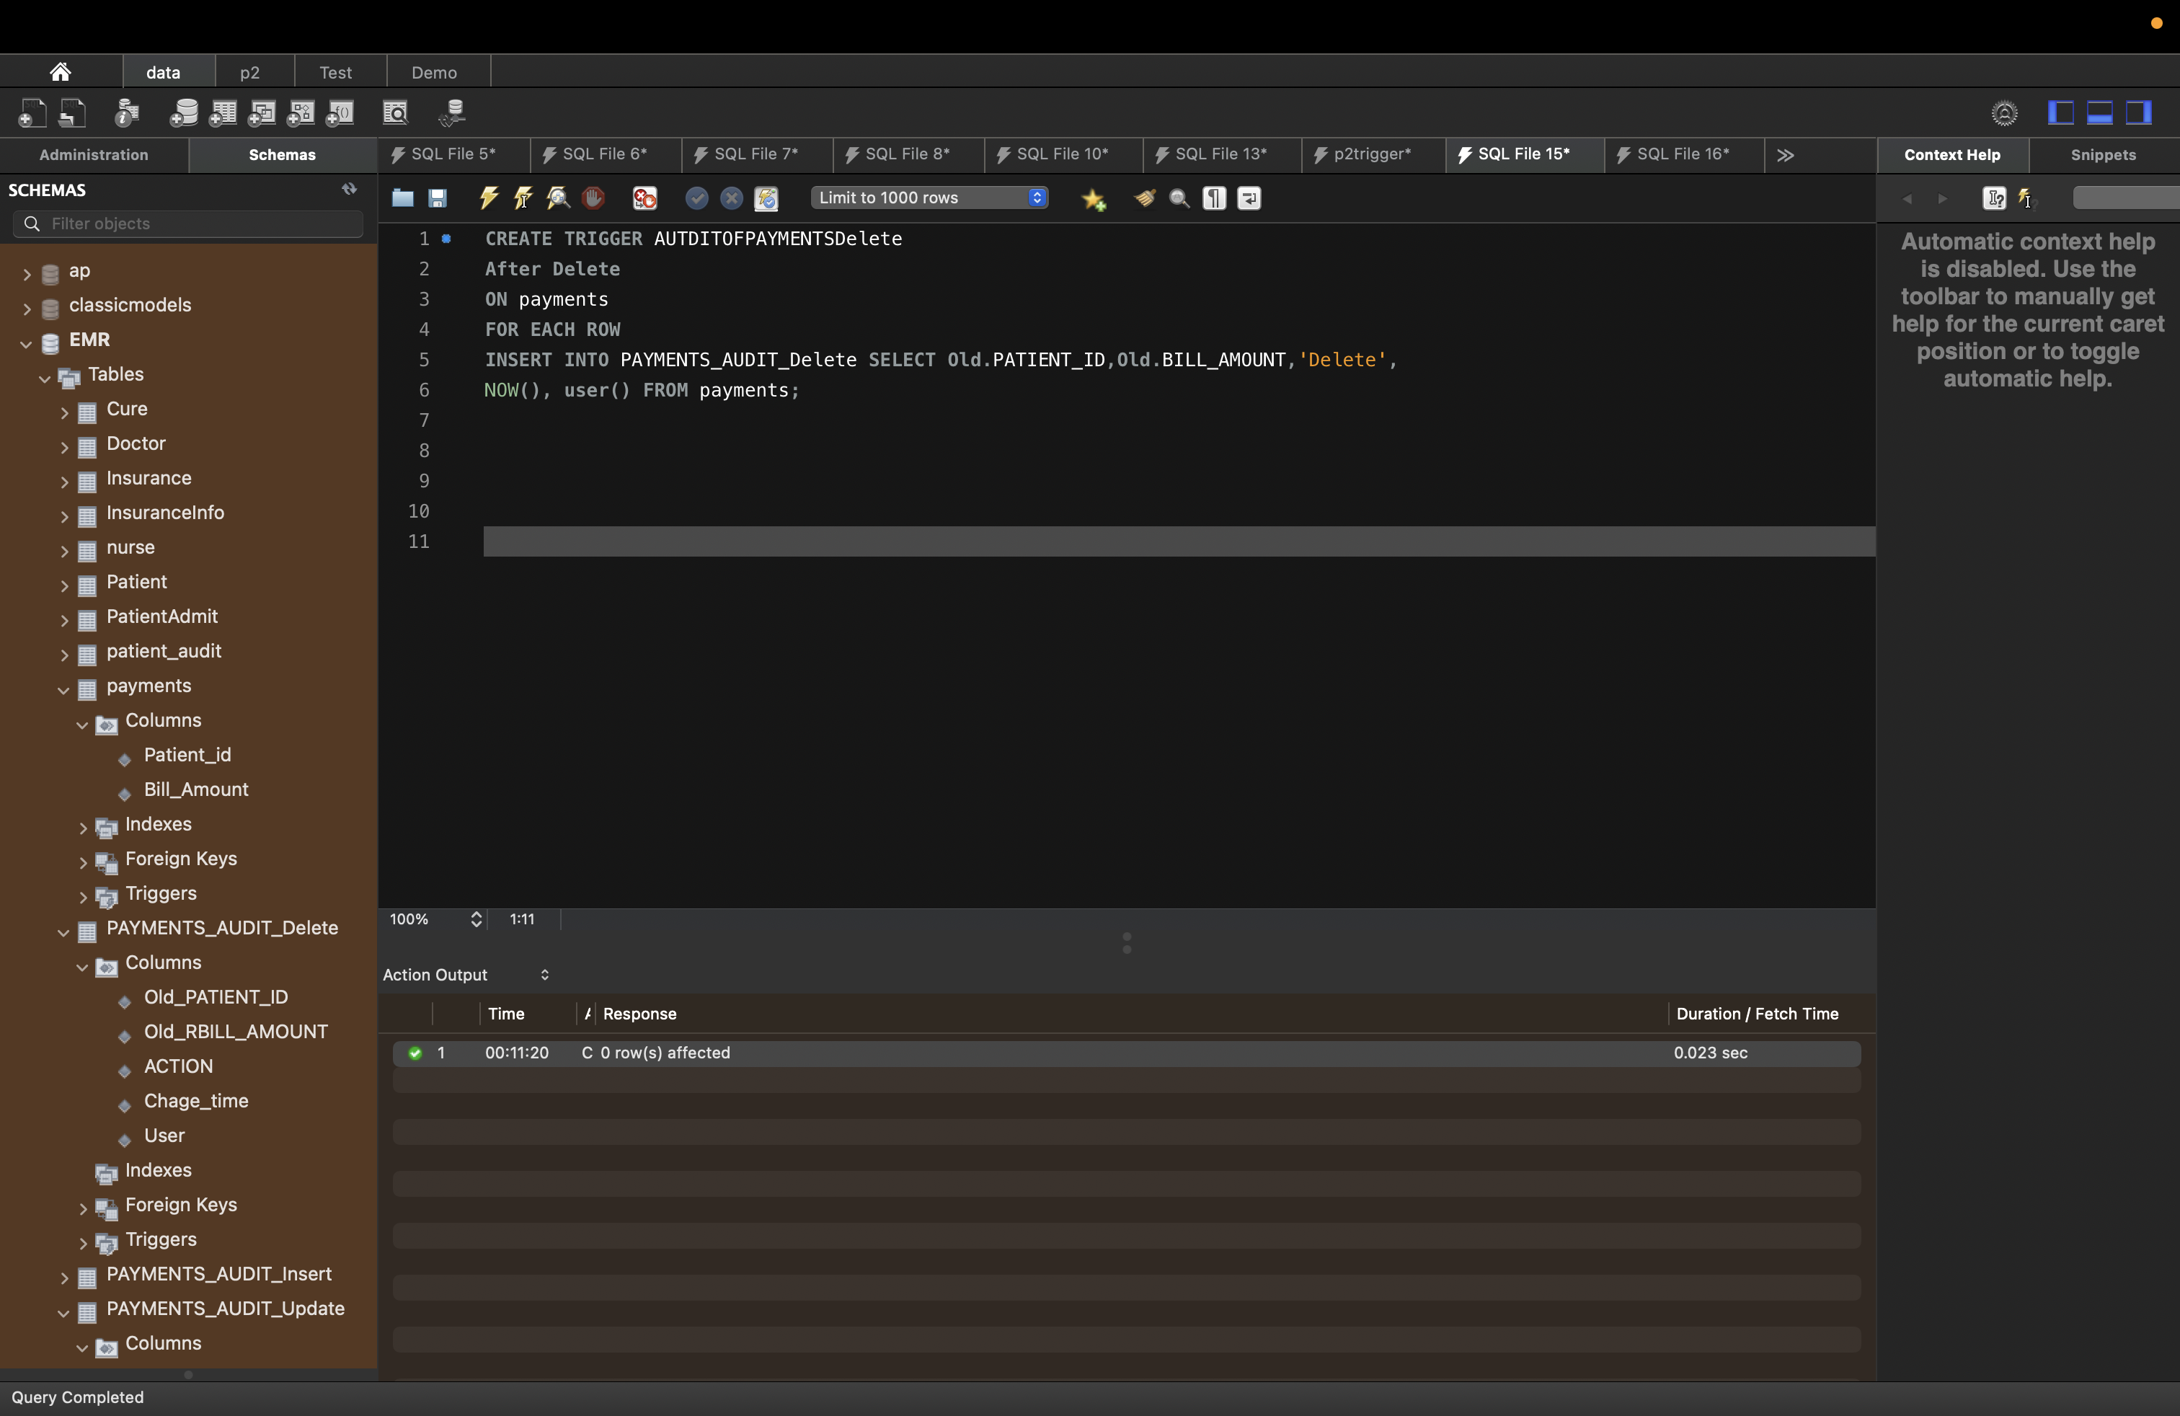

Tables I created for Audit_Trail(New):

1. **ROOM_AUDIT_Insert**
2. New_ROOM_NUMBER
3. New_Room_Availability
4. New_Room_EntryDate
5. New_Room_ExitDate
6. ACTION
7. Chage_time
8. User
9. **ROOM_AUDIT_Update**
10. Old_ROOM_NUMBER
11. Old_Room_Availability
12. Old_Room_EntryDate
13. Old_Room_ExitDate
14. New_ROOM_NUMBER
15. New_Room_Availability
16. New_Room_EntryDate
17. New_Room_ExitDate
18. ACTION
19. Chage_time
20. User
21. **ROOM_AUDIT_Delete**
22. old_ROOM_NUMBER
23. old_Room_Availability
24. old_Room_EntryDate
25. old_Room_ExitDate
26. ACTION
27. Chage_time
28. User
29. **PAYMENTS_AUDIT_Insert**
30. New_PATIENT_ID
31. New_BILL_AMOUNT
32. ACTION
33. Chage_time
34. User
35. **PAYMENTS_AUDIT_Update**
36. Old_PATIENT_ID
37. Old_RBILL_AMOUNT
38. New_PATIENT_ID
39. New_RBILL_AMOUNT
40. ACTION
41. Chage_time
42. User
43. **PAYMENTS_AUDIT_Delete**
44. Old_PATIENT_ID
45. Old_RBILL_AMOUNT
46. ACTION
47. Chage_time
48. User

**Triggers List**

1. AUTDITOFROOMUPDATE
2. AUTDITOFROOMInsert
3. AUTDITOFROOMDelete
4. AUTDITOFPAYMENTSUPDATE
5. AUTDITOFPAYMENTSInsert
6. AUTDITOFPAYMENTSDelete

**View List**

1. PatientReasonOfVisit
2. PatientDoctor
3. PatientSymptoms
4. PatientCure
5. PatientBillAmount

**Indexes List**

1. Patient_Patient_id
2. Doctor_Doctor_Name
3. Visit_ReasonOfVisit
4. Room_Room_Number
5. Payment_Bill_Amount

# Section 12: Tools Used

1. MySql Workbench for writing SQL queries
2. Lucid Chart for drawing UML Diagram
3. Word for documentation